Reliable Data Transmission and Efficient Vehicle Path-Planning in Cooperative Vehicular Networks

1st Mohammed I. Habelalmateen
Department of Computer Technical Engineering
College of Technical Engineering
The Islamic University
Najaf, Iraq
moh.almateen@gmail.com.
4th Rusul Lsmael Hadi
National University of Science and Technology
Dhi Qar, Iraq
rusul.l.hadi@nust.edu.iq.
2nd Nejood F. Abdulsattar
Department of Computer Technical Engineering
Imam Al-Kadhum College (IKC)
Al-Diwaniyah, Iraq
nejodfaisal@gmail.com.
5th Hassan Mohammed Abed
Department of Computer Techniques Engineering
Mazaya University College
DhiQar, Iraq;
eng.hassan@mpu.edu.iq.
3rd Amit Gangopadhyay
Department of Electronics and Communication Engineering
Erstwhile Sree Vidyanikethan Engineering College
Mohan Babu University
Tirupati, India
ag102091@gmail.com
6th Fatima Hashim Abbas
Medical Laboratories Techniques Department
Al-Mustaqbal University
Hillah, Iraq
fatimahashim@mustaqbal-college.edu.iq

Abstract—In recent times an increased number of vehicles create a traffic congestion problem in urban enrollment. In recent scientific research to normalize the communication issues of the vehicles, unmanned aerial vehicles (UAVs) are embedded with the vehicular communication mainly to control the traffic congestion and insufficient bandwidth utilization of the vehicles. The aerial vehicles are highly flexible and efficient so that they are able to control the vehicles in an efficient manner. But still certain drawbacks are present in the aerial vehicles such as improper localization and ineffective data transmission. To solve these flaws, in this article reliable data transmission and efficient vehicle path planning in the cooperative communication model (RDTEVP) is developed. The core modules of this model are reliability base network modeling and path planning based routing. Through this process the efficiency of the network is maximized and the data transmission quality is improvised. This model is structured to analyses the device performance are packet delivery ratio, network throughput, energy efficiency, average delay and routing overhead. The term delay and routing overhead are greatly minimized in the RDTEVP when compared with the earlier schemes.
Keywords— Reliable Data Transmission, Efficient Vehicle Path-Planning, Vehicular Ad-hoc networks and Unmanned Aerial Vehicles.

Introduction
VANETs are one among the ad hoc networks which provides data transmission among the roadside units and the ground vehicles [1-5]. This technology was intended to provide vehicle safety in a collaborative manner and the general transmission modes of this model are inter vehicular [6-9] and infrastructure based [10-14]. Due to high speed vehicles there is always an alert to congestion at the time of data transmission so that the traffic information can take a specific path to reach the destination without delay in inter vehicular communication process [4]. In infrastructure based models the vehicles directly transmit the data to the roadside unit so that it is able to reduce the network delay [15-19]. In recent times, the number of vehicles which are present in a particular area is tremendously increased and directly affects the communication quality and efficiency [20-24].
The dynamic nature and frequently changing topology of the vehicles results in high power consumption and transmission delay [25-27]. To overcome such drawbacks unmanned aerial vehicles (UAVs) [28-31] are developed in the cooperative vehicle network to obtain effective communication [32-36]. With the presence of this technology the ground level and air communication is standardized and the transmitted data is secured from the ground level obstacles and external environment. In the present Times certain drawbacks are identified in the UAV communication where the vehicles are suffered from improper path planning and irregular data transmission [37-40]. To overcome these drawbacks in this article reliable data transmission and efficient vehicle path planning developed the major contribution of the researches listed below.
The primary goal of this article is to support high-quality communication between aerial and ground-level vehicles by offering efficient network models and the best path choices. This proposed paradigm falls into three main categories: path planning based routing, dependability based communication, and efficient network development. The efficiency of communication and its transmission standards are improvised through this method.

Related Works
In [41], introduced CUV, a proactive, energy-efficient, and reliable collaborative scheme for integrating UAVs with VANETs. The proposed scheme utilizes Base Station Association Messages in a selective unicast manner. In [42], proposed the integration of UAV (UAVs) into the Smart City's info communication network, particularly focusing on their role in ITS and VANETs. It explores key parameters of UAVs as components of the telecommunications network and monitoring systems. In [43], aim to improve data transmission performance, particularly when the distance between a vehicular node (ambulance) and a static mobile node (hospital) is significant, and the vehicular node is immobile due to traffic or natural disasters.
In [44], explored the use of UAVs for emergency response in urban areas. It detects incidents on roads, relay locations to rescue teams, and establish efficient paths for intervention. A robust routing scheme ensures stable communication. In [45], introduced the Collaborative UAVs scheme, a proactive energy-efficient and reliable collaboration between UAVs and VANETs for road surveillance. This scheme utilizes BAM in a unicast manner to establish connectivity with the Base Station. In [46], proposed an efficient routing protocol, VANET Routing with UAVs. The VRU protocol includes two distinct routing components, VRU_vu for delivering data packets between vehicles using UAV assistance and VRU_u for routing data packets between UAVs. In [47], provide a new adaptive jumping multi-objective firefly algorithm designed to optimize data distribution in VANETs. This method is fresh and innovative in its approach. This approach is included with a Clustering and Forwarding Mechanism in VANETs.
The authors of [48] have created an optimization-based model that aims to enhance the energy efficiency and minimize network latency by introducing a cluster-based aerial network model. The objective is to develop energy-efficient aerial vehicles that minimize energy usage during data transfer between vehicles in the network [49].In [50], a new network model is developed to monitor the high speed vehicles and it requires bandwidth allocation with the presence of optimization strategy. On analyzing previous research, it is evident that this network architecture still has several unresolved study topics, namely in the improvement of reliability and the optimization of route planning between devices. The demerits of the previously discussed models are summarized in table I.
- Earlier Research Summary.
No | Methodology | Advantages | Disadvantages
[42] | Integration of UAVs and VANETs | Enhances the robustness | Network density is lower
[43] | Vehicles-Assisted UAVs Network | Improved Performance Metrics | Computation delay is high
[44] | Improved Particle Swarm Optimization (PSO) | Communication ensures data privacy | Power utilization and delay is high
[45] | Modeling GT Locations | Satisfaction of inter-vehicular distance constraints | Overall performance is moderate
[47] | Modeling GT Locations | Satisfaction of inter-vehicular distance constraints | Overall performance is moderate
[48] | mixed-integer nonlinear problem (MINLP) | Efficient solution of the optimization problem | Data transmission accuracy is moderate
[49] | Privacy-Guaranteed V2V Communication | Emergency communications in disaster scenarios | Network latency is high
[50] | Vehicles-Assisted UAVs Network | Impact of lost messages due to hidden nodes | Produce more power consumption

Proposed RDTEVP Approach.
In this section the proposed model is elaborated and it consists of two core modules such as reliable data transmission and efficient path planning among the UAV and the ground vehicles. This model is able to provide a better success rate in data transmission and throughput generation. The flow of the RDTEVP is given in “Fig.1”.

Network Model.
The network architecture is based on three modes of communication: Vehicle-to-Base Station (V2BS), Vehicle-to-Unmanned Aerial Vehicle (V2U), and Vehicle-to-Vehicle (V2V). Within V2U communication, UAVs has the capacity to establish direct communication with vehicles, assuming that they will not be hindered by any barriers as long as they are within each other's range. Additionally, they may function as collector nodes, regularly acquiring all data pertaining to cars from any available source.
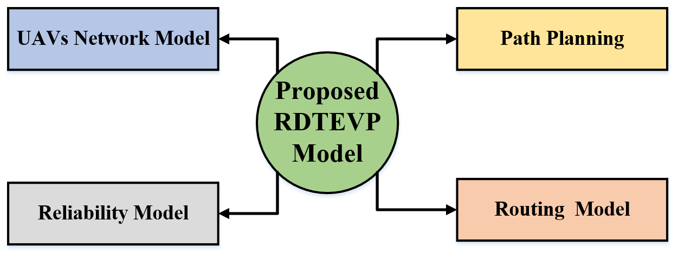
- RDTEVP Process Flow.
V2BS are used for the distribution of control messages, as well as the regular collection of vehicles' information, such as their location, speed, and direction, which is contained in their Hello packets, obtained from either vehicles or UAVs. It is crucial to highlight that UAVs establish connection with automobiles inside their coverage area, but the BSs establish communication with vehicles placed beyond the coverage range of any UAVs. Put simply, UAVs are given the highest level of importance in gathering traffic data on roadways while they are flying over certain regions, with the aim of minimizing the burden on 5G BSs. Furthermore, each base station constantly monitors real-time traffic information and delivers essential updates about the traffic conditions to all surrounding vehicles that need route planning.

Reliability Model.
The assumption was made that the likelihood of a successful transfer of data between two vehicles serves as a measure of the dependability of the connection. Therefore, it was presumed that $AT$ and $L$ represent the length of affiliation, the duration of data exchange, and the overall lifetime of the connection, respectively. Then, $P_{s}=\operatorname{Pr}\left\{A+T_{s}≤L\right\}$represents the probability of a successful data exchange, which is determined by the condition that the sum of the association time and the data exchange time is less than or equal to the total transmission time. The duration required to deliver a certain message with a size denoted as $S$ is determined using “(1)” and “(2)”.
$T_{S}=\frac{S}{D_{r}}$ 
where: $S$ represents the magnitude of the message and $D_{r}$ represents the data rate.
$P_{s}=min⁡(1, \frac{\frac{D_{i,j}}{v_{rel}}}{A+\frac{S}{D_{r}}})$ 2
$D_{i,j}$ represents the relative velocity between vehicle i and vehicle j. Similarly, the symbol $v_{rel}$ represents the relative velocity between vehicle i and vehicle j. Every communication has a certain magnitude, which therefore results in varying levels of link dependability.

Routing Model
The routing method combines geometric and dependability factors to determine the most efficient path for the messages. The process of determining which candidate nodes should route the request message will be achieved by using the geometrical information from the geometrical block and the reliability information from the reliability block. Through the use of the probabilistic technique, the two criteria are combined. Using the fusion $α$ parameter, the greatest percentage was chosen as ${PR}_{next-hop }$from the candidate next-hop in the neighbouring updated zone. If the number exceeds $α$, the selection is made based on the greatest priority in terms of dependability. Alternatively, the geometrical model selects the greatest priority. This procedure is iterated until the ${PR}_{next-hop }$ nodes have been chosen from the pool of candidate nodes. This process is repeated until the ${PR}_{next-hop }$ values have been selected from the pool of candidate nodes.
The route discovery process is triggered either by a γ percentage change in the neighboring zone or by receiving a route error report from the most recently discovered route. The purpose of the neighbor zone update operation is to collect the mobility data from each node about its neighboring nodes. This cycle is performed regularly in each $[+T_{nzu}]$. The data is gathered via a salutation message. The sent data consists of the location, velocity, and acceleration. Therefore, each vehicle has the capability to calculate the relative distance, relative velocity, and relative acceleration with respect to its adjacent vehicles.

Path Planning based Routing:
This work presents the UVAR protocol, which is a routing protocol designed for VANETs. This protocol employs UAVs to assist vehicular nodes in the routing process. The UAVs use the multi-criteria score ${Score}_{G }$ to assess the level of connectivity of each road section. This score is determined using “ (3)”.
${Score}_{G }=δ*(\frac{R_{v}}{(1+σ)*D_{w}})$ 3
Where the variable $\frac{R_{v}}{D_{w}}$ represents the quotient of the transmission range of the vehicles and the shortest distance to the final destination and δ, and σ are the connection and vehicular dispersion degrees, respectively, of each road segment. In this scenario, UAVs collect the Hello messages from ground vehicles in each specific portion of the route. Based on the collected data, each UAV creates a table-of-density that is constantly updated with the number of vehicles and their specific position between two road intersections. Subsequently, the calculated score ${Score}_{G }$ for each road segment in a UAV is transmitted to the vehicles through $Hello$ messages. Only the vehicles located at the junctions have the option to pick the route by choosing the road segment with the best degree of connection and is geographically closest to the destination. If there are a few vehicles on the road or if the most connected road segment is far from the next junction, packet delivery relies only on UAVs employing a reactive routing strategy. In this instance, the routing does not rely on a location service. In order to determine the most optimal route, the destination UAV calculates the ${Score}_{s }$ “(4)”, for the received RREQ packets.
${Score}_{s }=\prod_{i=0}^{H-1}{[\frac{R_{U}}{dist(∆_{n_{i}}, ∆_{n_{i+1}})}]}$ 4
Where UAV transmission range is denoted as $R_{U}$. H denotes the quantity of intermediary steps between the origin and the target and $dist(∆_{n_{i}}, ∆_{n_{i+1}})$ indicates the distance between two consecutive nodes. This technique has several limitations. Initially, the protocol assumes that there is at least one nearby UAV. It utilizes a greedy forwarding method to transmit the packet on the ground. However, this approach may encounter difficulties when the routing encounters a local maximum. In addition, when there are a few vehicles on the ground, the protocol relies on UAVs to handle the forwarding operation, using a reactive method. When a node is unable to send a packet, a DTN technique is used, resulting in significant delays in the routing process. With the presence of certain methods, the proposed model performed better in terms of efficiency and the workflow is described in the pseudo code below.
The Pseudo Code of Proposed RDTEVP-UAV
Inputs: Network Model, Reliability Model, Routing Model and Path Planning
Step 1 - Network Model Creation
Vehicles, UAVs and BSs creation
Step 2 - Reliability Model Construction
Successful Data Exchange - $T_{S}=\frac{S}{D_{r}}$
Probability of Data Exchange - $P_{s}=min⁡(1, \frac{\frac{D_{i,j}}{v_{rel}}}{A+\frac{S}{D_{r}}})$
Step 3 - Routing Model Creation
Best next hop selection process
Step 4 - Path Planning
Multi-Criteria Score - ${Score}_{G }=δ*(\frac{R_{v}}{(1+σ)*D_{w}})$
Optimal Route for Destination - ${Score}_{s }=\prod_{i=0}^{H-1}{[\frac{R_{U}}{dist(∆_{n_{i}}, ∆_{n_{i+1}})}]}$
Step 5 – Performance Analysis

Simulation Results.
By using the NS2 simulator, we assessed the efficiency of the RIED-UAV [48], ECIT-UAV [49], and JSBO-UAV [50] methods to analyse the proposed RDTEVP-UAV. The assessment procedure incorporates many indicators such as performance data delivery ratio, energy efficiency; throughput, average delay, and routing overhead and as well the parameters considered for simulation experimentation are given in table II.
- Input Parameters Table
Input Parameters | Values
Running Time | 200 ms
Coverage Distance | 2000m*2000m
Number of Vehicles | 500 Vehicles
Vehicles Radius | 100m
Initial Energy | 100 Joules
Transmission Power | 0.500 Joules
Receiving Power | 0.050 Joules

Packet delivery Ratio.
It represents the proportion of packets that have been successfully conveyed inside a network, out of the total number of packets sent.
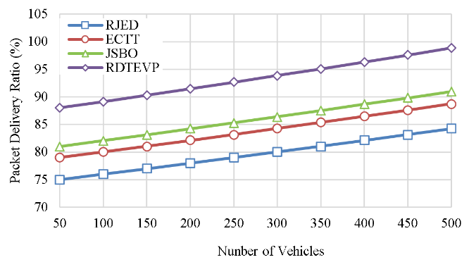
- Packet Delivery Ratio Calculation.
The “Fig.2”, shows the packet delivery ratio calculation of RDTEVP-UAV which is compared with earlier works RIED-UAV, ECIT-UAV, and JSBO-UAV.
The Proposed RDTEVP has a high Packet Delivery Ratio of 99%, showing that almost all sent packets are successfully delivered. The suggested technique demonstrates superior reliability and efficiency compared to the existing techniques RJED at 84%, ECTT at 89%, and JSBO at 91%.

Throughput
Throughput is the measure of the speed at which data is effectively transferred over a communication connection. The “Fig.3”, shows the network throughput calculation of RDTEVP-UAV which is compared with earlier works RIED-UAV, ECIT-UAV, and JSBO-UAV.
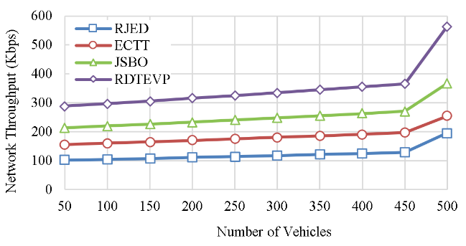
- Network Throughput Calculation.
The Proposed RDTEVP has a superior capacity to process a greater amount of data compared to the existing technique of RJED at 196 kbps, ECTT at 254 kbps, and JSBO at 368 kbps, as seen by its higher throughput of 564 kbps. This indicates a higher level of performance in terms of both the speed and efficiency of data transport.

Energy Efficiency.
Energy efficiency refers to the proportion of usable energy production, specifically in the context of data transmission, to the energy input absorbed by the network during the transmission process. The “Fig.4”, shows the Energy efficiency calculation of RDTEVP-UAV which is compared with earlier works RIED-UAV, ECIT-UAV, and JSBO-UAV.
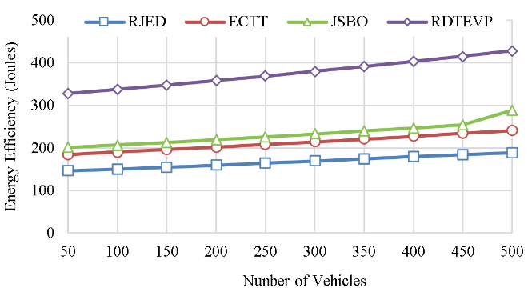
- Energy efficiency calculation.
The Proposed RDTEVP demonstrates superior energy efficiency, with reduced energy consumption per unit of data of 429 joules, compared to RJED at 189 joules, ECTT at 241 joules, and JSBO at 289 joules. These findings indicate that the suggested approach successfully provides data transfer while minimizing energy use.

Average Delay
It is the average duration utilized by the data packets which is travel from the source to the destination.
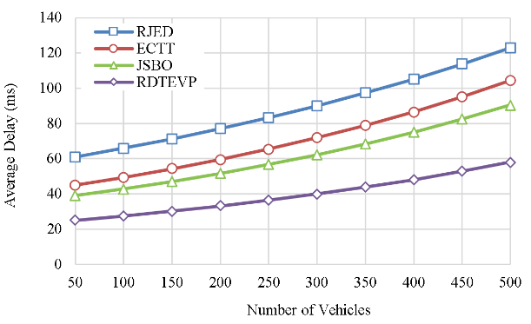
- Average delay calculation.
The “Fig.5”, shows the Average delay calculation of RDTEVP-UAV which is compared with earlier works RIED-UAV, ECIT-UAV, and JSBO-UAV. The Proposed RDTEVP has a reduced Average Delay of 58 ms, indicating quicker data transmission compared to RJED at 123 ms, ECTT at 104 ms, and JSBO at 91 ms. this implies a decrease in the amount of time it takes for data to be sent and a faster delivery of data in the suggested approach.

Routing Overhead.
Routing Overhead is the extra data packets that are used to handle routing information inside a network. The “Fig.6”, shows the routing overhead calculation of RDTEVP-UAV which is compared with earlier works RIED-UAV, ECIT-UAV, and JSBO-UAV.
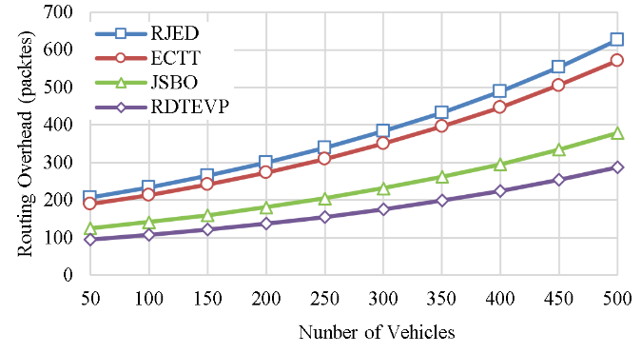
- Routing overhead calculation.
The Proposed RDTEVP has a reduced Routing Overhead of 287 packets, indicating a more efficient and optimized routing procedure in comparison to RJED at 626 packets, ECTT at 572 packets, and JSBO at 378 packets.

Conclusion.
These path planning and network reliability models result in the action of traffic congestion reduction among the aerial vehicles and the ground vehicles. Optimal path selection is after and using this model that greatly reduces the network delay and routing overhead by the reduction of data forwarded ratio among the vehicles in the network. Efficient deployment of the aerial vehicles results in the minimization of power at the time of data transmission. The simulated results show that the overall performance of the proposed model is higher than the earlier baseline methodologies. In future work it is suggested to concentrate on a clustering approach to improve the quality service of the aerial vehicles and to provide condition control.

References
- A. H. Abbas, N. F. Abdulsattar, H. S. Mansour, M. H. Mutar, M. I. Habelalmateen, L. Audah, N. A. M. Alduais, and A. Mohammed, "A New Hybrid Approach Cluster-Heads Election to reduce the number of clusters in VANETs," in 2022 5th International Conference on Engineering Technology and its Applications (IICETA), pp. 436-440, 2022. DOI: https://doi.org/10.1109/IICETA54559.2022.9888442.
- M. I. Habelalmateen, A. H. Abbas, L. Audah, and N. A. M. Alduais, "Dynamic multiagent method to avoid duplicated information at intersections in VANETs," Telkomnika (Telecommunication Computing Electronics and Control), vol. 18, no. 2, pp. 613-621, 2020. DOI: http://doi.org/10.12928/telkomnika.v18i2.13947.
- M. K. Hasan, M. M. Ahmed, N. F. Wani, A. H. Abbas, L. M. Alkwai, S. Islam, A. K. M. A. Habib, and R. Hassan, "Dynamic load modeling for bulk load-using synchrophasors with wide area measurement system for smart grid real-time load monitoring and optimization," Sustainable Energy Technologies and Assessments, vol. 57, p. 103190, 2023. doi: https://doi.org/10.1016/j.seta.2023.103190.
- A. H. Abbas, A. J. Ahmed, and S. A. Rashid, "A Cross-Layer Approach MAC/NET with Updated-GA (MNUG-CLA)-Based Routing Protocol for VANET Network," World Electric Vehicle Journal, vol. 13, no. 5, article no. 87, 2022. DOI: https://doi.org/10.3390/wevj13050087.
- H. S. Mansour, M. H. Mutar, I. A. Aziz, S. A. Mostafa, H. Mahdin, A. H. Abbas, M. H. Hassan, N. F. Abdulsattar, and M. A. Jubair, "Cross-Layer and Energy-Aware AODV Routing Protocol for Flying Ad-Hoc Networks," Sustainability, vol. 14, no. 15, article no. 8980, 2022. DOI: https://doi.org/10.3390/su14158980.
- M. A. Jubair, S. A. Mostafa, D. A. Zebari, H. M. Hariz, N. F. Abdulsattar, M. H. Hassan, A. H. Abbas, F. H. Abbas, A. Alasiry, and M. Turki-Hadj, "A QoS Aware Cluster Head Selection and Hybrid Cryptography Routing Protocol for Enhancing Efficiency and Security of VANETs," IEEE Access, vol. 10, pp. 124792-124804, 2022. doi: https://doi.org/10.1109/ACCESS.2022.3224466.
- M. I. Habelalmateen, A. J. Ahmed, A. H. Abbas, and S. A. Rashid, "TACRP: Traffic-Aware Clustering-Based Routing Protocol for Vehicular Ad-Hoc Networks," Designs, vol. 6, no. 5, article no. 89, 2022. DOI: https://doi.org/10.3390/designs6050089.
- S. A. Rashid, M. I. Habelalmateen, A. J. Ahmed, A. H. Abbas, M. A. Jubair, M. H. Hassan, A. Abdulhadi, S. Hammed, and L. Audah, "Congestion Aware Genetic Q-learning Based RPL Routing Protocol for Vehicle Ad-Hoc Networks," in 2022 5th International Conference on Engineering Technology and its Applications (IICETA), pp. 464-469, 2022. doi: https://doi.org/10.1109/IICETA54559.2022.9888583.
- A. H. Abbas, A. J. Ahmed, S. A. Rashid, N. F. Abdulsattar, M. H. Hassan, M. A. Jubair, and M. I. Habelalmateen, "Predictive Hybrid Routing with Multi Objective Optimization Model for Opportunistic Routing for VANET," in 2022 5th International Conference on Engineering Technology and its Applications (IICETA), pp. 470-476, 2022. doi: https://doi.org/10.1109/IICETA54559.2022.9888274
- A. H. Najim, A. H. Abbas, K. Al-sharhanee, and H. M. Hariz, "Reinforcement Learning-based Topology-Aware Routing Protocol with Priority Scheduling for Internet of Drones in Agriculture Application," International Journal of Intelligent Engineering and Systems, vol. 16, no. 5, pp. 395-405, 2023. doi: https://doi.org/10.22266/ijies2023.1031.34.
- A. H. Alwan, A. A. Aziz, M. A. Jubair, A. H. Abbas, M. H. Hassan, S. Alheejawi, N. F. Abdulsattar, A. S. Mustafa, and M. I. Habelalmateen, "Monitoring the Impact of the Nodes Density on the MANETs’ Environment," in 2022 5th International Conference on Engineering Technology and its Applications (IICETA), pp. 546-549, 2022. doi: https://doi.org/10.1109/IICETA54559.2022.9888339.
- Mostafa, S.A., Mustapha, A., Ramli, A.A., Jubair, M.A., Hassan, M.H., Abbas, A.H. (2021). Comparative Analysis to the Performance of Three Mobile Ad-Hoc Network Routing Protocols in Time-Critical Events of Search and Rescue Missions. In: Cassenti, D., Scataglini, S., Rajulu, S., Wright, J. (eds) Advances in Simulation and Digital Human Modeling. AHFE 2020. Advances in Intelligent Systems and Computing, vol 1206. Springer, Cham. https://doi.org/10.1007/978-3-030-51064-0_16.
- M. H. Hassan, M. A. Jubair, A. H. Abbas, A. J. Ahmed, S. A. Rashid, M. H. Mutar, H. S. Mansour, A. Ali, and M. I. Habelalmateen, "AODV based Crow Search Algorithm for Improving the QoS of MANET," in 2022 5th International Conference on Engineering Technology and its Applications (IICETA), pp. 424-428, 2022. DOI: https://doi.org/10.1109/IICETA54559.2022.9888484.
- M. A. Jubair, M. H. Hassan, S. A. Mostafa, H. Mahdin, A. Mustapha, L. H. Audah, F. S. Shaqwi, and A. H. Abbas, "Competitive analysis of single and multi-path routing protocols in MANET," Indonesian Journal of Electrical Engineering and Computer Science, vol. 19, no. 1, pp. 293-300, 2020. http://doi.org/10.11591/ijeecs.v19.i1.pp293-300.
- S. A. Rashid, A. J. Ahmed, M. H. Hassan, A. H. Abbas, M. I. Habelalmateen, M. A. Jubair, L. Audah, and W. Al-Azzawi, "Ranking Based Routing Protocol for Residual Energy Estimation in Wireless Sensor Network Based IoT Network," in 2022 5th International Conference on Engineering Technology and its Applications (IICETA), pp. 453-459, 2022. https://doi.org/10.1109/IICETA54559.2022.9888349.
- A. J. Ahmed, A. H. Abbas, S. A. Rashid, M. A. Jubair, M. H. Hassan, A. Abdulhadi, N. F. Abdulsattar, and M. I. Habelalmateen, "Congestion Aware Q-Learning (CAQL) in RPL Protocol – WSN based IoT Networks," in 2022 5th International Conference on Engineering Technology and its Applications (IICETA), pp. 429-435, 2022. doi: https://doi.org/10.1109/IICETA54559.2022.9888322.
- R. Q. Malik, K. N. Ramli, Z. H. Kareem, M. I. Habelalmatee, A. H. Abbas, and A. Alamoody, "An Overview on V2P Communication System: Architecture and Application," in 2020 3rd International Conference on Engineering Technology and its Applications (IICETA), pp. 174-178, 2020. doi: https://doi.org/10.1109/IICETA50496.2020.9318863.
- Y.S. Jghef, M.J.M. Jasim, H.M.A. Ghanimi, A.D. Algarni, N.F. Soliman, W. El-Shafai, S.R.M. Zeebaree, A. Alkhayyat, A.S. Abosinnee, N.F. Abdulsattar, A.H. Abbas, H.M. Hariz, and F.H. Abbas, "Bio-Inspired Dynamic Trust and Congestion-Aware Zone-Based Secured Internet of Drone Things (SIoDT)," Drones, vol. 6, no. 11, pp. 337, 2022. https://doi.org/10.3390/drones6110337
- G.G. Shayea, D.A. Mohammed, A.H. Abbas, and N.F. Abdulsattar, "Privacy-Aware Secure Routing through Elliptical Curve Cryptography with Optimal RSU Distribution in VANETs," Designs, vol. 6, no. 6, pp. 121, 2022. doi: https://doi.org/10.3390/designs6060121.
- M.H. Hassan, A.H. Abbas, M.H. Mutar, M.A. Jubair, S.A. Rashid, A.J. Ahmed, M.I. Habelalmateen, A. Mohammed, and L. Audah, "Investigative Study on Routing Protocols in Flying Ad Hoc Networks Environment," in 2022 5th International Conference on Engineering Technology and its Applications (IICETA), pp. 460-463, 2022. doi: https://doi.org/10.1109/IICETA54559.2022.9888600
- N.F. Abdulsattar, F. Abedi, H.M.A. Ghanimi, S. Kumar, A.H. Abbas, A.S. Abosinnee, A. Alkhayyat, M.H. Hassan, and F.H. Abbas, "Botnet Detection Employing a Dilated Convolutional Autoencoder Classifier with the Aid of Hybrid Shark and Bear Smell Optimization Algorithm-Based Feature Selection in FANETs," Big Data and Cognitive Computing, vol. 6, no. 4, article no. 112, 2022. DOI: https://doi.org/10.3390/bdcc6040112.
- V. O. Nyangaresi, I. M. Al-Joboury, K. A. Al-sharhanee, A. H. Najim, A. H. Abbas, and H. M. Hariz, "A biometric and physically unclonable function–Based authentication protocol for payload exchanges in internet of drones," e-Prime - Advances in Electrical Engineering, Electronics and Energy, vol. 7, pp. 100471, 2024. DOI: https://doi.org/10.1016/j.prime.2024.100471.
- N.F. Abdulsattar, A.H. Abbas, M.H. Mutar, M.H. Hassan, M.A. Jubair, and M.I. Habelalmateen, "An Investigation Study for Technologies, Challenges and Practices of IoT in Smart Cities," in 2022 5th International Conference on Engineering Technology and its Applications (IICETA), pp. 554-557, 2022. DOI: https://doi.org/10.1109/IICETA54559.2022.9888474.
- F. Abedi, H. M. A. Ghanimi, M. A. M. Sadeeq, A. Alkhayyat, Z. H. Kareem, S. N. Mahmood, A. H. Abbas, A. S. Abosinnee, W. K. Al-Azzawi, M. M. Jaber, and M. Dauwed, "Hybrid Deep Learning Enabled Load Prediction for Energy Storage Systems," Computers, Materials & Continua, vol. 75, no. 2, pp. 3359-3374, 2023. DOI: https://doi.org/10.32604/cmc.2023.034221.
- I. Ahmad, S. Hussain, S. N. Mahmood, H. Mostafa, A. Alkhayyat, M. Marey, A. H. Abbas, and Z. Abdulateef Rashed, "Co-Channel Interference Management for Heterogeneous Networks Using Deep Learning Approach," Information, vol. 14, no. 2, article no. 139, 2023. DOI: https://doi.org/10.3390/info14020139.
- A. M. Abdulkarem, F. Abedi, H. M. A. Ghanimi, S. Kumar, W. K. Al-Azzawi, A. H. Abbas, A. S. Abosinnee, I. M. Almaameri, and A. Alkhayyat, "Robust Automatic Modulation Classification Using Convolutional Deep Neural Network Based on Scalogram Information," Computers, vol. 11, no. 11, article no. 162, 2022. DOI: https://doi.org/10.3390/computers11110162.
- S. Alsubai, A. K. Dutta, A. H. Alkhayyat, M. M. Jaber, A. H. Abbas, and A. Kumar, "Hybrid deep learning with improved Salp swarm optimization based multi-class grape disease classification model," Computers and Electrical Engineering, vol. 108, p. 108733, 2023. DOI: https://doi.org/10.1016/j.compeleceng.2023.108733.
- I. S. Al-Hawary, E. Ali, S. M. H. Kamona, L. Hussain Saleh, A. S. Abdulwahid, D. N. Al-Saidi, M. S. Alhassan, F. A. Rasen, H. Abdullah Abbas, A. Alawadi, A. H. Abbas, and M. Sina, "Prediction of geomechanical bearing capacity using autoregressive deep neural network in carbon capture and storage systems," Heliyon, vol. 9, no. 11, pp. e21913, Nov. 2023. doi: https://doi.org/10.1016/j.heliyon.2023.e21913.
- M. R. M. Alsemawi, M. H. Mutar, E. H. Ahmed, H. O. Hanoosh, and A. H. Abbas, "Emotions recognition from human facial images based on fast learning network," Indonesian Journal of Electrical Engineering and Computer Science, vol. 30, no. 3, pp. 1478-1487, 2023. doi: http://doi.org/10.11591/ijeecs.v30.i3.pp1478-1487.
- J. Tang, A. K. Abbas, N. A. Koka, N. Sadoon, J. K. Abbas, R. A. Abdalhuseen, M. Abosaooda, N. M. Ahmed, and A. H. Abbas, "Optimization of thermal biofuel production from biomass using CaO-based catalyst through different algorithm-based machine learning approaches," Case Studies in Thermal Engineering, vol. 50, p. 103419, 2023. doi: https://doi.org/10.1016/j.csite.2023.103419.
- F. Abedi, H. M. A. Ghanimi, A. D. Algarni, N. F. Soliman, W. El-Shafai, A. H. Abbas, Z. H. Kareem, H. M. Hariz, and A. Alkhayyat, "Chimp Optimization Algorithm Based Feature Selection with Machine Learning for Medical Data Classification," Computer Systems Science and Engineering, vol. 47, no. 3, pp. 2791–2814, 2023. doi: https://doi.org/10.32604/csse.2023.038762.
- M. A. A. Albadr et al., "Online sequential extreme learning machine approach for breast cancer diagnosis," Neural Computing and Applications, vol. Volume, no. Issue, pp. Page, 2024. DOI: https://doi.org/10.1007/s00521-024-09617-x.
- N. F. Abdulsattar, D. A. Mohammed, A. Alkhayyat, S. Z. Hamed, H. M. Hariz, A. S. Abosinnee, A. H. Abbas, M. H. Hassan, M. A. Jubair, F. H. Abbas, A. D. Algarni, N. F. Soliman, and W. El-Shafai, "Privacy-Preserving Mobility Model and Optimization-Based Advanced Cluster Head Selection (P2O-ACH) for Vehicular Ad Hoc Networks," Electronics, vol. 11, no. 24, p. 4163, 2022, DOI: https://doi.org/10.3390/electronics11244163.
- F. Abedi, S. R. M. Zeebaree, Z. S. Ageed, H. M. A. Ghanimi, A. Alkhayyat, M. A. M. Sadeeq, S. N. Mahmood, A. S. Abosinnee, Z. H. Kareem, A. H. Abbas, W. K. Al-Azzawi, M. M. Jaber, and M. Dauwed, "Severity Based Light-Weight Encryption Model for Secure Medical Information System," Computers, Materials & Continua, vol. 74, no. 3, pp. 5691-5704, 2023. DOI: https://doi.org/10.32604/cmc.2023.034435.
- A. H. Kadhim, A. M. Razaq, M. A. Jubair, N. F. Abdulsattar, A. H. Abbas, M. H. Hassan, A. Jamal Ahmed, S. AbdulJabbar Rashid, and M. I. Habelalmateen, "A Real-Time Low-Cost Remote Doctor Monitoring System," in 2022 5th International Conference on Engineering Technology and its Applications (IICETA), pp. 558-561, 2022. doi: https://doi.org/10.1109/IICETA54559.2022.9888536.
- F. Abedi, H. M. A. Ghanimi, A. D. Algarni, N. F. Soliman, W. El-Shafai, A. H. Abbas, Z. H. Kareem, H. M. Hariz, and A. Alkhayyat, "Computational Intelligence Driven Secure Unmanned Aerial Vehicle Image Classification in Smart City Environment," Computer Systems Science and Engineering, vol. 47, no. 3, pp. 3127-3144, 2023. DOI: https://doi.org/10.32604/csse.2023.038959.
- M. S. Alshuhri, S. G. Al-Musawi, A. A. Al-Alwany, H. Uinarni, I. Rasulova, P. Rodrigues, A. T. Alkhafaji, A. M. Alshanberi, A. H. Alawadi, and A. H. Abbas, "Artificial intelligence in cancer diagnosis: Opportunities and challenges," Pathology - Research and Practice, vol. 253, pp. 154996, 2024. https://doi.org/10.1016/j.prp.2023.154996.
- A. H. Abbas, M. I. Habelalmateen, L. Audah, and N. A. M. Alduais, "A novel intelligent cluster-head (ICH) to mitigate the handover problem of clustering in VANETs," International Journal of Advanced Computer Science and Applications, vol. 10, no. 6, pp. 281-287, 2019. DOI: https://doi.org/10.14569/IJACSA.2019.0100627.
- A. Abdulbari, S. K. Abdul Rahim, F. Abedi, P. J. Soh, A. Hashim, R. Qays, S. Ahmad, and M. Y. Zeain, "Single-Layer Planar Monopole Antenna-Based Artificial Magnetic Conductor (AMC)," International Journal of Antennas and Propagation, vol. 2022, pp. 6724175, 2022. https://doi.org/10.1155/2022/6724175.
- A. H. Abbas, M. I. Habelalmateen, S. Jurdi, L. Audah, and N. A. M. Alduais, "GPS based location monitoring system with geo-fencing capabilities," AIP Conference Proceedings, vol. 2173, no. 1, p. 020014, Nov. 2019. DOI: https://doi.org/10.1063/1.5133929.
- N. Bashir and S. Boudjit, "An energy-efficient collaborative scheme for UAVs and VANETs for dissemination of real-time surveillance data on highways," in 2020 IEEE 17th Annual Consumer Communications & Networking Conference (CCNC), Jan. 2020, pp. 1-6, doi: 978-1-7281-3893-0/20.
- A. Khakimov, D. Alekseeva, A. Muthanna, and M. Al-Bahri, "Traffic Offloading Algorithm for VANET Network Based on UAV," in 2020 IEEE Conference of Russian Young Researchers in Electrical and Electronic Engineering (EIConRus), Jan. 2020, pp. 28-32, doi: 978-1-7281-5761-0/20.
- A. Mukhopadhyay and D. Ganguly, "FANET based emergency healthcare data dissemination," in 2020 Second International Conference on Inventive Research in Computing Applications (ICIRCA), Jul. 2020, pp. 170-175, doi: 978-1-7281-5374-2/20.
- O. S. Oubbati, A. Lakas, P. Lorenz, M. Atiquzzaman, and A. Jamalipour, "Leveraging communicating UAVs for emergency vehicle guidance in urban areas," IEEE Transactions on Emerging Topics in Computing, vol. 9, no. 2, Apr. 2019, pp. 1070-1082, doi: 10.1109/TETC.2019.2930124.
- H. Fatemidokht, M. K. Rafsanjani, B. B. Gupta, and C. H. Hsu, "Efficient and secure routing protocol based on artificial intelligence algorithms with UAV-assisted for vehicular ad hoc networks in intelligent transportation systems," IEEE Transactions on Intelligent Transportation Systems, vol. 22, no. 7, Jul. 2021, pp. 4757-4769, doi: 10.1109/TITS.2020.3041746.
- F. Z. Rabahi, S. Boudjit, C. Bemmoussat, and M. Benaissa, "Uavs-based mobile radars for real-time highways surveillance," in 2020 IEEE 17th International Conference on Mobile Ad Hoc and Sensor Systems (MASS), Dec. 2020, pp. 80-87, doi: 10.1109/MASS50613.2020.00020.
- A. H. Abbas, A. J. Ahmed, S. A. Rashid, M. A. Jubair, N. F. Abdulsattar, H. S. Mansour, and M. I. Habelalmateen, "Hybrid ANT Based Continuous Cuckoo Search Optimization Algorithm for Vehicle Adhoc Networks," in 2022 5th International Conference on Engineering Technology and its Applications (IICETA), pp. 447-452, May 31-June 1, 2022. https://doi.org/10.1109/IICETA54559.2022.9888404
- Somayeh Mokhtari and Nima Nouri, “Relaying Data With Joint Optimization of Energy and Delay in Cluster-Based UAV-Assisted VANETs”, IEEE Internet of Things Journal, vol. 9, no. 23, pp. 24541 – 24559, 2022, doi: 10.1109/JIOT.2022.3188563.
- Nan Hu and Xiaoqi Qin, “Energy-efficient Caching and Task offloading for Timely Status Updates in UAV-assisted VANETs”, International Conference on Communications in China (ICCC), 2022, doi: 10.1109/ICCC55456.2022.9880683
- Yue Fu and Demin Li, “Joint Speed and Bandwidth Optimized Strategy of UAV-Assisted Data Collection in Post-Disaster Areas”, Mediterranean Communication and Computer Networking Conference (MedComNet), 2022, doi: 10.1109/MedComNet55087.2022.9810444

