Energy consumption modeling and Grey Wolf Optimization for vehicular communication

1st Nejood F. Abdulsattar
Department of Computer Technical Engineering
Imam Al-Kadhum College (IKC)
Al-Diwaniyah, Iraq
nejodfaisal@gmail.com.
4th Mohammed I. Habelalmateen
Department of Computer Technical Engineering
College of Technical Engineering
The Islamic University
Najaf, Iraq
moh.almateen@gmail.com.
2nd Hassan Mohammed Abed
Department of Computer Techniques Engineering
Mazaya University College
DhiQar, Iraq;
eng.hassan@mpu.edu.iq.
5th Fatima Hashim Abbas
Medical Laboratories Techniques Department
Al-Mustaqbal University
Hillah, Iraq
fatimahashim@mustaqbal-college.edu.iq
3rd Amit Gangopadhyay
Department of Electronics and Communication Engineering
Erstwhile Sree Vidyanikethan Engineering College
Mohan Babu University
Tirupati, India
ag102091@gmail.com
6th Rusul Lsmael Hadi
National University of Science and Technology
Dhi Qar, Iraq
rusul.l.hadi@nust.edu.iq.

Abstract—A novel energy consumption model and grey wolf optimization model (ECGWO) is developed in the vehicular network to attend high efficiency among the vehicles. Reduction of power utilization for each transmission among the vehicles from one place to another, helps to improvise the efficiency of the network. Providing optimization at the time of data transmission the information gets travelled in optimal path so that the network delay and overhead is greatly reduced. As a whole, this model provides a better communication standard for the vehicles in the network. The proposed model is data success rate, data loss rate, average delay, network throughput and routing overhead. The simulation result shows that the ECGWO has better success rate and throughput than other related methods.
Keywords— Vehicular Ad hoc Network, Energy Consumption Model, Grey Wolf Optimization Model and Optimal Path Selection.

Introduction
The goal of the vehicular communication is to provide highly secure data transmission for the vehicles [1-5]. Periodically exchange of information among the vehicles consists of certain details such as vehicles location, identification and speed [6-9]. To achieve effective communication the vehicles need to concentrate on the current traffic condition, data safety and efficiency [10-12]. The primary characteristics of the vehicles which are present in the network are high speed [13-17], variable mobility and rapid change of topology [18-22]. Achieving maximum efficiency in the dynamically changing topology is the most challenging task [23-28].
In recent times several reactive and proactive protocols are developed to provide efficient routing among the vehicles and to periodically maintain the root broadcast data [29-31] and its exchange information which gets maintained in its routine table [32-34]. Due to improper path selection the energy consumption for transportation is increased which directly affects the efficiency of the network [35-38]. Show the primary drawbacks which are present in the high speed vehicular communication are high energy consumption and improper path selection [39-40]. To overcome such drawbacks in the earlier methods in this article an efficient energy consumption model with an optimization model is developed. The contribution of this article is described as follows.
An intelligent energy consumption model is proposed in this article to improve the efficiency of the vehicular communication. Second, a grey wolf optimization model is created to offer the best route between the source and the destination. The existence of these models increases the vehicles' efficiency by lowering their power consumption.

Related Works
In [41], introduced a clustered cognitive radio VANETs system that relies on link stability and mobility prediction. The system incorporates CR-VANET architecture, clustering model, speed-based mobility prediction, and link-based multipath routing. In [42], introduced a control technique with a high level of efficiency for Interior Permanent Magnet Synchronous Motors used in electric vehicles. The control method combines a high-efficiency control system with an algorithm that predicts the ideal speed. In [43], proposed a new integrated capacity model for WCHs that takes into account both power and communication resources for planning and managing daily operations. In [44], introduced a system aimed at enhancing the efficiency of electric autonomous cars in smart urban areas by using solar power. The charging stations are properly positioned according to past solar energy trends. In [45], introduced Blockchain-based ideas for demand response programmes that make effective use of electric cars and renewable energy sources in the power markets. It emphasizes the future of power systems and smart grids.
In [46], designed an ITS supporting platooning management for global optimization, aiming to reduce energy consumption. This algorithm is based on Grey Wolf Optimization searches for the optimal platoon. In [47], presented an energy consumption model that is based on concepts of combinatorial optimization multi-objectives, assignment problem, and game theory. This model aims to answer the urgent need for effective energy usage. In [48], introduced a reliable predictive speed controller for CAVs that makes use of V2V communication while ensuring privacy protection. This is the first controller that consistently takes into account both energy and emissions. In [49], provide a scalable modulation-based task offloading technique for vehicular edge computing. The technique employs mobile vehicles as dynamic relays to tackle the issues presented by compute offloading.
In [50], the optimization based vehicular communication was concentrated to provide traffic safety and entertainment services. Mainly to improve the connection quality of the devices unicast routing scheme with an optimization model is developed. The obtained results are moderate and it needs further improvisation. In [51], cluster based optimization model is developed among the vehicular communication mainly to reduce the communication cost and routing overhead of the vehicles and to extend the network lifespan but this method is not suitable for high speed vehicles. In [52], an optimization based data dissemination model is developed to reduce the congestion among the devices. After analyzing the earlier models it is concluded that there is still a research gap present in terms of efficiency improvisation. The details of the methods which are involved in these analyses are summarized in table I and its drawbacks are identified.
- Earlier Research Summary.
No | Methodology | Advantages | Disadvantages
[42] | Clustering Model | Significant performance improvement | Network density is lower
[48] | Robust Predictive Speed Controller | Link Stability and Mobility Prediction | High power consumption and delay
[49] | Privacy-Guaranteed V2V Communicatio | Cluster Formation | High power utilization
[50] | Concurrent Consideration of Energy and Emissions | Improved Energy Efficiency and Emissions Reduction | Data transmission accuracy is moderate
[51] | Robust Design | Constraint Satisfaction | Network latency is high
[52] | CR-VANET Construction | Communication ensures data privacy | Produce more power consumption

Proposed ECGWO Approach.
In this section, energy consumption model and optimization using grey wolf algorithm is presented which can efficiently maximize the data success ratio and vehicles throughput. The flow of the ECGWO is described in “Fig.1”,
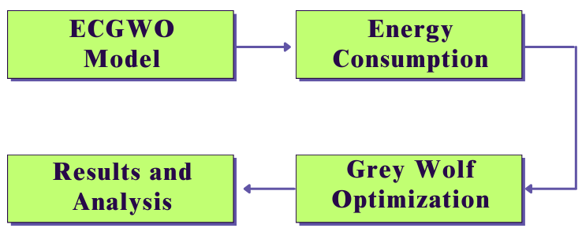
- ECGWO Model Process.

Energy consumption modeling.
A wireless system's efficiency can be affected by a number of factors. Energy and power consumption are two of the limitations. As a result, numerous studies have been carried out to improve wireless systems' energy efficiency. This is due to the fact that reducing energy use has several benefits, including lower costs. The total energy used in the transmitting (tr), receiving, listening, and operating modes can be used to determine the energy usage of a wireless communication network. The overall quantity of energy required by all of the architecture's equipment, including V2V, V2N, V2P, and V2I, is known as the energy consumption in “(1)”.
$E_{t}=\sum_{j}{E_{j}}$ 
Where consists of the following elements: transmitting, receiving, listening, and operation. The outcome of the multi-objective combinatorial optimization “(1)”, will be:
$Minimize {\sum_{j}{h_{j}(E_{t})}}_{ }$ 2
Subject to:
$r_{j}≥r_{j}^{min}$
$P_{j}≤p_{j}^{max}$
$I_{j}≤I_{j}^{max}$
Where :
$r_{j}$ : Rate of data transfer for the jth user
$P_{j}$ : Power limitation imposed on the jth user's transmission
$I_{j}$ : jth user is constrained by channel interference.

In accordance with the assignment problem “(2)”,
$$Minimize \sum_{x}{\sum_{j}{\sum_{i}{f_{q}(m_{j}, γ_{j},ϑ_{j},n_{j}, E_{i}\left(E_{qj}\left(v2x\right)\right))}}}$$
Subject to:
$r_{q}≥r_{q}^{min}$
$P_{q}≤p_{q}^{max}$
$I_{q}≤I_{q}^{max}$
Where:
$$i=\left\{transmitting, receiving, listening, operation\right\}$$
$V2x=\{V2V ,V2N,V2P,V2I \}$
$E_{qj}$ is the jth equipment
$n_{j}$ : quantity of identical equipment
$m_{j}$ is the current status of the device (either idle or active).
$Y_{j}$ : Equipment activity level factor refers to the degree of activity such as busy hour, medium, or low.
$v_{j}$ a mobility factor that accounts for the influence of velocity, cell location, and handover operation type.
In this context, we shall establish the parameters and characteristics of our game:
$$G=\{players P_{i},strategies S_{i},outcomes O\}$$
Players in this context will function as equipment that engage in cooperative competition when they are both included in the same cell, and as operators that engage in non-cooperative competition when they are not. Consequently, we establish a collaborative trade-off $t_{j}$ that considers energy efficiency and quality of service based on a priority list that includes factors such as the kind of data, type of user, and geographic location. Each participant has two strategies: forwarding ($s_{j}=1$) or dropping ($s_{j}=0$) the received packet. Each of the players has two strategies, to forward ($s_{j}=1$) or to drop ($s_{j}=0$) the received packet. On the other hand, the energy used by a single unit of data $∅_{k}$in a certain phase and 𝒊 associated to a particular equipment $j$ within a given time period $T$ is denoted as $φ_{i:j:k}$.as in “(3)”,
$E_{i}(E_{qj}\left(V2x\right)=\sum_{k}{φ_{i:j:k}×∅_{k}}$ 3
Where $∅_{k}$ represents the size of the kth packet. The formula has been revised in “(4)”,
$Minimize \sum_{x}{\sum_{j}{\sum_{i}{f_{q}(m_{j}, γ_{j},ϑ_{j},n_{j}, S_{j}, t_{j}\sum_{k}{φ_{i:j:k}×∅_{k}}}}}$ 4
Subject to:
$r_{q}≥r_{q}^{min}$
$P_{q}≤p_{q}^{max}$
$I_{q}≤I_{q}^{max}$
Nash equilibrium (NE) is a key idea in GT that serves as a solution to a game. Essentially, a NE refers to a set of activities that ensures that no person may enhance their own utility without the cooperation of others. Alternatively, we may express it as follows: in a Nash Equilibrium, no player has any motivation to alter their approach. Hence, NE is a stable result of the game.

Grey Wolf Optimization
Considering the optimization issue falls under the category of NP-complete, a Wolf Hunting technique is used to explore the solution space. Three ideal candidate solutions, namely α (the first one), β (the second one), and γ (the third one), are randomly generated in accordance with the specified requirements. Furthermore, further prospective solutions are formulated using the GWO approach. Once the algorithm reaches a certain number of iterations, it will provide the three most optimum solutions ($α, β, γ)$, from which the best solution $α$ is chosen. The algorithm implements the subsequent updating procedure “(5)”.
$X_{i}^{d}\left(t+1\right)=X_{p}^{d}\left(t\right)-A_{i}^{d}\left|C_{i}^{d}X_{p}^{d}\left(t\right)-X_{i}^{d}\left(t\right)\right|$ 5
Where $t$ indicate the number of iterations.$X_{i}$ is the vector that denotes the location of a grey wolf (candidate solution), while $X_{p}$ is the vector that denotes the position of the prey (possible solution). $A_{i}^{d}=2a.r_{1}-a, C_{i}^{d}=2.r_{2}$and $r_{1}$ randomly chosen from the range [0,1]. The value is decrease linearly from 2 to 0.

Simulation Results.
With the use of the NS2 simulator, we were able to evaluate the performance of the IUACO-UAV [50], BCOER-UAV [51], and DDPSO-UAV [52] methods in order to conduct an analysis of the proposed ECGWO-UAV. During the evaluation process, the measures that are used include performance data delivery ratio, energy efficiency, throughput, energy consumption, and routing overhead and as well the parameters which are present in this simulation at the initial stage are given in table II.
- Input Parameters Table
Input Parameters | Values
Running Time | 100 ms
Coverage Distance | 750m*750m [53]
Number of Vehicles | 200 Vehicles [54]
Vehicle Radius | 100m [55]
Initial Energy | 100 Joules [56]
Transmission Power | 0.500 Joules [57]
Receiving Power | 0.050 Joules [57]

Data Success rate.
Data Success Ratio is a metric that quantifies the proportion of data packets that have been successfully sent compared to the total number of packets sent. The “Fig.2”, shows the Data success rate of ECGWO-UAV with is compared with IUACO-UAV, BCOER-UAV, and DDPSO-UAV methods.
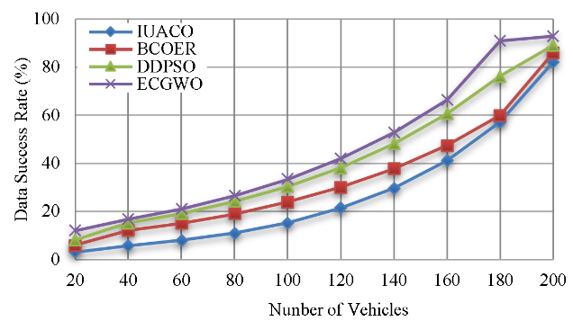
- Data success rate calculation.
The Data Success Ratio for each protocol reflects the dependability of data transfer. The suggested ECGWO has the greatest Data Success Ratio (93%), shows that 93% of sent data packets were successfully delivered. This surpasses IUACO (82%), BCOER (86%), and DDPSO (89%), demonstrating ECGWO's exception.

Data loss Ratio.
Data Loss Rate is the proportion of data packets lost during transmission. The “Fig.3”, shows the Data loss rate of ECGWO-UAV with is compared with IUACO-UAV, BCOER-UAV, and DDPSO-UAV methods.
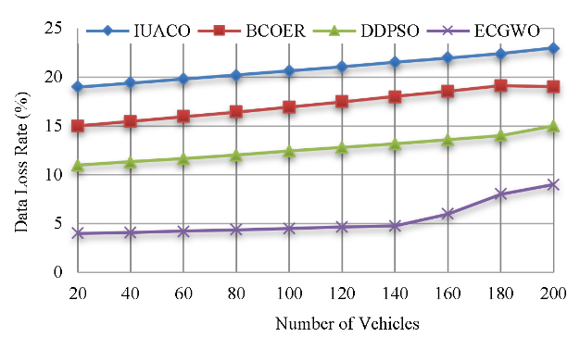
- Data loss rate calculation.
The proposed ECGWO has the lowest data loss rate (9%), indicating a good degree of data integrity. This is an improvement compared to IUACO (23%), BCOER (19%), and DDPSO (15%), highlighting the usefulness of ECGWO in decreasing data loss.

Average Delay (ms.
The mean delay of data packets from the source to the destination, measured in milliseconds. The “Fig.4”, shows the average delay of ECGWO-UAV with is compared with IUACO-UAV, BCOER-UAV, and DDPSO-UAV methods.
The suggested ECGWO algorithm has a significantly shorter Average Delay of 81 ms in comparison to IUACO of 125 ms, BCOER of 103 ms, and DDPSO of 96 ms. this indicates that the proposed ECGWO algorithm accomplishes expedited data transmission.
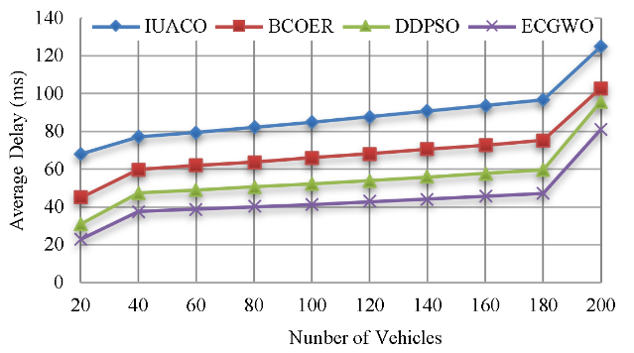
- Average Delay Calculation.

Throughput.
The data transmission rate of a communication medium. The “Fig.5”, shows the throughput calculation of ECGWO-UAV with is compared with IUACO-UAV, BCOER-UAV, and DDPSO-UAV methods.
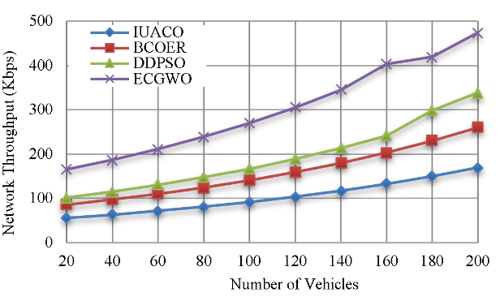
- Throughput Calculation.
The ECGWO algorithm produces a much greater throughput of 474 kbps, exceeds the throughput of IUACO of 169 kbps, BCOER of 260 kbps, and DDPSO of 338 kbps. This suggests that the proposed ECGWO has the capability to process and transfer a greater amount of data.

Routing Overhead.
The additionally data packets used for the transmission of routing information inside a network. The “Fig.6”, shows the Routing overhead calculation of ECGWO-UAV with is compared with IUACO-UAV, BCOER-UAV, and DDPSO-UAV methods.
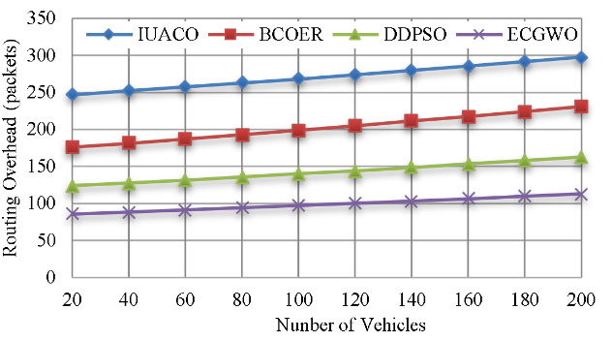
- Routing overhead calculation.
The ‘Proposed ECGWO algorithm reduces the Routing Overhead to 113 packets, showing superior efficiency in routing when compared to IUACO (298 packets), BCOER (231 packets), and DDPSO (163 packets).

Conclusion.
In this paper, an efficient energy consumption model and optimal path selection model is combined to attend maximum efficiency among the vehicles in the network. Using proper energy utilization models each data transmission is normalized so that the required power for the information is reduced that helps to increase the efficiency of the devices. With the presence of optimal path selection process the transmitted data from the source vehicle to the destination is optimized which reduces the data forwarding ratio of the vehicles. Experimental results prove that the proposed model can efficiently maximize the success rate of the transmitted information with typical related schemes. In future scope, the main focus is about increasing the density of the vehicles and the transmission quality in the densely populated area.

References
- A. H. Abbas, A. J. Ahmed, S. A. Rashid, M. A. Jubair, N. F. Abdulsattar, H. S. Mansour, and M. I. Habelalmateen, "Hybrid ANT Based Continuous Cuckoo Search Optimization Algorithm for Vehicle Adhoc Networks," in 2022 5th International Conference on Engineering Technology and its Applications (IICETA), pp. 447-452, May 31-June 1, 2022. https://doi.org/10.1109/IICETA54559.2022.9888404.
- M. I. Habelalmateen, A. H. Abbas, L. Audah, and N. A. M. Alduais, "Dynamic multiagent method to avoid duplicated information at intersections in VANETs," Telkomnika (Telecommunication Computing Electronics and Control), vol. 18, no. 2, pp. 613-621, 2020. DOI: http://doi.org/10.12928/telkomnika.v18i2.13947.
- M. K. Hasan, M. M. Ahmed, N. F. Wani, A. H. Abbas, L. M. Alkwai, S. Islam, A. K. M. A. Habib, and R. Hassan, "Dynamic load modeling for bulk load-using synchrophasors with wide area measurement system for smart grid real-time load monitoring and optimization," Sustainable Energy Technologies and Assessments, vol. 57, p. 103190, 2023. doi: https://doi.org/10.1016/j.seta.2023.103190.
- A. H. Abbas, A. J. Ahmed, and S. A. Rashid, "A Cross-Layer Approach MAC/NET with Updated-GA (MNUG-CLA)-Based Routing Protocol for VANET Network," World Electric Vehicle Journal, vol. 13, no. 5, article no. 87, 2022. DOI: https://doi.org/10.3390/wevj13050087
- H. S. Mansour, M. H. Mutar, I. A. Aziz, S. A. Mostafa, H. Mahdin, A. H. Abbas, M. H. Hassan, N. F. Abdulsattar, and M. A. Jubair, "Cross-Layer and Energy-Aware AODV Routing Protocol for Flying Ad-Hoc Networks," Sustainability, vol. 14, no. 15, article no. 8980, 2022. DOI: https://doi.org/10.3390/su14158980.
- A. H. Abbas, N. F. Abdulsattar, H. S. Mansour, M. H. Mutar, M. I. Habelalmateen, L. Audah, N. A. M. Alduais, and A. Mohammed, "A New Hybrid Approach Cluster-Heads Election to reduce the number of clusters in VANETs," in 2022 5th International Conference on Engineering Technology and its Applications (IICETA), pp. 436-440, 2022. DOI: https://doi.org/10.1109/IICETA54559.2022.9888442.
- M. A. Jubair, S. A. Mostafa, D. A. Zebari, H. M. Hariz, N. F. Abdulsattar, M. H. Hassan, A. H. Abbas, F. H. Abbas, A. Alasiry, and M. Turki-Hadj, "A QoS Aware Cluster Head Selection and Hybrid Cryptography Routing Protocol for Enhancing Efficiency and Security of VANETs," IEEE Access, vol. 10, pp. 124792-124804, 2022. doi: https://doi.org/10.1109/ACCESS.2022.3224466.
- M. I. Habelalmateen, A. J. Ahmed, A. H. Abbas, and S. A. Rashid, "TACRP: Traffic-Aware Clustering-Based Routing Protocol for Vehicular Ad-Hoc Networks," Designs, vol. 6, no. 5, article no. 89, 2022. DOI: https://doi.org/10.3390/designs6050089.
- S. A. Rashid, M. I. Habelalmateen, A. J. Ahmed, A. H. Abbas, M. A. Jubair, M. H. Hassan, A. Abdulhadi, S. Hammed, and L. Audah, "Congestion Aware Genetic Q-learning Based RPL Routing Protocol for Vehicle Ad-Hoc Networks," in 2022 5th International Conference on Engineering Technology and its Applications (IICETA), pp. 464-469, 2022. doi: https://doi.org/10.1109/IICETA54559.2022.9888583.
- A. H. Abbas, A. J. Ahmed, S. A. Rashid, N. F. Abdulsattar, M. H. Hassan, M. A. Jubair, and M. I. Habelalmateen, "Predictive Hybrid Routing with Multi Objective Optimization Model for Opportunistic Routing for VANET," in 2022 5th International Conference on Engineering Technology and its Applications (IICETA), pp. 470-476, 2022. doi: https://doi.org/10.1109/IICETA54559.2022.9888274.
- A. H. Najim, A. H. Abbas, K. Al-sharhanee, and H. M. Hariz, "Reinforcement Learning-based Topology-Aware Routing Protocol with Priority Scheduling for Internet of Drones in Agriculture Application," International Journal of Intelligent Engineering and Systems, vol. 16, no. 5, pp. 395-405, 2023. doi: https://doi.org/10.22266/ijies2023.1031.34.
- A. H. Abbas, H. Mansour, and A. Al-Fatlawi, "Self-Adaptive Efficient Dynamic Multi-Hop Clustering (SA-EDMC) Approach for Improving VANET’s Performance," International Journal of Interactive Mobile Technologies (iJIM), vol. 16, no. 14, pp. 136-151, Jul. 2022. DOI: https://doi.org/10.3991/ijim.v16i14.31081.
- A. H. Alwan, A. A. Aziz, M. A. Jubair, A. H. Abbas, M. H. Hassan, S. Alheejawi, N. F. Abdulsattar, A. S. Mustafa, and M. I. Habelalmateen, "Monitoring the Impact of the Nodes Density on the MANETs’ Environment," in 2022 5th International Conference on Engineering Technology and its Applications (IICETA), pp. 546-549, 2022. doi: https://doi.org/10.1109/IICETA54559.2022.9888339.
- Mostafa, S.A., Mustapha, A., Ramli, A.A., Jubair, M.A., Hassan, M.H., Abbas, A.H. (2021). Comparative Analysis to the Performance of Three Mobile Ad-Hoc Network Routing Protocols in Time-Critical Events of Search and Rescue Missions. In: Cassenti, D., Scataglini, S., Rajulu, S., Wright, J. (eds) Advances in Simulation and Digital Human Modeling. AHFE 2020. Advances in Intelligent Systems and Computing, vol 1206. Springer, Cham. https://doi.org/10.1007/978-3-030-51064-0_16.
- M. H. Hassan, M. A. Jubair, A. H. Abbas, A. J. Ahmed, S. A. Rashid, M. H. Mutar, H. S. Mansour, A. Ali, and M. I. Habelalmateen, "AODV based Crow Search Algorithm for Improving the QoS of MANET," in 2022 5th International Conference on Engineering Technology and its Applications (IICETA), pp. 424-428, 2022. DOI: https://doi.org/10.1109/IICETA54559.2022.9888484.
- M. A. Jubair, M. H. Hassan, S. A. Mostafa, H. Mahdin, A. Mustapha, L. H. Audah, F. S. Shaqwi, and A. H. Abbas, "Competitive analysis of single and multi-path routing protocols in MANET," Indonesian Journal of Electrical Engineering and Computer Science, vol. 19, no. 1, pp. 293-300, 2020. http://doi.org/10.11591/ijeecs.v19.i1.pp293-300.
- S. A. Rashid, A. J. Ahmed, M. H. Hassan, A. H. Abbas, M. I. Habelalmateen, M. A. Jubair, L. Audah, and W. Al-Azzawi, "Ranking Based Routing Protocol for Residual Energy Estimation in Wireless Sensor Network Based IoT Network," in 2022 5th International Conference on Engineering Technology and its Applications (IICETA), pp. 453-459, 2022. https://doi.org/10.1109/IICETA54559.2022.9888349.
- A. J. Ahmed, A. H. Abbas, S. A. Rashid, M. A. Jubair, M. H. Hassan, A. Abdulhadi, N. F. Abdulsattar, and M. I. Habelalmateen, "Congestion Aware Q-Learning (CAQL) in RPL Protocol – WSN based IoT Networks," in 2022 5th International Conference on Engineering Technology and its Applications (IICETA), pp. 429-435, 2022. doi: https://doi.org/10.1109/IICETA54559.2022.9888322.
- A. H. Abbas, M. I. Habelalmateen, L. Audah, and N. A. M. Alduais, "A novel intelligent cluster-head (ICH) to mitigate the handover problem of clustering in VANETs," International Journal of Advanced Computer Science and Applications, vol. 10, no. 6, pp. 281-287, 2019. DOI: https://doi.org/10.14569/IJACSA.2019.0100627.
- R. Q. Malik, K. N. Ramli, Z. H. Kareem, M. I. Habelalmatee, A. H. Abbas, and A. Alamoody, "An Overview on V2P Communication System: Architecture and Application," in 2020 3rd International Conference on Engineering Technology and its Applications (IICETA), pp. 174-178, 2020. doi: https://doi.org/10.1109/IICETA50496.2020.9318863.
- Y.S. Jghef, M.J.M. Jasim, H.M.A. Ghanimi, A.D. Algarni, N.F. Soliman, W. El-Shafai, S.R.M. Zeebaree, A. Alkhayyat, A.S. Abosinnee, N.F. Abdulsattar, A.H. Abbas, H.M. Hariz, and F.H. Abbas, "Bio-Inspired Dynamic Trust and Congestion-Aware Zone-Based Secured Internet of Drone Things (SIoDT)," Drones, vol. 6, no. 11, pp. 337, 2022. https://doi.org/10.3390/drones6110337.
- G.G. Shayea, D.A. Mohammed, A.H. Abbas, and N.F. Abdulsattar, "Privacy-Aware Secure Routing through Elliptical Curve Cryptography with Optimal RSU Distribution in VANETs," Designs, vol. 6, no. 6, pp. 121, 2022. doi: https://doi.org/10.3390/designs6060121.
- M.H. Hassan, A.H. Abbas, M.H. Mutar, M.A. Jubair, S.A. Rashid, A.J. Ahmed, M.I. Habelalmateen, A. Mohammed, and L. Audah, "Investigative Study on Routing Protocols in Flying Ad Hoc Networks Environment," in 2022 5th International Conference on Engineering Technology and its Applications (IICETA), pp. 460-463, 2022. doi: https://doi.org/10.1109/IICETA54559.2022.9888600.
- N.F. Abdulsattar, F. Abedi, H.M.A. Ghanimi, S. Kumar, A.H. Abbas, A.S. Abosinnee, A. Alkhayyat, M.H. Hassan, and F.H. Abbas, "Botnet Detection Employing a Dilated Convolutional Autoencoder Classifier with the Aid of Hybrid Shark and Bear Smell Optimization Algorithm-Based Feature Selection in FANETs," Big Data and Cognitive Computing, vol. 6, no. 4, article no. 112, 2022. DOI: https://doi.org/10.3390/bdcc6040112.
- V. O. Nyangaresi, I. M. Al-Joboury, K. A. Al-sharhanee, A. H. Najim, A. H. Abbas, and H. M. Hariz, "A biometric and physically unclonable function–Based authentication protocol for payload exchanges in internet of drones," e-Prime - Advances in Electrical Engineering, Electronics and Energy, vol. 7, pp. 100471, 2024. DOI: https://doi.org/10.1016/j.prime.2024.100471.
- N.F. Abdulsattar, A.H. Abbas, M.H. Mutar, M.H. Hassan, M.A. Jubair, and M.I. Habelalmateen, "An Investigation Study for Technologies, Challenges and Practices of IoT in Smart Cities," in 2022 5th International Conference on Engineering Technology and its Applications (IICETA), pp. 554-557, 2022. DOI: https://doi.org/10.1109/IICETA54559.2022.9888474.
- F. Abedi, S. R. M. Zeebaree, Z. S. Ageed, H. M. A. Ghanimi, A. Alkhayyat, M. A. M. Sadeeq, S. N. Mahmood, A. S. Abosinnee, Z. H. Kareem, A. H. Abbas, W. K. Al-Azzawi, M. M. Jaber, and M. Dauwed, "Severity Based Light-Weight Encryption Model for Secure Medical Information System," Computers, Materials & Continua, vol. 74, no. 3, pp. 5691-5704, 2023. DOI: https://doi.org/10.32604/cmc.2023.034435.
- A. H. Kadhim, A. M. Razaq, M. A. Jubair, N. F. Abdulsattar, A. H. Abbas, M. H. Hassan, A. Jamal Ahmed, S. AbdulJabbar Rashid, and M. I. Habelalmateen, "A Real-Time Low-Cost Remote Doctor Monitoring System," in 2022 5th International Conference on Engineering Technology and its Applications (IICETA), pp. 558-561, 2022. doi: https://doi.org/10.1109/IICETA54559.2022.9888536.
- F. Abedi, H. M. A. Ghanimi, A. D. Algarni, N. F. Soliman, W. El-Shafai, A. H. Abbas, Z. H. Kareem, H. M. Hariz, and A. Alkhayyat, "Computational Intelligence Driven Secure Unmanned Aerial Vehicle Image Classification in Smart City Environment," Computer Systems Science and Engineering, vol. 47, no. 3, pp. 3127-3144, 2023. DOI: https://doi.org/10.32604/csse.2023.038959.
- N. F. Abdulsattar, D. A. Mohammed, A. Alkhayyat, S. Z. Hamed, H. M. Hariz, A. S. Abosinnee, A. H. Abbas, M. H. Hassan, M. A. Jubair, F. H. Abbas, A. D. Algarni, N. F. Soliman, and W. El-Shafai, "Privacy-Preserving Mobility Model and Optimization-Based Advanced Cluster Head Selection (P2O-ACH) for Vehicular Ad Hoc Networks," Electronics, vol. 11, no. 24, p. 4163, 2022, DOI: https://doi.org/10.3390/electronics11244163.
- I. Ahmad, S. Hussain, S. N. Mahmood, H. Mostafa, A. Alkhayyat, M. Marey, A. H. Abbas, and Z. Abdulateef Rashed, "Co-Channel Interference Management for Heterogeneous Networks Using Deep Learning Approach," Information, vol. 14, no. 2, article no. 139, 2023. DOI: https://doi.org/10.3390/info14020139.
- A. M. Abdulkarem, F. Abedi, H. M. A. Ghanimi, S. Kumar, W. K. Al-Azzawi, A. H. Abbas, A. S. Abosinnee, I. M. Almaameri, and A. Alkhayyat, "Robust Automatic Modulation Classification Using Convolutional Deep Neural Network Based on Scalogram Information," Computers, vol. 11, no. 11, article no. 162, 2022. DOI: https://doi.org/10.3390/computers11110162.
- S. Alsubai, A. K. Dutta, A. H. Alkhayyat, M. M. Jaber, A. H. Abbas, and A. Kumar, "Hybrid deep learning with improved Salp swarm optimization based multi-class grape disease classification model," Computers and Electrical Engineering, vol. 108, p. 108733, 2023. DOI: https://doi.org/10.1016/j.compeleceng.2023.108733.
- I. S. Al-Hawary, E. Ali, S. M. H. Kamona, L. Hussain Saleh, A. S. Abdulwahid, D. N. Al-Saidi, M. S. Alhassan, F. A. Rasen, H. Abdullah Abbas, A. Alawadi, A. H. Abbas, and M. Sina, "Prediction of geomechanical bearing capacity using autoregressive deep neural network in carbon capture and storage systems," Heliyon, vol. 9, no. 11, pp. e21913, Nov. 2023. doi: https://doi.org/10.1016/j.heliyon.2023.e21913.
- M. R. M. Alsemawi, M. H. Mutar, E. H. Ahmed, H. O. Hanoosh, and A. H. Abbas, "Emotions recognition from human facial images based on fast learning network," Indonesian Journal of Electrical Engineering and Computer Science, vol. 30, no. 3, pp. 1478-1487, 2023. doi: http://doi.org/10.11591/ijeecs.v30.i3.pp1478-1487.
- J. Tang, A. K. Abbas, N. A. Koka, N. Sadoon, J. K. Abbas, R. A. Abdalhuseen, M. Abosaooda, N. M. Ahmed, and A. H. Abbas, "Optimization of thermal biofuel production from biomass using CaO-based catalyst through different algorithm-based machine learning approaches," Case Studies in Thermal Engineering, vol. 50, p. 103419, 2023. doi: https://doi.org/10.1016/j.csite.2023.103419.
- F. Abedi, H. M. A. Ghanimi, A. D. Algarni, N. F. Soliman, W. El-Shafai, A. H. Abbas, Z. H. Kareem, H. M. Hariz, and A. Alkhayyat, "Chimp Optimization Algorithm Based Feature Selection with Machine Learning for Medical Data Classification," Computer Systems Science and Engineering, vol. 47, no. 3, pp. 2791–2814, 2023. doi: https://doi.org/10.32604/csse.2023.038762.
- A. H. Abbas, L. Audah, and N. A. M. Alduais, "An Efficient Load Balance Algorithm for Vehicular Ad-Hoc Network," in 2018 Electrical Power, Electronics, Communications, Controls and Informatics Seminar (EECCIS), pp. 207-212, 2018. https://doi.org/10.1109/EECCIS.2018.8692827.
- M. A. A. Albadr et al., "Online sequential extreme learning machine approach for breast cancer diagnosis," Neural Computing and Applications, vol. Volume, no. Issue, pp. Page, 2024. DOI: https://doi.org/10.1007/s00521-024-09617-x.
- F. Abedi, H. M. A. Ghanimi, M. A. M. Sadeeq, A. Alkhayyat, Z. H. Kareem, S. N. Mahmood, A. H. Abbas, A. S. Abosinnee, W. K. Al-Azzawi, M. M. Jaber, and M. Dauwed, "Hybrid Deep Learning Enabled Load Prediction for Energy Storage Systems," Computers, Materials & Continua, vol. 75, no. 2, pp. 3359-3374, 2023. DOI: https://doi.org/10.32604/cmc.2023.034221.
- M. S. Alshuhri, S. G. Al-Musawi, A. A. Al-Alwany, H. Uinarni, I. Rasulova, P. Rodrigues, A. T. Alkhafaji, A. M. Alshanberi, A. H. Alawadi, and A. H. Abbas, "Artificial intelligence in cancer diagnosis: Opportunities and challenges," Pathology - Research and Practice, vol. 253, pp. 154996, 2024. https://doi.org/10.1016/j.prp.2023.154996.
- P. A. Ajithkumar and A. Vijayakumari, "High Efficiency Control with Optimum Speed Prediction for Interior Permanent Magnet Synchronous Motor in Electric Vehicle applications," in 2020 Fourth International Conference on Computing Methodologies and Communication (ICCMC), Mar. 2020, pp. 1018-1023, doi: 10.1109/ICCMC48092.2020.ICCMC-000190.
- D. Sikeridis and M. Devetsikiotis, "Joint Capacity Modeling for Electric Vehicles in V2I-enabled Wireless Charging Highways," in 2020 IEEE International Conference on Communications, Control, and Computing Technologies for Smart Grids (SmartGridComm), Nov. 2020, pp. 1-6, doi: 978-1-7281-6127-3/20.
- P. Zhou, C. Wang, and Y. Yang, "Design and optimization of electric autonomous vehicles with renewable energy source for smart cities," in IEEE INFOCOM 2020-IEEE Conference on Computer Communications, Jul. 2020, pp. 1399-1408.
- M. Shekari and M. P. Moghaddam, "An introduction to blockchain-based concepts for demand response considering of electric vehicles and renewable energies," in 2020 28th Iranian Conference on Electrical Engineering (ICEE), Aug. 2020, pp. 1-4, doi: 978-1-7281-7296-5/20.
- F. De Rango, M. Tropea, P. Raimondo, and A. F. Santamaria, "Grey wolf optimization in vanet to manage platooning of future autonomous electrical vehicles," in 2020 IEEE 17th Annual Consumer Communications & Networking Conference (CCNC), Jan. 2020, pp. 1-2, doi: 978-1-7281-3893-0/20.
- S. Oulaourf, A. Haidine, and H. Ouahmane, "Energy consumption modeling in vehicular communication based on 4G," in 2020 International Conference on Electrical and Information Technologies (ICEIT), Mar. 2020, pp. 1-4, doi: 978-1-7281-4341-5/20.
- C. Huang, X. Zhang, R. Salehi, T. Ersal, and A. G. Stefanopoulou, "A robust energy and emissions conscious cruise controller for connected vehicles with privacy considerations," in 2020 American Control Conference (ACC), Jul. 2020, pp. 4881-4886, doi: 978-1-5386-8266-1.
- W. Li, N. Zhang, Q. Liu, W. Feng, R. Ning, and S. Lin, "Scalable modulation based computation offloading in vehicular edge computing system," in 2020 IEEE 92nd Vehicular Technology Conference (VTC2020-Fall), Nov. 2020, pp. 1-5, doi: 10.1109/VTC2020-Fall49728.2020.9348752.
- Hao Zhu, Jingru Liu, et.al, “Intersection-Based Unicast Routing Using Ant Colony Optimization in Software-Defined Vehicular Networks”, Electronics , vol. 12, no. 7, 2023, doi: 10.3390/electronics12071620
- Ghassan Husnain, Shahzad Anwar, et.al, “A Bio-Inspired Cluster Optimization Schema for Efficient Routing in Vehicular Ad Hoc Networks (VANETs)”, Energies , vol. 16, no. 3, 2023, doi: 10.3390/en16031456
- Dhwani Desai, Hosam El-Ocla and Surbhi Purohit, “Data Dissemination in VANETs Using Particle Swarm Optimization”, Sensors , vol. 23, no. 4, 2023, doi: 10.3390/s23042124
- A. H. Najim, H. S. Mansour, and A. H. Abbas, "Characteristic analysis of queue theory in Wi-Fi applications using OPNET 14.5 modeler," Eastern-European Journal of Enterprise Technologies, vol. 2, no. 9-116, pp. 35–43, 2022. doi: http://doi.org/10.15587/1729-4061.2022.255520.
- A. Abdulbari, S. K. Abdul Rahim, F. Abedi, P. J. Soh, A. Hashim, R. Qays, S. Ahmad, and M. Y. Zeain, "Single-Layer Planar Monopole Antenna-Based Artificial Magnetic Conductor (AMC)," International Journal of Antennas and Propagation, vol. 2022, pp. 6724175, 2022. https://doi.org/10.1155/2022/6724175.
- A. H. Abbas, M. I. Habelalmateen, S. Jurdi, L. Audah, and N. A. M. Alduais, "GPS based location monitoring system with geo-fencing capabilities," AIP Conference Proceedings, vol. 2173, no. 1, p. 020014, Nov. 2019. DOI: https://doi.org/10.1063/1.5133929.
- A. J. Ahmed, S. A. Rashid, A. H. Abbas, N. F. Abdulsattar, H. S. Mansour, M. H. Hassan, M. I. Habelalmateen, and A. Hussain, "An Effectual Secure Cryptography Scheme for Multipath Routing in A Wsn-Based IoT Environment," in 2022 5th International Conference on Engineering Technology and its Applications (IICETA), pp. 441-446, 2022. doi: https://doi.org/10.1109/IICETA54559.2022.9888604.
- A. J. Ahmed, A. H. Abbas, and S. A. Rashid, "Multi level trust calculation with improved ant colony optimization for improving quality of service in wireless sensor network," IAES International Journal of Artificial Intelligence, vol. 12, no. 3, pp. 1224–1237, 2023. doi: https://doi.org/10.11591/ijai.v12.i3.pp1224-1237.

