Experimental Demonstration of Data Collection System and Effective Relaying Model in UAV network

1st Nejood F. Abdulsattar
Department of Computer Technical Engineering
Imam Al-Kadhum College (IKC)
Al-Diwaniyah, Iraq
nejodfaisal@gmail.com.
4th Rizgar Rahman Ghafour
National University of Science and Technology
Dhi Qar, Iraq
rizgar.r.ghafour@nust.edu.iq
2nd Zahraa Hassan Ward
Department of Computer Techniques Engineering
Mazaya University College
DhiQar, Iraq;
Eng.co.zahraa@mpu.edu.iq.
5th Fatima Hashim Abbas
Medical Laboratories Techniques Department
Al-Mustaqbal University
Hillah, Iraq
fatimahashim@mustaqbal-college.edu.iq.
3rd Neeraj Shrivastava
Department of Electrical Engineering
Medicaps University
Indore (MP), India
njcool21@gmail.com.
6th Mohammed I. Habelalmateen
Department of Computer Technical Engineering
College of Technical Engineering
The Islamic University
Najaf, Iraq
moh.almateen@gmail.com.

Abstract—In the recent times unmanned aerial vehicles (UAVs) are constructed in the vehicular network. Through this technology the communication becomes more flexible and efficient but still it consists of certain drawbacks in terms of device deployment and data collection. For that purpose, in this article an efficient data collection system and effective relaying model (DCERM-UAV) is constructed in the aerial vehicles to improve the network stability. The core concentrations of these models are providing effective data aggregation, relaying among the vehicles and improving deployment of it. Through this process the stability of the vehicles is increased and that leads to high quality communication among them. The parameters which are used to analyses the performance of the network model are energy efficiency, energy consumption, network throughput, routing overhead and data delivery ratio. From the final results it gets proven that the DCERM-UAV achieves maximum efficiency when compared with the earlier research works.
Keywords— Unmanned Aerial Vehicles, Data Collection System, Effective Relaying Model, Effective Data Aggregation and Improved Deployment Model.

Introduction
In recent times the study of Unmanned aerial networks (UAVs) are highly concentrated to get flexible deployment of vehicles in an energy saving manner [1-5]. In order to reduce the energy consumption of the aerial vehicles the base stations are developed pitch provides maximum coverage to any two UAV is present in the network [6-10]. Secondly to achieve effective communication several optimization algorithms are developed which emits minimal power and it gets limited to the single UAV [11-14]. With the presence of aerial vehicles, the ground level and air-based communication is performed in an efficient manner in the densely populated area [15-20]. In some conditions moderate deployment of aerial vehicles can reduce the congestion among the data in the emergency situation [21-24]. To protect the date from the ground level obstacles and the external environment the UAVs are utilized [25-29]. It monitors the network frequently and that helps to attain maximum stability among the vehicles [30-33].
In the ground service area the highly demanded letters are transmitted through the aerial vehicles uplink and those vehicles send the data to the required based station all the satellite medium [33-37]. This is the general communication process of the aerial vehicle network [38-39]. Nowadays certain drawbacks are created in the aerial network [40] for that purpose in this article the data collection system and efficient relaying model is developed among the aerial vehicles. The major contribution of the research is described below.
This proposed methodology is developed to provide efficient communication among the aerial vehicles. The major modules of this article are effective data aggregation among the aerial vehicles, relaying model and improved deployment process. This processes the efficiency and the links stability of the network is greatly increased.

Related Works
For UAV Ad hoc networks in post-earthquake rescue situations, the authors presented a dynamic cluster head choosing technique in [41]. To maximize cluster head selection, this method considers energy, mobility, distance, and node correlation degree. In [42], introduced a mesh flying ad-hoc network as a UAV swarm-based linking scheme. It explores the integration of UAVs in emergency communication systems through the concept of air-space-ground vehicular networks. In [43], Shows the significance of disaster monitoring and advocates the use of UAVs equipped with cameras. It focuses on communication technologies supporting UAV disaster management systems. In [44], Using UAVs with the IoTs, suggested an integrated data collecting platform. This design consists of a ground monitoring system, a data aggregation system, and a UAV node delivery system with a large wheelbase and high load. In [45], proposed a strategic deployment strategy for V2I communication, integrating c-RSUs and u-RSUs. By optimizing the deployment, the two-layer enhanced greedy algorithm significantly raises the maximum effective traffic coverage ratio.
In [46], proposed an ad-hoc network with UAVs to enhance emergency healthcare data dissemination. Integrating VANET, FANET, and MANET nodes, with a hospital as the authorized receiver is to optimize data transmission. Kwame Sarfo et al. investigated a number of UAV relay situations in [47], including outage probability, QPSK modulation, theoretical route loss using the Friss technique, and fixed-gain amplify-and-forward relay cooperation. Three optimization approaches were presented by Anirudh Agarwal et al. in [48]: jointly optimal UAV HL and PA, individual PA optimization for fixed UAV HL, and individual UAV HL optimization with fixed power. In [49], focused on establishing positioning methods for emergencies by detecting WiFi signals from victims' phones using a UAV-based flying network.
In [50], emergency vehicle communication is performed among the aerial devices and the meaning is to achieve maximum data transmission efficiency but still the results are moderate and it needs improvement. In [51] the load balancing and resource allocation is concentrated among the vehicles which are present in the network. In [52] network failure and link disconnection among the aerial vehicles are highly concentrated but the results for moderate when it is applied to the multipath communication in the densely populated area. After analyzing the earlier research it is understood that the proposed model still needs improvement in terms of efficient data collection process. The earlier work processes are tabulated in table I.
- Earlier Research Summary.
No | Methodology Details | Advantages | Disadvantages
[44] | Data Aggregation UAV Subsystem | Dynamic and Suddenness Response | Transmission delay is high among the sensors
[45] | Two-Layer Improved Greedy Algorithm (TLIGA) | Maximal Effective Traffic Coverage Ratio | Trust worthiness is lower among the sensors
[46] | Ad-hoc Network with UAVs | Enhanced Data Transmission | Power utilization and delay is high
[48] | Power Allocation (PA) | Maximization of Network Throughput | High power consumption and delay
[49] | Positioning Methods Based on Flying Network | Optimized Searching Time | High power utilization
[50] | Reconfigurable Intelligent Surface (RIS)-Equipped-UAV System | Low Complexity and High Energy Efficiency | Data transmission accuracy is moderate
[51] | Cooperative Method of Multiple UAVs | Enhanced Coverage and Reliability | Network latency is high
[52] | Queueing System Modeling | Efficient Resource Utilization | Produce more power consumption

Proposed DCERM-UAV Systems
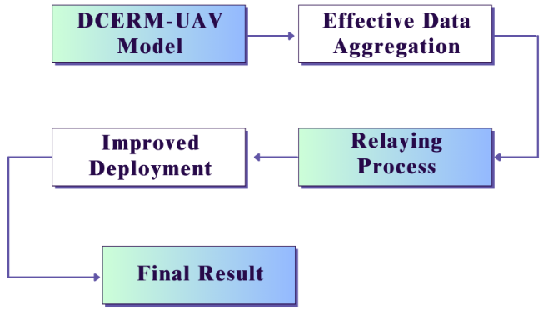
- DCERM-UAV Workflow.
Mainly to improve the data collection quality of the aerial devices this DCERM-UAV model is designed. The major sub sections of this model are effective data aggregation, network relaying process among the UAVs and improved deployment of the aerial vehicles that leads to attend maximum quality of service of the network. The work Flow of the DCERM-UAV is described in “Fig. 1”.

Effective Data Aggregation in UAVs.
The main purpose of the UAV is to perform low-quality sink node cruising, which is mostly achieved by using a single flight route and a long flight time. The UAV that was utilized to aggregate data is displayed. The optimal weight range for the data aggregation UAV is 2.5 to 3.5 kg. Because they are less expensive, aircraft with wheelbases under 600 may be stable, able to fly for extended periods of time, and the best choice overall. More accurately, under this wheelbase, the motor's power supply current during flight varies from 4.3 to 14.7 a. In real-world applications, the low-cost 18650 battery pack is a highly practical way to circumvent the rapid drain rate of standard lithium polymer batteries for this charge release. The battery duration for the 6s-5p 3450mAh configuration is a maximum of 1 hour and 17 minutes. The voltage protection module utilizes the energy produced by the battery pack to provide the flight control and sinusoidal electronic governor with a voltage of 5 to 25.2 volts. When compared to conventional square-wave electrical modulation generation, the governor will improve battery life by about 15% by converting the input analog amount into a digital number. Below is an example of a 2.4 G wireless remote control designed for manual flight control. Among the three main wireless technologies, the 2.4 G band signal stands out as the most advantageous due to its limited operational range of 500-1000 m and susceptibility to interference. The 2.4 G remote control will transmit signals within the frequency range of 2.400 GHz to 2.4835 GHz to the 16-channel receiver. The receiver acquires the 16-channel digital signal over SBUS and manages it by using a solitary DuPont line to get the serial bus output. Flight control receives each flight model and transmits real-time flight data to the ground station terminal of the PC connected to the local area network via a Wi-Fi module. To determine the precise position of the acquired cluster data, one may follow the flight route on the PC. Additionally, it is possible to track the velocity, latitude, longitude, dashboard, and distance from the present flying location of the aircraft.

Relaying Process
Amplify-and-forward (AF) relaying is one kind of non-regenerative collaboration that has garnered a lot of attention because of its practicality in real-world applications. Unlike regenerative cooperative systems like decode-and-forward (DF) relaying, which just amplifies and retransmits the received signals, the UAV functioning as a relay does not need to conduct demodulation or decoding. As the input power of the signal nears its saturation point, the power amplifier (PA) being employed will often display non-linear features. Apart from generating adjacent channel interference (ACI) via out-of-band radiation, this nonlinear amplification also results in in-band distortion. Therefore, to avoid this nonlinear distortion effect, the PA has to be operated with a significant input back-off. But doing so may defeat the objective of adopting AF relaying and drastically diminish PA efficiency. Adjusting the relay $\left({UAV}_{2}\right)$gain inside the linearity area is necessary to reduce the impact of this high instantaneous power of AF relaying. Remember that ${UAV}_{1}$ signals ${UAV}_{2}$ with this information. Mobile users in the targeted region receive the boosted signal received at ${UAV}_{2}$ and are then connected to it. The relay node specified by receives the unit-power symbol $T_{S}$ from the source “(1)”.
$T_{S}=\sum_{j=1}^{N}{\sqrt{(b_{j}P_{s}X_{j})}}$ 
Where $X_{j}$is user j's transmit symbol, $b_{j}$ is user j's power allocation factor, and $b_{1}>b_{2}$ is the transmitted power at S. The signal received at $R({UAV}_{2})$ is provided by “(2)”.
$T_{R}=\left({\hat{g}}_{u_{1}u_{2}}+e_{u_{2}u_{K}}\right)\sum_{j=1}^{N}{\sqrt{\left(b_{j}P_{s}X_{j}\right)}}+W_{R}$ 2
Where the additive white Gaussian noise, or $W_{R}$, is present at R. The following gives the amplification coefficient “(3)”:
$G=\frac{1}{\sqrt{P_{s}{\left|{\hat{g}}_{u_{1}u_{2}}\right|}^{2}+P_{s}ρ_{u_{1}u_{2}}d_{u_{1}u_{2}}^{-α}+δ_{u_{2}}^{2}}}$ 3
$y_{RD}=\sqrt{P_{R}G}({\hat{g}}_{u_{1}u_{2}}+e_{u_{2}u_{k}}$)$({\hat{g}}_{u_{2}u_{k}}+e_{u_{1}u_{u_{2}}})\sum_{j=1}^{N}{\sqrt{\left(b_{j}P_{s}X_{j}\right)}}$ | (4)

Improved Deployment Process
The purpose of this study is to create an effective user-based UAV optimum deployment that will allow the whole communication system to operate at peak efficiency. It is expected that two types of users with distinct QoS needs are included in the clustering scope, and that the ground users are grouped at varying distances. Next, this paper's main objective is reduced to effectively achieving the UAV optimum placement inside a single clustering. The deployment issue may be reformulated as the following optimization question by taking into account the effects of route loss, the UAV's own energy consumption constraint, and the various QoS expectations of the user upon real deployment, the maximize(Rt).
$Rt\left(n,PL,E\right)=\frac{\left(\frac{n}{N}\right).\left(∆PL-∆E\right)}{{(e^{∆e})}^{1/40}}$ 5
where n is the number of users that the UAV can cover, as indicated by the user's received SNR. Stated otherwise, when the user's SNR above the least allowable SNR threshold value. The user's coverage is shown by ${SNR}_{th}$; the difference between the maximum permissible path loss and the path loss that is presently detected is indicated by $∆PL$. According to “(4)”, the user terminal's SNR increases with decreasing PL. Stated otherwise, the higher the $∆PL$ value, the more effective the communication system is; the difference in energy between the UAV's initial and subsequent positions is represented by $∆E$. As may be seen, the gain realized following UAV deployment is represented by the numerator of Rt. As a result, “(5)”, will take into account the coverage, path loss (which is equivalent to the user's receiving SNR, or QoS), and the energy loss of the UAV during measurement. The ideal deployment of UAVs involves maximizing the value of Rt. This proposed DCERM-UAV greatly increased the network performance and the whole process is described in Pseudo Code below.
The Pseudo Code of DCERM-UAV
Inputs: Data aggregation, Relaying Process, Deployment Process
Step 1 – UAV network creation and data collection
Step 2 – Relaying Process
Relay Node Selection - $T_{S}=\sum_{j=1}^{N}{\sqrt{(b_{j}P_{s}X_{j})}}$
Receiver Power - $T_{R}=\left({\hat{g}}_{u_{1}u_{2}}+e_{u_{2}u_{K}}\right) \sum_{j=1}^{N}{\sqrt{\left(b_{j}P_{s}X_{j}\right)}}+W_{R}$
Gaussian noise - $G=\frac{1}{\sqrt{P_{s}{\left|{\hat{g}}_{u_{1}u_{2}}\right|}^{2}+P_{s}ρ_{u_{1}u_{2}}d_{u_{1}u_{2}}^{-α}+δ_{u_{2}}^{2}}}$
$y_{RD}=\sqrt{P_{R}G}({\hat{g}}_{u_{1}u_{2}}+e_{u_{2}u_{k}}$)$({\hat{g}}_{u_{2}u_{k}}+e_{u_{1}u_{u_{2}}})\sum_{j=1}^{N}{\sqrt{\left(b_{j}P_{s}X_{j}\right)}}$
Step 3 - Deployment Process
Real deployment calculation - $Rt\left(n,PL,E\right)=\frac{\left(\frac{n}{N}\right).\left(∆PL-∆E\right)}{{(e^{∆e})}^{1/40}}$
Step 4 – Performance Analysis

Simulation Results.
We conducted a comparative study using the NS2 simulator to assess the performance of the, PAEW-UAV [50], EULB-UAV [51] and ESNF-UAV [52] protocols in order to evaluate the proposed DCERM-UAV protocol. The evaluation criteria are energy efficiency, throughput, packet delivery ratio, average delay, and routing overhead and as well the input parameters which are present in this simulation experimentation are given in table II.
- Input Parameters Table
Input Parameters | Values
Running Time | 250 ms
Coverage Distance | 500m*500m
Number of Nodes | 100 Nodes
Node Radius | 100m
Initial Energy | 100 Joules
Transmission Power | 0.500 Joules
Receiving Power | 0.050 Joules

Energy Efficiency
Energy efficiency quantifies the system's ability to optimally use energy resources for communication purposes.
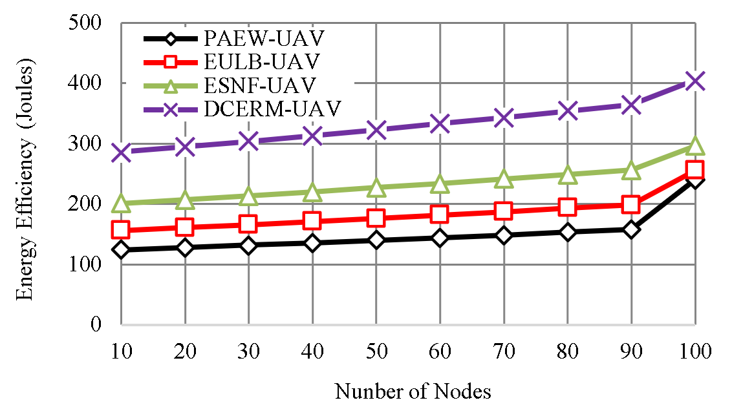
- Energy Efficiency Calculation.
The “Fig.2”, represents the energy utilization of the DCERM-UAV methods with compares with PAEW-UAV, EULB-UAV and ESNF-UAV. The DCERM-UAV prototype demonstrates the utmost energy efficiency, obtaining energy usage of 405 Joules for data transmission. DCERM-UAV surpasses PAEW-UAV (241 Joules), EULB-UAV (256 Joules), and ESNF-UAV (296 Joules), shows its superior data transmission efficiency and lower energy usage.

Energy Consumption
Energy consumption refers to the aggregate quantity of energy used for communication purposes.
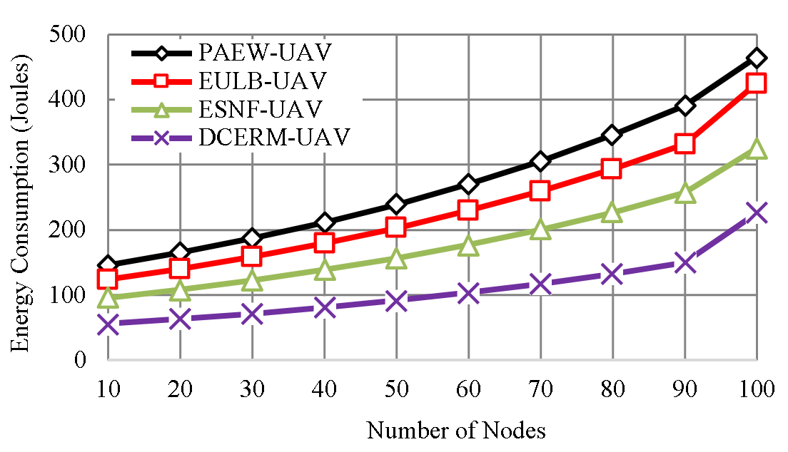
- Energy Consumption Calculation.
The “Fig.3”, shows the energy consumption calculation of the DCERM-UAV methods with compares with PAEW-UAV, EULB-UAV and ESNF-UAV.
The DCERM-UAV, as suggested, exhibits the minimum energy consumption, measuring at 226 Joules. This shows that it necessitates the least amount of energy for the transmission of data. On the other hand, PAEW-UAV, EULB-UAV, and ESNF-UAV have greater energy consumption levels, with PAEW-UAV using 465 Joules, EULB-UAV consuming 425 Joules, and ESNF-UAV consuming 325 Joules.

Throughput
Throughput quantifies the speed at which data is effectively transferred over the network. The “Fig.4”, represents the throughput calculation of the DCERM-UAV methods with compares with PAEW-UAV, EULB-UAV and ESNF-UAV.
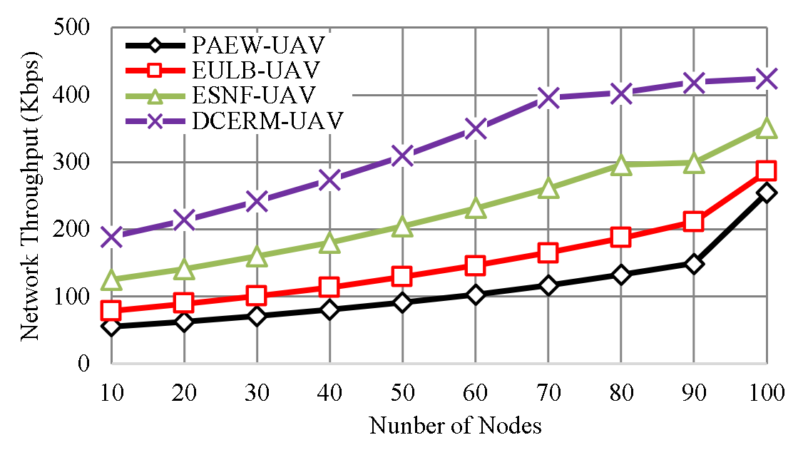
- Throughput Calculation.
The DCERM-UAV, as suggested, shows the highest throughput value of 425 kbps, showing its superior capability to transfer data at a faster rate compared to the existing technique PAEW-UAV (254 kbps), EULB-UAV (286 kbps), and ESNF-UAV (352 kbps). This enhanced data transmission capabilities in the proposed DCERM-UAV method.

Routing Overhead
Routing Overhead refers to the extra packets that are used for the management and maintenance of the routing process. This “Fig.5”, shows the routing overhead calculation of the DCERM-UAV methods with compares with PAEW-UAV, EULB-UAV and ESNF-UAV.
The DCERM-UAV model has the lowest routing overhead with 196 packets, whereas the existing technique PAEW-UAV has 564 packets, EULB-UAV has 475 packets, and ESNF-UAV has 352 packets. This Reduced routing overhead values indicate efficient use of resources.
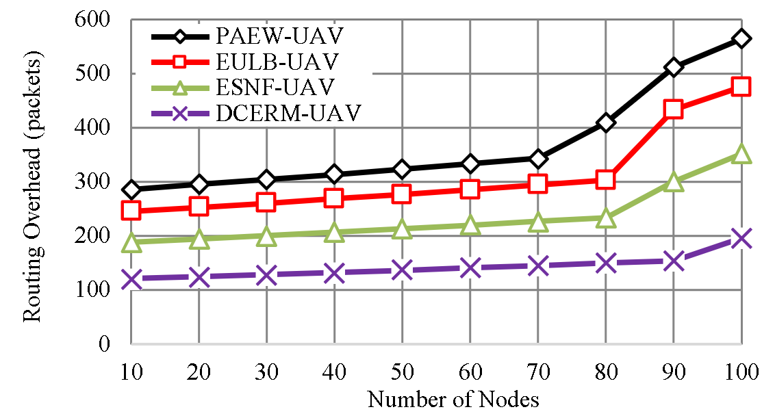
- Routing Overhead Calculation.

Packet Delivery Ratio
It is the ratio of data packets that are successfully reached the destination form the total packets used in the network. This “Fig.6”,F shows the Packet Delivery Ratio calculation of the DCERM-UAV methods with compares with PAEW-UAV, EULB-UAV and ESNF-UAV.
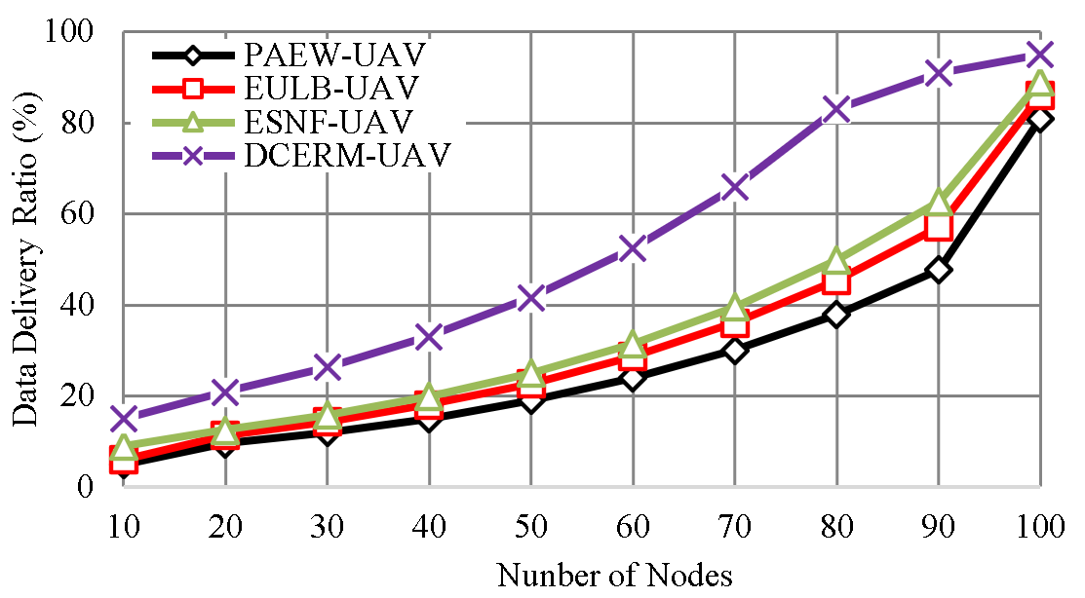
- Packet Delivery Ratio calculation.
The DCERM-UAV has the high Packet Delivery Ratio of 95%, showing its higher data delivery compared to the existing technique PAEW-UAV (81%), EULB-UAV (86%), and ESNF-UAV (89%).

Conclusion.
It is very essential to provide data aggregation among the aerial vehicles to achieve efficient data transmission with the quickest response when the user position changes dynamically when it is travelling at high speed. Improved vehicle deployment and effective aggregation process are mainly employed here to achieve maximum deployment accuracy among the aerial vehicles. From the final result it is shown that maximum accuracy is achieved by the proposed model in terms of energy efficiency and data delivery rate than the earlier methodologies.

References
- Y.S. Jghef, M.J.M. Jasim, H.M.A. Ghanimi, A.D. Algarni, N.F. Soliman, W. El-Shafai, S.R.M. Zeebaree, A. Alkhayyat, A.S. Abosinnee, N.F. Abdulsattar, A.H. Abbas, H.M. Hariz, and F.H. Abbas, "Bio-Inspired Dynamic Trust and Congestion-Aware Zone-Based Secured Internet of Drone Things (SIoDT)," Drones, vol. 6, no. 11, pp. 337, 2022. https://doi.org/10.3390/drones6110337.
- G.G. Shayea, D.A. Mohammed, A.H. Abbas, and N.F. Abdulsattar, "Privacy-Aware Secure Routing through Elliptical Curve Cryptography with Optimal RSU Distribution in VANETs," Designs, vol. 6, no. 6, pp. 121, 2022. doi: https://doi.org/10.3390/designs6060121.
- M.H. Hassan, A.H. Abbas, M.H. Mutar, M.A. Jubair, S.A. Rashid, A.J. Ahmed, M.I. Habelalmateen, A. Mohammed, and L. Audah, "Investigative Study on Routing Protocols in Flying Ad Hoc Networks Environment," in 2022 5th International Conference on Engineering Technology and its Applications (IICETA), pp. 460-463, 2022. doi: https://doi.org/10.1109/IICETA54559.2022.9888600.
- N.F. Abdulsattar, F. Abedi, H.M.A. Ghanimi, S. Kumar, A.H. Abbas, A.S. Abosinnee, A. Alkhayyat, M.H. Hassan, and F.H. Abbas, "Botnet Detection Employing a Dilated Convolutional Autoencoder Classifier with the Aid of Hybrid Shark and Bear Smell Optimization Algorithm-Based Feature Selection in FANETs," Big Data and Cognitive Computing, vol. 6, no. 4, article no. 112, 2022. DOI: https://doi.org/10.3390/bdcc6040112.
- V. O. Nyangaresi, I. M. Al-Joboury, K. A. Al-sharhanee, A. H. Najim, A. H. Abbas, and H. M. Hariz, "A biometric and physically unclonable function–Based authentication protocol for payload exchanges in internet of drones," e-Prime - Advances in Electrical Engineering, Electronics and Energy, vol. 7, pp. 100471, 2024. DOI: https://doi.org/10.1016/j.prime.2024.100471.
- A. J. Ahmed, S. A. Rashid, A. H. Abbas, N. F. Abdulsattar, H. S. Mansour, M. H. Hassan, M. I. Habelalmateen, and A. Hussain, "An Effectual Secure Cryptography Scheme for Multipath Routing in A Wsn-Based IoT Environment," in 2022 5th International Conference on Engineering Technology and its Applications (IICETA), pp. 441-446, 2022. doi: https://doi.org/10.1109/IICETA54559.2022.9888604.
- A. H. Alwan, A. A. Aziz, M. A. Jubair, A. H. Abbas, M. H. Hassan, S. Alheejawi, N. F. Abdulsattar, A. S. Mustafa, and M. I. Habelalmateen, "Monitoring the Impact of the Nodes Density on the MANETs’ Environment," in 2022 5th International Conference on Engineering Technology and its Applications (IICETA), pp. 546-549, 2022. doi: https://doi.org/10.1109/IICETA54559.2022.9888339.
- Mostafa, S.A., Mustapha, A., Ramli, A.A., Jubair, M.A., Hassan, M.H., Abbas, A.H. (2021). Comparative Analysis to the Performance of Three Mobile Ad-Hoc Network Routing Protocols in Time-Critical Events of Search and Rescue Missions. In: Cassenti, D., Scataglini, S., Rajulu, S., Wright, J. (eds) Advances in Simulation and Digital Human Modeling. AHFE 2020. Advances in Intelligent Systems and Computing, vol 1206. Springer, Cham. https://doi.org/10.1007/978-3-030-51064-0_16.
- M. H. Hassan, M. A. Jubair, A. H. Abbas, A. J. Ahmed, S. A. Rashid, M. H. Mutar, H. S. Mansour, A. Ali, and M. I. Habelalmateen, "AODV based Crow Search Algorithm for Improving the QoS of MANET," in 2022 5th International Conference on Engineering Technology and its Applications (IICETA), pp. 424-428, 2022. DOI: https://doi.org/10.1109/IICETA54559.2022.9888484.
- M. A. Jubair, M. H. Hassan, S. A. Mostafa, H. Mahdin, A. Mustapha, L. H. Audah, F. S. Shaqwi, and A. H. Abbas, "Competitive analysis of single and multi-path routing protocols in MANET," Indonesian Journal of Electrical Engineering and Computer Science, vol. 19, no. 1, pp. 293-300, 2020. http://doi.org/10.11591/ijeecs.v19.i1.pp293-300.
- S. A. Rashid, A. J. Ahmed, M. H. Hassan, A. H. Abbas, M. I. Habelalmateen, M. A. Jubair, L. Audah, and W. Al-Azzawi, "Ranking Based Routing Protocol for Residual Energy Estimation in Wireless Sensor Network Based IoT Network," in 2022 5th International Conference on Engineering Technology and its Applications (IICETA), pp. 453-459, 2022. https://doi.org/10.1109/IICETA54559.2022.9888349.
- A. J. Ahmed, A. H. Abbas, S. A. Rashid, M. A. Jubair, M. H. Hassan, A. Abdulhadi, N. F. Abdulsattar, and M. I. Habelalmateen, "Congestion Aware Q-Learning (CAQL) in RPL Protocol – WSN based IoT Networks," in 2022 5th International Conference on Engineering Technology and its Applications (IICETA), pp. 429-435, 2022. doi: https://doi.org/10.1109/IICETA54559.2022.9888322..
- A. J. Ahmed, A. H. Abbas, and S. A. Rashid, "Multi level trust calculation with improved ant colony optimization for improving quality of service in wireless sensor network," IAES International Journal of Artificial Intelligence, vol. 12, no. 3, pp. 1224–1237, 2023. doi: https://doi.org/10.11591/ijai.v12.i3.pp1224-1237.
- A. H. Abbas, H. Mansour, and A. Al-Fatlawi, "Self-Adaptive Efficient Dynamic Multi-Hop Clustering (SA-EDMC) Approach for Improving VANET’s Performance," International Journal of Interactive Mobile Technologies (iJIM), vol. 16, no. 14, pp. 136-151, Jul. 2022. DOI: https://doi.org/10.3991/ijim.v16i14.31081.
- N.F. Abdulsattar, A.H. Abbas, M.H. Mutar, M.H. Hassan, M.A. Jubair, and M.I. Habelalmateen, "An Investigation Study for Technologies, Challenges and Practices of IoT in Smart Cities," in 2022 5th International Conference on Engineering Technology and its Applications (IICETA), pp. 554-557, 2022. DOI: https://doi.org/10.1109/IICETA54559.2022.9888474.
- A. H. Abbas, N. F. Abdulsattar, H. S. Mansour, M. H. Mutar, M. I. Habelalmateen, L. Audah, N. A. M. Alduais, and A. Mohammed, "A New Hybrid Approach Cluster-Heads Election to reduce the number of clusters in VANETs," in 2022 5th International Conference on Engineering Technology and its Applications (IICETA), pp. 436-440, 2022. DOI: https://doi.org/10.1109/IICETA54559.2022.9888442.
- M. I. Habelalmateen, A. H. Abbas, L. Audah, and N. A. M. Alduais, "Dynamic multiagent method to avoid duplicated information at intersections in VANETs," Telkomnika (Telecommunication Computing Electronics and Control), vol. 18, no. 2, pp. 613-621, 2020. DOI: http://doi.org/10.12928/telkomnika.v18i2.13947.
- M. K. Hasan, M. M. Ahmed, N. F. Wani, A. H. Abbas, L. M. Alkwai, S. Islam, A. K. M. A. Habib, and R. Hassan, "Dynamic load modeling for bulk load-using synchrophasors with wide area measurement system for smart grid real-time load monitoring and optimization," Sustainable Energy Technologies and Assessments, vol. 57, p. 103190, 2023. doi: https://doi.org/10.1016/j.seta.2023.103190.
- A. H. Abbas, A. J. Ahmed, and S. A. Rashid, "A Cross-Layer Approach MAC/NET with Updated-GA (MNUG-CLA)-Based Routing Protocol for VANET Network," World Electric Vehicle Journal, vol. 13, no. 5, article no. 87, 2022. DOI: https://doi.org/10.3390/wevj13050087.
- H. S. Mansour, M. H. Mutar, I. A. Aziz, S. A. Mostafa, H. Mahdin, A. H. Abbas, M. H. Hassan, N. F. Abdulsattar, and M. A. Jubair, "Cross-Layer and Energy-Aware AODV Routing Protocol for Flying Ad-Hoc Networks," Sustainability, vol. 14, no. 15, article no. 8980, 2022. DOI: https://doi.org/10.3390/su14158980.
- M. A. Jubair, S. A. Mostafa, D. A. Zebari, H. M. Hariz, N. F. Abdulsattar, M. H. Hassan, A. H. Abbas, F. H. Abbas, A. Alasiry, and M. Turki-Hadj, "A QoS Aware Cluster Head Selection and Hybrid Cryptography Routing Protocol for Enhancing Efficiency and Security of VANETs," IEEE Access, vol. 10, pp. 124792-124804, 2022. doi: https://doi.org/10.1109/ACCESS.2022.3224466.
- M. I. Habelalmateen, A. J. Ahmed, A. H. Abbas, and S. A. Rashid, "TACRP: Traffic-Aware Clustering-Based Routing Protocol for Vehicular Ad-Hoc Networks," Designs, vol. 6, no. 5, article no. 89, 2022. DOI: https://doi.org/10.3390/designs6050089.
- S. A. Rashid, M. I. Habelalmateen, A. J. Ahmed, A. H. Abbas, M. A. Jubair, M. H. Hassan, A. Abdulhadi, S. Hammed, and L. Audah, "Congestion Aware Genetic Q-learning Based RPL Routing Protocol for Vehicle Ad-Hoc Networks," in 2022 5th International Conference on Engineering Technology and its Applications (IICETA), pp. 464-469, 2022. doi: https://doi.org/10.1109/IICETA54559.2022.9888583.
- A. H. Abbas, A. J. Ahmed, S. A. Rashid, N. F. Abdulsattar, M. H. Hassan, M. A. Jubair, and M. I. Habelalmateen, "Predictive Hybrid Routing with Multi Objective Optimization Model for Opportunistic Routing for VANET," in 2022 5th International Conference on Engineering Technology and its Applications (IICETA), pp. 470-476, 2022. doi: https://doi.org/10.1109/IICETA54559.2022.9888274.
- N. F. Abdulsattar, D. A. Mohammed, A. Alkhayyat, S. Z. Hamed, H. M. Hariz, A. S. Abosinnee, A. H. Abbas, M. H. Hassan, M. A. Jubair, F. H. Abbas, A. D. Algarni, N. F. Soliman, and W. El-Shafai, "Privacy-Preserving Mobility Model and Optimization-Based Advanced Cluster Head Selection (P2O-ACH) for Vehicular Ad Hoc Networks," Electronics, vol. 11, no. 24, p. 4163, 2022, DOI: https://doi.org/10.3390/electronics11244163.
- A. H. Najim, A. H. Abbas, K. Al-sharhanee, and H. M. Hariz, "Reinforcement Learning-based Topology-Aware Routing Protocol with Priority Scheduling for Internet of Drones in Agriculture Application," International Journal of Intelligent Engineering and Systems, vol. 16, no. 5, pp. 395-405, 2023. doi: https://doi.org/10.22266/ijies2023.1031.34.
- F. Abedi, S. R. M. Zeebaree, Z. S. Ageed, H. M. A. Ghanimi, A. Alkhayyat, M. A. M. Sadeeq, S. N. Mahmood, A. S. Abosinnee, Z. H. Kareem, A. H. Abbas, W. K. Al-Azzawi, M. M. Jaber, and M. Dauwed, "Severity Based Light-Weight Encryption Model for Secure Medical Information System," Computers, Materials & Continua, vol. 74, no. 3, pp. 5691-5704, 2023. DOI: https://doi.org/10.32604/cmc.2023.034435.
- A. H. Kadhim, A. M. Razaq, M. A. Jubair, N. F. Abdulsattar, A. H. Abbas, M. H. Hassan, A. Jamal Ahmed, S. AbdulJabbar Rashid, and M. I. Habelalmateen, "A Real-Time Low-Cost Remote Doctor Monitoring System," in 2022 5th International Conference on Engineering Technology and its Applications (IICETA), pp. 558-561, 2022. doi: https://doi.org/10.1109/IICETA54559.2022.9888536.
- F. Abedi, H. M. A. Ghanimi, A. D. Algarni, N. F. Soliman, W. El-Shafai, A. H. Abbas, Z. H. Kareem, H. M. Hariz, and A. Alkhayyat, "Computational Intelligence Driven Secure Unmanned Aerial Vehicle Image Classification in Smart City Environment," Computer Systems Science and Engineering, vol. 47, no. 3, pp. 3127-3144, 2023. DOI: https://doi.org/10.32604/csse.2023.038959.
- I. Ahmad, S. Hussain, S. N. Mahmood, H. Mostafa, A. Alkhayyat, M. Marey, A. H. Abbas, and Z. Abdulateef Rashed, "Co-Channel Interference Management for Heterogeneous Networks Using Deep Learning Approach," Information, vol. 14, no. 2, article no. 139, 2023. DOI: https://doi.org/10.3390/info14020139.
- A. M. Abdulkarem, F. Abedi, H. M. A. Ghanimi, S. Kumar, W. K. Al-Azzawi, A. H. Abbas, A. S. Abosinnee, I. M. Almaameri, and A. Alkhayyat, "Robust Automatic Modulation Classification Using Convolutional Deep Neural Network Based on Scalogram Information," Computers, vol. 11, no. 11, article no. 162, 2022. DOI: https://doi.org/10.3390/computers11110162.
- F. Abedi, H. M. A. Ghanimi, M. A. M. Sadeeq, A. Alkhayyat, Z. H. Kareem, S. N. Mahmood, A. H. Abbas, A. S. Abosinnee, W. K. Al-Azzawi, M. M. Jaber, and M. Dauwed, "Hybrid Deep Learning Enabled Load Prediction for Energy Storage Systems," Computers, Materials & Continua, vol. 75, no. 2, pp. 3359-3374, 2023. DOI: https://doi.org/10.32604/cmc.2023.034221.
- S. Alsubai, A. K. Dutta, A. H. Alkhayyat, M. M. Jaber, A. H. Abbas, and A. Kumar, "Hybrid deep learning with improved Salp swarm optimization based multi-class grape disease classification model," Computers and Electrical Engineering, vol. 108, p. 108733, 2023. DOI: https://doi.org/10.1016/j.compeleceng.2023.108733.
- I. S. Al-Hawary, E. Ali, S. M. H. Kamona, L. Hussain Saleh, A. S. Abdulwahid, D. N. Al-Saidi, M. S. Alhassan, F. A. Rasen, H. Abdullah Abbas, A. Alawadi, A. H. Abbas, and M. Sina, "Prediction of geomechanical bearing capacity using autoregressive deep neural network in carbon capture and storage systems," Heliyon, vol. 9, no. 11, pp. e21913, Nov. 2023. doi: https://doi.org/10.1016/j.heliyon.2023.e21913.
- M. R. M. Alsemawi, M. H. Mutar, E. H. Ahmed, H. O. Hanoosh, and A. H. Abbas, "Emotions recognition from human facial images based on fast learning network," Indonesian Journal of Electrical Engineering and Computer Science, vol. 30, no. 3, pp. 1478-1487, 2023. doi: http://doi.org/10.11591/ijeecs.v30.i3.pp1478-1487.
- J. Tang, A. K. Abbas, N. A. Koka, N. Sadoon, J. K. Abbas, R. A. Abdalhuseen, M. Abosaooda, N. M. Ahmed, and A. H. Abbas, "Optimization of thermal biofuel production from biomass using CaO-based catalyst through different algorithm-based machine learning approaches," Case Studies in Thermal Engineering, vol. 50, p. 103419, 2023. doi: https://doi.org/10.1016/j.csite.2023.103419.
- F. Abedi, H. M. A. Ghanimi, A. D. Algarni, N. F. Soliman, W. El-Shafai, A. H. Abbas, Z. H. Kareem, H. M. Hariz, and A. Alkhayyat, "Chimp Optimization Algorithm Based Feature Selection with Machine Learning for Medical Data Classification," Computer Systems Science and Engineering, vol. 47, no. 3, pp. 2791–2814, 2023. doi: https://doi.org/10.32604/csse.2023.038762.
- M. A. A. Albadr et al., "Online sequential extreme learning machine approach for breast cancer diagnosis," Neural Computing and Applications, vol. Volume, no. Issue, pp. Page, 2024. DOI: https://doi.org/10.1007/s00521-024-09617-x.
- M. S. Alshuhri, S. G. Al-Musawi, A. A. Al-Alwany, H. Uinarni, I. Rasulova, P. Rodrigues, A. T. Alkhafaji, A. M. Alshanberi, A. H. Alawadi, and A. H. Abbas, "Artificial intelligence in cancer diagnosis: Opportunities and challenges," Pathology - Research and Practice, vol. 253, pp. 154996, 2024. https://doi.org/10.1016/j.prp.2023.154996.
- A. Abdulbari, S. K. Abdul Rahim, F. Abedi, P. J. Soh, A. Hashim, R. Qays, S. Ahmad, and M. Y. Zeain, "Single-Layer Planar Monopole Antenna-Based Artificial Magnetic Conductor (AMC)," International Journal of Antennas and Propagation, vol. 2022, pp. 6724175, 2022. https://doi.org/10.1155/2022/6724175.
- L. Ye, Y. Zhang, Y. Li, and S. Han, "A dynamic cluster head selecting algorithm for UAV ad hoc networks," in 2020 International Wireless Communications and Mobile Computing (IWCMC), June 2020, pp. 225-228, doi: 978-1-7281-3129-0/20
- Y. Zhou, X.X. Zhang, J. Sun, J. Yang, and G. Gui, "Implementation of mesh flying ad-hoc network for emergency communication systems," in 2020 7th International Conference on Dependable Systems and Their Applications (DSA), November 2020, pp. 299-304, doi: 10.1109/DSA51864.2020.00053.
- N. Nikhil, S.M. Shreyas, G. Vyshnavi, and S. Yadav, "Unmanned aerial vehicles (UAV) in disaster management applications," in 2020 Third International Conference on Smart Systems and Inventive Technology (ICSSIT), August 2020, pp. 140-148, doi: 978-1-7281-5821-1/20.
- Y. Gao, X. Chen, J. Yuan, Y. Li, and H. Cao, "A data collection system for environmental events based on unmanned aerial vehicle and wireless sensor networks," in 2020 IEEE 4th Information Technology, Networking, Electronic and Automation Control Conference (ITNEC), June 2020, vol. 1, pp. 2175-2178, doi: 978-1-7281-4390-3/20.
- R. Cai, Y. Feng, D. He, Y. Xu, Y. Zhang, and W. Xie, "A combined cable-connected RSU and UAV-assisted RSU deployment strategy in V2I communication," in ICC 2020-2020 IEEE International Conference on Communications (ICC), June 2020, pp. 1-6, doi: 978-1-7281-5089-5/20.
- A. Mukhopadhyay and D. Ganguly, "FANET based emergency healthcare data dissemination," in 2020 Second International Conference on Inventive Research in Computing Applications (ICIRCA), July 2020, pp. 170-175, doi: 978-1-7281-5374-2/20.
- K. Sarfo, K. Wang, and K. Ntiamoah-Sarpong, "Estimation of UAV to UAV performance as a hotspot by proposed friss model on downlink AF co-operative NOMA," in 2020 IEEE 10th International Conference on Electronics Information and Emergency Communication (ICEIEC), July 2020, pp. 5-9, doi: 978-1-7281-6313-0/20.
- A. Agarwal and D. Mishra, "Hovering localization and power allocation for UAV assisted DF relaying ad hoc network," in 2020 IEEE International Conference on Communications Workshops (ICC Workshops), June 2020, pp. 1-6, doi: 978-1-7281-7440-2/20.
- R. Kirichek, T.D. Dinh, M. Zakharov, D.T. Le, and A. Koucheryavy, "Positioning methods based on flying network for emergencies," in 2020 22nd International Conference on Advanced Communication Technology (ICACT), February 2020, pp. 245-250.
- Yinong Chen and Wenchi Cheng, “Performance Analysis of RIS-equipped-UAV Based Emergency Wireless Communications”, IEEE International Conference on Communications, 2022, doi: 10.1109/ICC45855.2022.9839157
- Gaoyu He, Weidong Bao and Yan Hui, “A UAV Emergency Network User Allocation Method for Load Balancing”, International Conference on Big Data and Information Analytics (BigDIA), 2022, doi: 10.1109/BigDIA56350.2022.9874090
- Ali Alnoman, “UAV-to-UAV Communication Scheme for Enabling Emergency Services During Network Failure”, International Conference on Electrical and Computing Technologies and Applications (ICECTA), 2022, doi: 10.1109/ICECTA57148.2022.9990222

