The trend of high microbial contamination in livestock milk in the ASEAN region and distribution mapping

1st Biatna Dulbert Tampubolon  Research Center for Testing Technology and Standards  National Research and Innovation Agency,  South Tangerang, Banten, 15314, Indonesia  biat001@brin.go.id | 2th Endi Hari Purwanto  Research Center for Testing Technology and Standards  National Research and Innovation Agency,  South Tangerang, Banten, 15314, Indonesia  endi003@brin.go.id | 3rd Putty Anggraeni  Research Center for Testing Technology and Standards  National Research and Innovation Agency,  South Tangerang, Banten, 15314, Indonesia  putt001@brin.go.id | 4rd Widia Citra Anggundari  Research Center for Testing Technology and Standards  National Research and Innovation Agency,  South Tangerang, Banten, 15314, Indonesia widi010@brin.go.id
5th Ary Budi Mulyono  Research Center for Testing Technology and Standards  National Research and Innovation Agency,  South Tangerang, Banten, 15314, Indonesia  aryb001@brin.go.id | 6th Budhy Basuki  Research Center for Testing Technology and Standards  National Research and Innovation Agency,  South Tangerang, Banten, 15314, Indonesia  budh007@brin.go.id | 7th Arif Nurhakim  Directorate of Multimedia Repository and Publishing  National Research and Innovation Agency,  South Tangerang, Banten, 15314, Indonesia  arif033@brin.go.id | 8th Bambang Prasetya  Research Center for Testing Technology and Standards  National Research and Innovation Agency,  South Tangerang, Banten, 15314, Indonesia  bamb066@brin.go.id
9th Daryono Restu Wahono  Research Center for Testing Technology and Standards  National Research and Innovation Agency,  South Tangerang, Banten, 15314, Indonesia  dary003@brin.go.id | 10th Abdul Manab  Faculty of Animal Science  Brawijaya University, Malang, East Java 65145, Indonesia  manabfpt@ub.ac.id | 11th Lilik Eka Radiati  Faculty of Animal Science  Brawijaya University, Malang, East Java 65145, Indonesia  lilik.eka@ub.ac.id  (corresponding author)

Abstract— Health risks associated with milk contamination can take many forms. There is currently little data on the trends in microbial contamination and the mapping of its distribution. This study aims to map the spread of microbial contamination in cattle milk throughout ASEAN and assess trends in this area. A database originating from Scopus is collected using Boolean operators. This research used 19,967 papers as references with topics or themes of bacteria, milk, microbes, and antibiotics with loci in the ASEAN region. The analysis results show that 2021 is the peak of article production with 49 articles, followed by 2022 with 40 articles. The most productive institution is Khon Kaen University. Key research topics include antimicrobial resistance, lactic acid bacteria, bovine health issues, and fermentation in milk production. Research on antimicrobial resistance, the use of lactic acid bacteria in dairy products, cow health, and the milk fermentation process needs to be explored further. Collaboration between countries, especially Thailand and Malaysia, must also be improved to produce higher-quality research.
Keywords— antibiotics, ASEAN, bibliometrics, regencies, scientific reference
- INTRODUCTION
Publications are an important indicator of scientific activities, knowledge production, and achieving recognition in society [1]. Consequently, bibliometric approaches are among the most widely used and recognized methodologies for evaluating research publications' output, quality, and evolution [2]. Consider the accessible databases (DB), their applicability, and the effects of utilizing each other on a study issue before undertaking a bibliometric analysis [3]. In this investigation, Scopus was chosen as an extensive and reliable DB bibliography [4, 5, 6].
This paper urgently needs a comprehensive investigation to map microbial and antimicrobial contamination in the ASEAN region and determine what needs to be done and where it should go. We will use the resulting bibliometric data from the analysis of published articles to examine trends in microbiological contamination in the ASEAN region. To evaluate the influence and spread of scientific output, identify players, sources, and information flows, and expose scientific communication patterns, bibliometrics is a quantitative analysis of publications, bibliographic references, and links [7]. Bibliometrics can assist researchers in comprehending how to carry out suitable bibliometric analyses and analyze the analysis's findings [8].
This study offers fresh perspectives on the microorganisms influencing these figures. Furthermore, a correlation has been suggested between figures and demographic features. Consequently, this publication can provide insight into the situation in the ASEAN region's emerging nations. An extensive bibliometric methodology combining performance analysis and perspective in microbial and antimicrobial mapping is reported here.

II. MICROBIAL CONTAMINATION STANDARDS

Food products from livestock have a high risk of microbial contamination, which is dangerous to human health. A few diseases caused by food from livestock are salmonellosis, clostridiosis, tuberculosis, brucellosis, anthrax, and diseases caused by Staphylococcus aureus contamination [9]. Milk contains protein, fat, lactose, minerals, vitamins, and enzymes [10]. Cow's milk from healthy cows can be contaminated with specific non-pathogenic microbes immediately after milking. Pollution can also come from cows, milking equipment, unclean storage rooms, dust, air, flies, and human handling [11].
Salmonella sp., Bacillus cereus, Listeria monocytogenes, Campylobacter sp., Staphylococcus aureus, and Brucella sp. are a few common pathogenic bacteria that infect milk. [12]. In addition, E. coli is a common pathogenic microbe that contaminates milk, so it is a requirement in national standards.
The Codex Alimentarius Commission (CAC) has regulated some essential provisions and guidelines governing microorganisms in dairy products. As stated in CAC/RCP 57-2004 concerning the Code of Hygienic Practice for Milk and Milk Products, Codex has released rules to assure the safety and appropriateness of milk and milk products to safeguard consumer health and facilitate commerce. CAC/GL 21-1997, which is about Principles for the Establishment and Application of Microbiological Criteria for Foods, contains the guidelines for establishing and implementing food microbiological criteria from primary production to final consumption. Comprehensive instructions for setting up a HACCP system can be found in Appendix CAC/RCP 1-1969, Rev 3-1997. It is necessary to base the establishment of microbiological standards on these ideas. ISO 7218, Microbiology of food and animal feeding stuff - General standards and advice for microbiological examinations, is another relevant standard.

III. MATERIAL AND METHOD
The data-collecting approach utilizes Boolean operators to examine a database sourced from Scopus. Elsevier Co. produces Scopus, an abstracting and indexing database containing full-text connections. The Hammerkop bird (Scopusumbretta), said to have exceptional navigational skills, served as the model for the name Scopus. More than 300 academics and librarians from 21 research institutes worked on the database's development [13].
Boolean operators allow you to create, restrict, and broaden a search by combining words and phrases with the operators AND, OR, and NOT [14]. After that, Biblioshiny, VosViewer, and Scopus were used to conduct bibliometric analysis on the generated metadata. In addition to bibliometric analysis, frequency distribution analysis was performed by classifying the microorganism kinds detected in each reference according to ASEAN member countries.
This study used 19,967 papers as references on the topic or theme of bacteria, dairy, microbial, and antibiotics, with a locus in the ASEAN region (Fig. 1).
The reason for taking this theme is to get information on the development of mastitis and the distribution of antibiotic problems in cow's milk in the ASEAN region, bearing in mind the circularity of the cow's milk trade in this region, so that information can be obtained on which country has the highest number of foot and mouth diseases, but which country. The selection of articles in the analysis is done by reviewing the relevance to the article's topic in terms of region, commodity, and scope. The data can also be used to inform which regions of the country are intensively handling treatment and which regions in ASEAN have the potential to experience an increase in cases of pesticide residue.

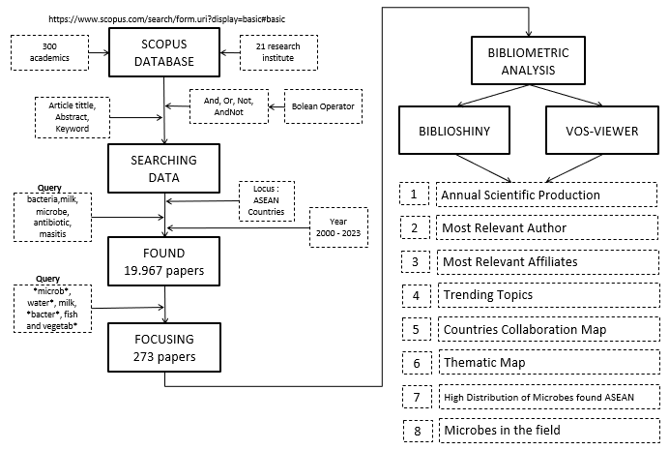
Fig. 1 Flowchart of method

IV. RESULT AND DISCUSSION
The following are the results of a Boolean operator search in the Scopus database for Microbial Contamination in Dairy Milk in the ASEAN Region, with restrictions on 2000–2023: On August 18, 2023, 273 documents were discovered using the Scopus search. Several keywords, including *microbe*, water*, milk, *bacteria*, fish, and vegetable*, were used to produce this query. This search finds papers that include these terms in the article's title, abstract, or content. This query results in a list of publications in the Scopus database pertinent to "Microbial Contamination in the ASEAN Region" and published in scientific journals, conferences, or other venues.
Based on these findings, the generated metadata will be processed using bibliometric tools like VOSViewer and Biblioshiny. Through an interactive web interface, Biblioshiny facilitates the easy input and conversion of data to a collection of data frames and bibliometric and visual analysis [7]. Meanwhile, maps based on co-occurrence networks, citations, co-citations, and bibliographic coupling matrices can be made using VOSviewer. Alternatively, keyword maps based on co-occurrence networks can be made. VOSviewer is very helpful when working with maps that have a significant number of elements [15]. The bibliometric visualization for this topic is known to exist based on metadata analysis from Scopus.

Main Information
The leading information from the process can be seen as follows. This research uses data and information from 2000 to 2023, involving the majority (209) of journal article documents and 47 conference papers (Table 1). The predominance of peer-reviewed journal articles in this dataset indicates that the documents used in this paper are highly scientifically trustworthy. If viewed from the regularity of appearing in scientific publications, this is high, namely 13.91%, or in 1 year, there are a minimum of 13–14 papers.

Table 1. Main information of the dataset
Description | Results
MAIN INFORMATION ABOUT DATA
Timespan | 2000:2023
Sources (Journals, Books, and others) | 137
Documents | 273
Annual Growth Rate % | 13.91
Document Average Age | 5.58
Average citations per doc | 13.51
References | 10373
DOCUMENT CONTENTS
Keywords Plus (ID) | 2382
Author's Keywords (DE) | 682
AUTHORS COLLABORATION
Authors | 1024
Authors of single-authored docs | 6
DOCUMENT TYPES
article | 209
book chapter | 2
conference paper | 47
review | 15
AUTHORS

Annual Scientific Production
In bibliometrics, annual scientific production refers to a statistical analysis of the total number of scientific articles published in a given year by individuals, research teams, organizations, or journals. In addition to measuring scientific productivity and performance, this technique can map patterns and trends in advancing specific scientific disciplines [16]. The following figure illustrates the annual scientific production from 2000 to 2023.

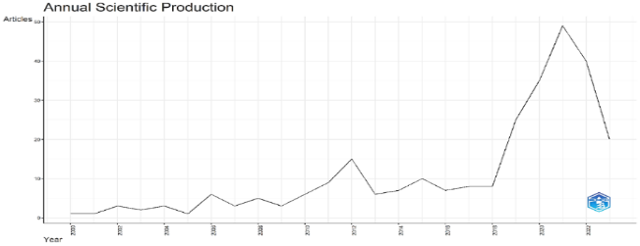
Fig. 2. Annual scientific production distribution (2000 – 2023)

According to the data above (Fig. 2), most articles were produced in 2021, with 49, followed by 2022, with 40; 2020, with 35; 2019, with 25; and 2023, with 20.

Most Relevant Author
According to bibliometrics, the author with the most publications or citations in a given dataset is called the Most Relevant Author [7]. The following figure represents the Most Relevant Authors from 2000 to 2023.

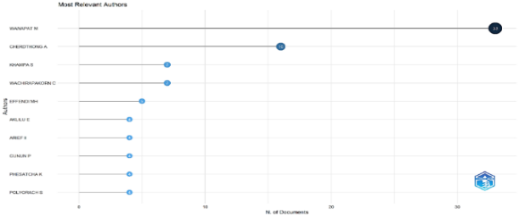
Fig. 3. The distribution of publications based on authors (2000 – 2023)

According to the data above (Fig. 3), WANAPAT M has the most documents, 33, followed by CHERDTHONG A with 16, KHAMPA S and WACHIRAPAKORN C with 7, and EFFENDI MH with 5.

Most Relevant Affiliates
The association that appears most frequently in bibliometric analysis is the most significant affiliation in bibliometrics. The connections shown most frequently in bibliometric analysis can reveal an institution's contribution to a field of study [17].

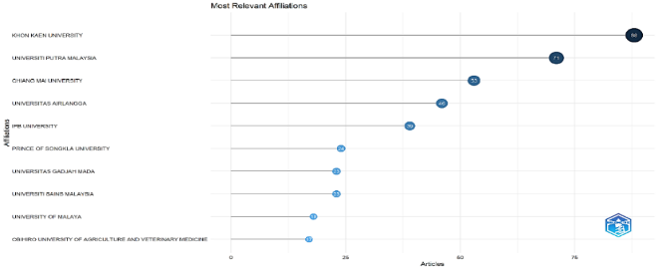
Fig. 4. The distribution of publications based on the affiliation (2000 – 2023)

According to the data above (Fig. 4), Khon Kaen University is in first place with 88 articles, followed by Universiti Putra Malaysia with 71 articles, Chiang Mai University with 53 articles, Airlangga University with 46 articles, IPB University with 39 articles, and Prince of Songkla University with 24 articles.
According to the data above, antimicrobial resistance, which refers to the ability of microorganisms to overcome antimicrobial drugs, is the focus, with 22 occurrences in the data. Lactic acid bacteria, with 21 occurrences, were also an important topic in this study. This bacteria is often used in various contexts, especially in dairy products. Bovine mastitis and rumen fermentation had 16 occurrences, indicating that cows' health and digestive processes are topics of concern. Words such as "milk," "mastitis," and "probiotics" also appeared quite frequently in the data, indicating that the role of milk and the use of probiotics in treating cow health problems is a relevant topic
. Fermentation, dairy cows, and Escherichia coli (E. coli bacteria) also appear in the data with considerable frequency, adding additional dimensions to this research, including aspects such as the fermentation process in milk production and the role of E. coli bacteria.

Trending Topics
Trending topic analysis can help researchers understand the latest research trends in a field or discipline and identify the topics or themes most discussed by researchers [18]. This data uses minimum word frequency parameters of 5 words and the number of words per year 3 times. Over the period 2012 to 2022, many topics trended highly, including "Lactic Acid Bacteria (LAB)," "Milk Yield," "Milk Products," "Prevalence," "Dairy Cattle," "Probiotic," "Mastitis," "Bovine Mastitis," "Raw Milk," and "Antimicrobial Resistance" (Fig. 5).

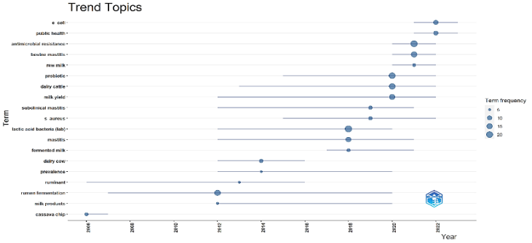
Fig. 5. Trending topics analysis
The trend analysis depicted in Figure 5 shows that research has focused on E. coli, public health, and antimicrobial resistance in the last decade, with these topics appearing most frequently and recently in the timeline. The topics "E. coli" and "Public Health" have recently trended, appearing in 2021 to 2023. The emergence of these topics in recent years indicates increased interest in public health issues and the E. coli bacteria.
From this analysis, we can conclude that cow and dairy health issues, including fermentation in the rumen, lactic acid bacteria (LAB), and antimicrobial resistance, have been a consistent research focus in recent years. Meanwhile, public health issues such as "E. coli" and "Public Health" have recently become a significant concern in research. This trend reflects changes in research priorities over time, emphasizing issues relevant to agriculture and public health.

Countries Collaboration Map
In bibliometrics, a country cooperation map is a map that illustrates how different nations work together to write scientific papers or publications. The frequency of collaboration between countries in particular research topics is depicted on this map. This map can be used to understand better international collaboration in specific research sectors and trends in global research. [19]. It is known that based on the collaboration data between countries provided, it is known that Thailand has a high level of collaboration with various countries, especially with the USA (10 times), the United Kingdom (6 times), and Cambodia (5 times). Malaysia also has significant collaboration with several countries, such as the United Kingdom (4 times), Iran (2 times), Nigeria (2 times), and Pakistan (2 times). Several countries, such as Australia, Austria, Egypt, Germany, Italy, Japan, and the Philippines, have collaborations with several other countries, but the number of collaborations tends to be lower, namely 1 or 2 (Table 6). Meanwhile, Indonesia has quite good collaborations with Japan and the Netherlands. Each has 3 collaborations.

Thematic Map
A niche theme in bibliometric analysis is a specific study field that requires more in-depth investigation. Research on the Motor Theme is a very productive and significant field. One field of study that is gaining popularity and attention is Emerging Themes. Research on declining themes is a field that is becoming less well-known and receiving less attention.
A subject of study's fundamental thought or idea is known as its "basic theme" [20].
This basic theme has led to the understanding that (Fig. 5):
1. Top left (Niche): There are many articles, but they only have a little impact because they are separated within a single theme.
2. Top Right (Motor): Numerous articles, a great deal of power.
3. Bottom Left (Emerging or Declining): Fewer papers have been published; some have only recently emerged or have no bearing (still in the early stages).
4. Bottom Right (Basic): Although there are few articles, they are quite influential. Below is a visualization based on the Thematic Map created between 2000 and 2023.

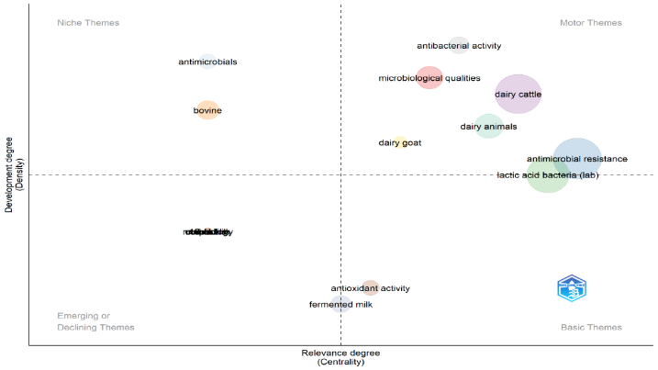
Fig. 6. Visualization on the thematic map produced (2000 – 2023)

High distribution of microbes found in ASEAN
Based on the results of the search for references collected, 85 types of microbes were found in the ASEAN region. The following is a ranking of the most common microbes in reference abstracts from Scopus (Fig. 7)
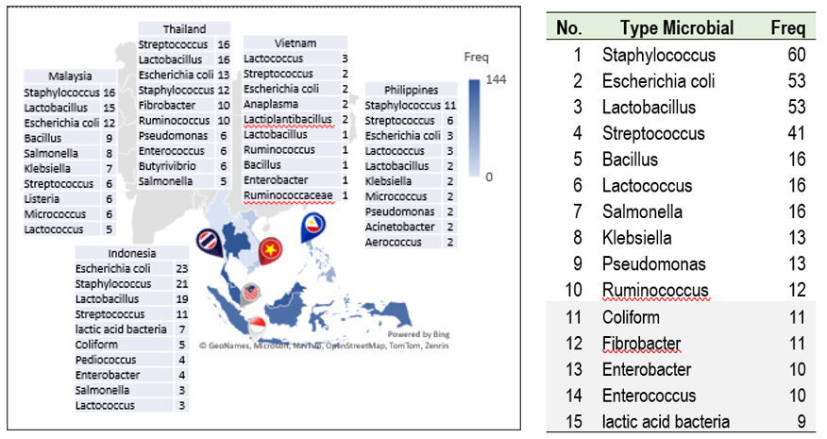

Fig. 7. Distribution of the most microbial types discovered in ASEAN member countries

Microbes in the field
Staphylococcus is a type of microbe that is mainly found in mastitis. Research on microbial contamination, one of which is the presence of stay, has been widely carried out and has a close relationship with dairy products [21]. In articles (no. 11, 12, 20, 37, 51, 56, 62, 66, 305, 308, 319, 326, and 335), found in Phatthalung and Khon Kaen (Thailand); Selangor and East Coast (Malaysia); Banyuwangi, Bogor, South Sulawesi (Indonesia); and the Philippines. Several of the farmers' treatments for Staphylococcus microbes are giving ethanol extract of Rhodomyrtus tomentosa leaves, dipping teats with 50% methanol extract of guava leaves, giving antimicrobials from Enhanced Virgin Coconut Oil (EVCO), giving Knema retusa wood extract (KRe) and giving other antimicrobials such as penicillin, amoxicillin, ampicillin, and streptomycin. However, most bacteria show high resistance to antibiotics. The research indicates that the extract of R. tomentosa. Its different formulations offer an alternate strategy for lowering contamination-related Staphylococcus infections; guava leaf extract can be used as an alternative teat disinfectant before milking to reduce the number of bacteria on the tip of the teat and can reduce the use of chemicals. EVCO has demonstrated antimicrobial efficacy against three powerful mastitis-causing agents, and administration of Kre wood extract can reduce the use of chemicals.
Escherichia coli is a type of microbe found in livestock suffering from mastitis. In articles (11, 12, 20, 37, 51, 56, 62, 66, 305, 308, 319, 326, and 335) found in Selangor (Malaysia); Nghe An (Vietnam); Malang, Pasuruan, Tulungagung, Blitar, Batu, Kediri, Probolinggo, Bogor (Indonesia); Maha Sarakham (Thailand); and the Philippines. Lincomycin, sulfamethoxazole, gentamicin, bacteriocin from L. plantarum IIA-1A5, various antimicrobials, and antibiotics are some potential treatments for Escherichia coli bacteria. These studies discovered that bacteriocin isolated from Weissella confusa A3 isolated from samples has inhibitory activity against pathogenic bacteria, that Industrial High-Pressure Processing (HPP) during storage reduces the number of Escherichia coli and Staphylococcus aureus, and that plantaricin IIA-1A5 at a concentration of 11.17 g/ml was able to suppress total microbial growth at room temperature for two hours.
Streptococcus is also a type of microbe that is often found in mastitis. In references (articles no. 300, 302, 319, 334, and 349), found in Chiang Mai and Khon Kaen (Thailand), Dong Nai (Vietnam). Some farmers treat these microorganisms by giving antibiotics to the teats and soaking them in a 50% methanol extract of guava leaves. These studies discovered that Strep. Agalactiae infection lasted longer and had a lower percentage of spontaneous recovery than Strep. Uberis, these microorganisms modify the protein profile of milk; guava leaf extract can reduce the usage of pesticides, resulting in more sanitary and safe milk; and the mastitis control program is linked to cow features and milking management.

V. CONCLUSIONS AND RECOMMENDATIONS
Based on bibliometric analysis using the Scopus database, it can be concluded that 2021 is the peak of article production with 49 articles, followed by 2022 with 40 articles. WANAPAT M is the author with the most documents (33 documents), while KHON KAEN UNIVERSITY is the most productive institution (88 articles). Key research topics include antimicrobial resistance, lactic acid bacteria, bovine health issues, and fermentation in milk production. The topic "Rumen Fermentation" has been trending the longest for 14 years (2007-2020). Recommendations based on this analysis are to continue to explore research on antimicrobial resistance, the use of lactic acid bacteria in dairy products, cow health, and the milk fermentation process. Apart from that, special attention must be paid to public health issues and the E. coli bacteria, which has recently become trending. Collaboration between countries, especially with Thailand and Malaysia, must also be improved to produce higher-quality research.
When analyzing data on milk trade and microbial distribution, it was found that the high export value of ASEAN member countries also showed that many types of microbes were found in that country. However, further research is needed regarding the transportation route for dairy products based on the results of inspections of dairy products at the port of entry.

VI. CONFLICTS OF INTEREST

The authors have not disclosed any conflict of interest. They decided to publish the findings, write the publication, collect, analyze, interpret the data, or design the study without the funders' input.

REFERENCES
- E. Aboagye, I. Jensen, G. Bergström, E. B. Brämberg, O. J. Pico-Espinosa, C. Björklund, "Investigating the association between publication performance and the work environment of university research academics: a systematic review" Scientometrics, vol. 126, pp. 3283-3301, 2021.
- J. R. López-Robles, J. R. Otegi-Olaso, I. P. Gómez, M. J. Cobo, "30 years of intelligence models in management and business: A bibliometric review" Int. J. Inf. Manage., vol. 48, pp. 22–38, 2019.
- A. D. Sánchez, M. D. L. C. Del Río, J. A. García, "Bibliometric analysis of publications on wine tourism in the databases Scopus and WoS" Eur. Res. Manag. and Bus. Econ., vol. 23, pp. 8-15, 2017.
- A. W. Harzing, S. Alakangas, "Google Scholar, Scopus and the Web of Science: A longitudinal and cross-disciplinary comparison" Scientometrics, vol. 106, pp. 787–804, 2016.
- R. Pranckutė, "Web of Science (WoS) and Scopus: The titans of bibliographic information in today's academic world" Publications, vol. 9, pp. 12, 2021.
- J. Zhu, W. Liu, "A tale of two databases: The use of Web of Science and Scopus in academic papers," Scientometrics, vol. 123, pp. 321–335, 2020.
- M. Aria, C. Cuccurullo, "Bibliometric: An R-tool for comprehensive science mapping analysis," J. Informetr., vol. 11, pp. 959–975, 2017.
- N. Donthu, S. Kumar, D. Mukherjee, N. Pandey, W. M. Lim, "How to conduct a bibliometric analysis: An overview and guidelines" J. Bus. Res., vol. 133, pp. 285–296, 2021.
- T. F. Djaafar, S. Rahayu, "Microbial contamination of agricultural products, diseases caused and prevention". Original title. "Cemaran mikroba pada produk pertanian, penyakit yang ditimbulkan dan pencegahannya" J. Litbang. Pertan., vol. 26, pp. 67-75, 2007.
- M. Lampert, Modern Dairy Product, New York Publishing: New York, 1980.
- W. A. Volk, M. F. Wheeler, Mikrobiologi Dasar Edisi V Jilid 2, Penerbit Erlangga: Jakarta, 1990.
- M. R. Adams, Y. Motarjemi, Basic Food Safety for Health Workers, World Health Organization: Geneva, 1999.
- J. Burnham, "Scopus database: A review" Biomed. Digit Libr., vol. 3, pp. 1-8, 2006
- M. Frické, "Boolean Logic" Knowl. Organ., vol. 48, pp. 177–191, 2021.
- N. J. Van Eck, Van, L. Waltman, VOSviewer Manual, Universiteit Leiden, 2018.
- R. Srivastava, S. Srivastava. Bibliometric Analysis of Indian Journal of Palliative Care from 1995 to 2022 using the VOSviewer and Bibliometrix Software" Indian J. Palliat. Care, vol. 28, pp. 338–353, 2022.
- G. Trivedi, "Visualization and Scientometric Mapping of Global Agriculture Big Data Research" Libr. Philos and Pract., 2019.
- C. Mejia, M. Wu, Y. Zhang, Y. Kajikawa, "Exploring topics in bibliometric research through citation networks and semantic analysis" Front Res. Metrics and Anal., vol. 6, pp. 1–16, 2021.
- B. P. Solis, J. C. C. Arguello, L. G. Barba, M. P. Gurrola, Z. Zarhri, D. L. Trejoarroyo, "Bibliometric analysis of the mass transport in a gas diffusion layer in PEM fuel cells" Sustainability, vol. 11, 2019.
- A. Khare, R. Jain, "Mapping the conceptual and intellectual structure of the consumer vulnerability field: A bibliometric analysis" J. Bus. Res., vol. 150, pp. 567–584, 2022.
- Tampubolon, B. D., Basuki, B., Anggraeni, P., Anggundari, W. C., Mulyono, A. B., Purwanto, E. H., ... & Radiati, L. E. (2024). Trend of High Microbial Contamination in Livestock Milk in Indonesia and Distribution Mapping. In E3S Web of Conferences (Vol. 527, p. 02003). EDP Sciences.

