Particle swarm-optimized fuzzy PID algorithm in motor control system of disaster rescue robots
Xiaotong Li
Department of industrial engineering, Ningxia Polytechnic, Yinchuan, 750021, China
2020100@nxtc.edu.cn
Abstract. The frequency of global natural disasters has surged, leading to the advent of disaster rescue robots that have significantly enhanced the capability of emergency rescue operations following disasters. The stepper motor, as the core driving device of these rescue robots, plays a pivotal role, with its precision being a crucial measure of the robot's effectiveness. This paper analyses the characteristics of the mechanical structure and control system of rescue robots. It combines the advantages of Proportional Integral Derivative (PID) control in controlling linear steady-state systems with the effective control of complex nonlinear systems by fuzzy control, and optimizes the fuzzy PID control using particle swarm algorithms. Focusing on stepper motors as the subject of study, a particle swarm-optimized fuzzy PID controller has been designed and simulated using MATLAB/Simulink software. Compared to fuzzy PID motor controllers, the particle swarm-optimized fuzzy PID control exhibits improved control performance, characterized by faster response times, reduced overshoot, and shorter adjustment periods.
Keywords: Rescue Robots, Fuzzy Control, Particle Swarm-Optimized Fuzzy Control.

Introduction
Over the past few years, the increasing incidence of natural catastrophes such as earthquakes, volcanoes, and mudslides has led to the emergence of post-disaster rescue robots, providing a new impetus to enhance disaster rescue capabilities [1]. Motor is the core driving device of the disaster rescue robot. High-precision motor control is an important indicator of the performance of these robots. In recent years, stepper motors have been used in a variety of disaster rescue robots due to their simple structure, high resolution, and low cost. However, stepper motors are nonlinear and time-varying. In situations with numerous environmental disturbances, using traditional PID control to manage stepper motors often fails to achieve the desired control outcomes.
Cui Ji designed a positioning and navigation control system for an omnidirectional mobile robot based on a fuzzy PID control algorithm [2]. He integrated the fuzzy control algorithm with the conventional PID algorithm (i.e., fuzzy PID algorithm), improving the PID control parameters, thereby enhancing the processing speed and endowing the system with excellent real-time performance. This meets the requirements of the robot's positioning system for high identification precision, rapid processing speed, and good real-time characteristics. Meng Jintao designed a fuzzy PID control for the positioning accuracy of the gripper on a multi-station hydraulic cylinder test bench [3]. To achieve rapid and precise gripping and releasing of hydraulic cylinders, a fuzzy PID control algorithm was employed to implement stepwise positioning control of the hydraulic cylinder gripper on the multi-station test bench. Through a comparative simulation analysis between fuzzy PID control and fixed-parameter PID control, it was concluded that the fuzzy PID control system exhibited superior performance in terms of both the time required to reach a steady state and response speed compared to the fixed-parameter PID control system.
However, this method has flaws and cannot overcome the drawback of fuzzy control's excessive reliance on expert experience. In response to this challenge, researchers have proposed a variety of optimization strategies based on intelligent algorithms.
Genetic algorithm-optimized fuzzy PID control utilizes the mechanisms of natural selection and genetics to search for optimal control parameters, demonstrating strong global search capabilities. However, it exhibits limitations in convergence speed and computational efficiency, particularly in the context of large parameter spaces where GA may require extended optimization periods.
Neural network fuzzy PID control leverages the self-learning capabilities of neural networks to adjust PID parameters and fuzzy rules, facilitating adaptation to complex system dynamics. Nevertheless, the training process of neural network models demands a significant amount of sample data, and the selection of network structure and learning rate significantly impacts performance, thereby increasing the complexity of design and debugging.
In comparison to the aforementioned methods, Particle Swarm Optimization (PSO) fuzzy PID control presents distinct advantages. Not only can PSO fuzzy PID control effectively overcome system nonlinearity and uncertainty, but it can also achieve efficient control performance adjustments through a rapid parameter optimization process. Moreover, the PSO algorithm is less affected by the choice of initial values during the parameter adjustment process, offering greater robustness and adaptability than GA and neural network methods.
Therefore, this paper selects the PSO fuzzy PID controller for controlling the stepper motor of a rescue robot. The superiority of this algorithm in the control process of stepper motors is demonstrated through MATLAB/Simulink simulations.

Structure of Rescue Robots

Types and exterior mechanical structure
The exterior mechanical structure of rescue robots is designed based on their application environment and task requirements to ensure that the robots can adapt to complex and variable rescue scenarios, effectively performing tasks such as search, rescue, and reconnaissance.
Tracked robots typically consist of a vehicle body, components mounted on the body, and a locomotion system on both sides of the body. Figure 1 shows the PackBot search and rescue robot developed by the American company “iRobot”, which uses a fin-like limb track structure. It can plan adjustments based on the shape of obstacles [4]. The robot has strong obstacle-crossing capabilities, enabling it to climb stairs and cross obstacles smoothly.
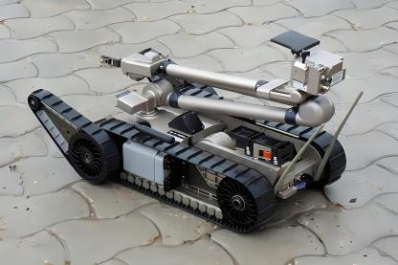
Figure 1. Tracked Rescue Robots [4]
The overall structure of snake-shaped disaster rescue robots is composed of several parts, such as the head shell, connecting joints, joint shells. Snake-like robots are small in volume, have many degrees of freedom, and are highly manoeuvrable, with powerful rubble search capabilities and environmental adaptability [5]. They are suitable for mine rescues and deep rescues which is shown in figure 2.

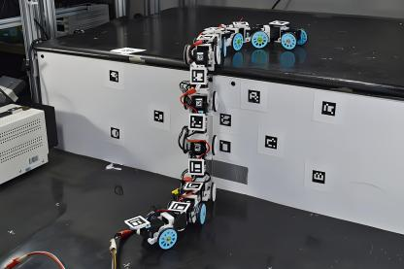
Figure 2. Snake-shaped rescue robot [5]
Bionic hexapod robots are developed to mimic the movement of multilegged insects. The overall structure of the rescue robot includes the head, neck, climbing arms, body, middle legs, and hind legs which is shown in figure 3. After earthquakes, landslides, or building collapses, hexapod rescue robots can traverse debris piles to enter narrow or dangerous spaces to search for survivors [6].
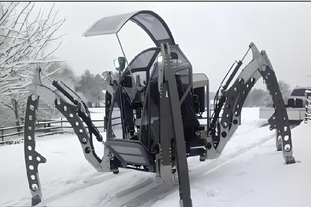
Figure 3. Bionic Hexapod Rescue Robots [6]

Control Structure of Rescue Robots
The control architecture of a rescue robot is sophisticatedly engineered to handle multifaceted tasks within volatile environments,This architecture comprises multiple critical components, each dedicated to distinct functions:
Central Processing Unit (CPU): Serving as the cerebral nexus of the rescue robot, the CPU executes software directives, processes multifaceted sensorial data, and adjudicates decisions through pre-established algorithms [7].
Power Supply System: This essential system furnishes the robot with operational energy, encompassing rechargeable or disposable batteries, photovoltaic cells, and innovative wireless energy transmission modalities.
Motion Control System: Facilitating environmental navigation and maneuverability, this system incorporates motors, actuators, and, as needed, intricate assemblies such as wheels, tracks, or appendages, to surmount diverse obstacles.
Sensory System: Comprising an array of sensors, this system aggregates environmental data via cameras, microphones, thermometric sensors, chemosensors, and additional modalities tailored to mission-specific exigencies.
Communication System: Essential for operational efficacy, this system facilitates interaction with human controllers, robotic counterparts, or command hubs via advanced wireless solutions—Wi-Fi, Bluetooth, satellite links—supporting extensive data, video, and command dissemination[8].
User Interface (UI):The UI is the point of interaction between the robot and its human operators. It can range from simple button controls to complex graphical interfaces displayed on a computer or handheld device.
These components are interconnected through a network of data and control buses, allowing for seamless communication and coordination within the robot which is shown in figure 4.
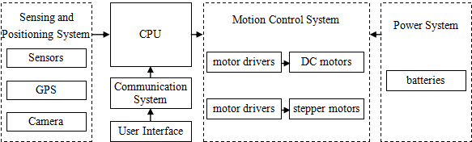
Figure 4. Control Structure of Rescue Robots (Photo/Picture credit: Original)

Theoretical Analysis of the Motor Control System in Rescue Robots
In robotic systems, stepper motors are utilized to control the movement of the robot's joints. Stepper motors achieve precise control over the robot's various joint positions or angles through the rotation of their shafts.

Establishment of motor mathematical model
Due to the non-linearity and coupling of stepper motors, establishing an accurate and simulation-friendly mathematical model is relatively challenging. Reference [1] mentioned the use of the finite element method to design the stepper motor model, which connects the electrical and mechanical modules together through a torque balance module. This paper selects the 57 series stepper motor, with parameters as follows in table 1.
Table 1. Parameters of 57 series stepper motor
1 | Tooth count $Z_{r}$ | 40
2 | Winding inductance $L$ | 4.2$mH$
3 | Motor rotational inertia $J$ | 0.48$kg∙cm^{2}$
4 | Motor viscous friction coefficient$K_{f}$ | 0.07
5 | Phase current i | 2$A$

When the motor is input with a step pulse voltage, the rotor turns through a standard step angle of 1, but the actual angle turned by the rotor is 2. According to the theory of small oscillations, the stepper motor’s transfer function is derived:
$G\left(s\right)=\frac{θ_{2}\left(s\right)}{θ_{1}\left(s\right)}$ (1)
The torque balance equation of the motor is:
$J\ddot{θ}+K_{f}\dot{θ}=\frac{Z_{r}Li^{2}}{2}sin\left(Z_{r}θ\right)$ (2)
In the development of the mathematical model for stepper motors, it is presupposed that at moment, the rotor achieves equilibrium, and i remains constant throughout the oscillation process, resulting in the formulation of the incremental equation as follows:
$J{\ddot{θ}}_{2}+K_{f}{\dot{θ}}_{2}+\frac{Z_{r}^{2}Li^{2}}{2}θ_{2}=\frac{Z_{r}^{2}Li^{2}}{2}θ_{1}$ (3)
By reorganizing Equation (2) and Equation (3), and conducting a Laplace transformation, the stepper motor’s transfer function is:
$G\left(s\right)=\frac{θ_{2}\left(s\right)}{θ_{1}\left(s\right)}=\frac{\frac{Z_{r}^{2}Li^{2}}{2J}}{S^{2}+\frac{K_{f}}{J}S+\frac{Z_{r}^{2}Li^{2}}{2J}}$ (4)
Incorporating the parameters of the 57 series stepper motor into Equation (4) yields the mathematical model of the stepper motor as:
$G\left(s\right)=\frac{28}{S^{2}+0.146S+28}$ (5)

Fuzzy PID control
Fuzzy PID control involves utilizing the output obtained through fuzzy control as the input for PID control to subsequently regulate the system, thereby amalgamating the advantages of both algorithms [9].

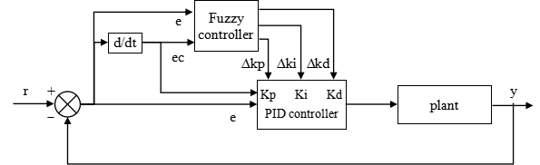
Figure 5. Control Schematic Diagram of Fuzzy PID Controller (Photo/Picture credit: Original)
The control system is illustrated in Figure 5. Design concept: By employing selected fuzzy rules, fuzzy inference is conducted on the real-time detected input, the system’s set point r, and the system’s output value y, along with the error e and the rate of error change ec, to determine the output $∆k_{p}$,$∆k_{I}$,$∆k_{d}$at that moment. During operation, the parameters of the PID controller: $k_{p}$,$k_{I}$,$k_{d}$ are tuned in real-time and online to achieve better control performance.
The adjustment formula for PID control parameters Is as follows:
$\left\{\begin{matrix}k_{p}=k_{p0}+Δk_{p} \\ k_{i}=k_{i0}+Δk_{i} \\ k_{d}=k_{d0}+Δk_{d}\end{matrix}\right.$ (6)
Where $k_{p0}$,$k_{i0}$,$k_{d0}$represent the initial values of the PID controller, while e and ec are the inputs, and $∆k_{p}$､$∆k_{i}$､$∆k_{d}$ are the outputs. A 'two-input three-output' structure is adopted.
In this system, the fuzzy controller takes the system error e and the rate of change of error ec as input variables, with the outputs$Δk_{p}$､$Δk_{i}$､$Δk_{d}$ serving as the basis for parameter adjustment.
In this controller, e and ec correspond to fuzzy variables E and EC, respectively, while$Δk_{p}$､$Δk_{i}$､$Δk_{d}$ correspond to fuzzy variables $ΔK_{p}$,$ΔK_{i}$,$ΔK_{d}$. The fuzzy domains of E, EC, $ΔK_{p}$,$ΔK_{i}$,$ΔK_{d}$are all chosen to be $\left[-6,6\right]$. The error e is divided into seven symmetrical fuzzy sets: NB, NM, NS, ZO, PS, PM, PB, represented by fuzzy linguistic variables as: Negative Big, Negative Medium, Negative Small, Zero, Positive Small, Positive Medium, Positive Big. Based on the control characteristics of stepper motors and the performance aspects of the controller, triangular membership functions are selected to represent the error.
This paper, drawing on fuzzy control theory and extensive experimental data from stepper motors, establishes the following fuzzy rule requirements: (1) If the error e is large, to endow the system with better rapid tracking and adjustment capabilities, $k_{p}$ is set larger, $k_{i}$smaller, and $k_{d}$ moderately small. (2) If e and ec are of medium magnitude, $k_{p}$ is made slightly smaller, while $k_{i}$ and $k_{d}$ are set to a moderate middle value. (3) As the control system enters a stable period, with both e and ec relatively small, $k_{p}$ and $k_{p}$ are appropriately increased to maintain system stability, with the selection of $k_{d}$ depending on the situation.

Particle Swarm-Optimized Fuzzy PID Control
Generally, optimization of fuzzy controllers encompasses three categories of methods: optimizing membership functions, optimizing the fuzzification quantization factors and defuzzification proportion factors, and optimizing the fuzzy rules of the controller. Considering the motion control characteristics of robots, this paper adopts the particle swarm algorithm to search for the most suitable proportion factor of the fuzzy controller within the search range based on the change in error e.
References [10] and [11] provide a detailed explanation of the standard particle swarm algorithm, its inertia weight optimization, and the optimization of learning factors. This paper will skip the discussion of these aspects and directly address the design of the particle swarm-optimized fuzzy PID (hereinafter referred to as PSO-Fuzzy PID) controller. The structural diagram of the PSO-Fuzzy PID controller is shown in Figure 6.
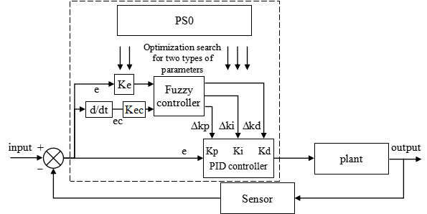
Figure 6. Structure Diagram of PSO-Fuzzy PID Controller (Photo/Picture credit: Original)
In the robot control system, to ensure the system's response speed, overshoot, and stability, etc., this paper employs the particle swarm algorithm to optimize the three parameters: proportion factors $Ck_{P},Ck_{i}$,$Ck_{d}$, targeting the shortcomings of stepper motor control. The specific optimization process is as follows: (1) Initialize the population size. Since there are three proportion factor parameters to be searched, the optimization dimension $n=3$, the speed $V_{max}=1,V_{min}=-1$, and the iteration count is set to 20. (2) Fitness calculation. The fitness of each particle is calculated by inserting it into the operational control model of the fuzzy PID controller. This paper uses ITAE to establish the optimization objective function, expressed as:
$J_{ITAE}=\int_{0}^{∞}{t}\left|e\right|dt$ (7)
Where t represents time, and e represents the system error. The fitness is updated by comparing it with historical values for $P_{best}$ and $g_{best}$ [10].
(3) Update particle position and velocity. The initial values of $c_{1},c_{2},ω$ are substituted into the velocity update formula to update the particle's velocity and position. In this paper, the initial values for $c_{1},c_{2},ω$ are set to 2, 2, and 0.6, respectively. (4) Termination judgment. If the maximum iteration count be achieved, or the optimal particle fitness be realized, the program is stopped. If these conditions are not met, the program returns to step 2 to continue optimization.

System Simulation and Analysis

System Simulation
Based on the motor's transfer function, a simulation is constructed using MATLAB/Simulink. Figure 7, 8, and 9 present the simulations of the motor control systems for PID, Fuzzy PID, and PSO-Fuzzy PID, respectively. The simulation of the stepper motor control system is as follows: At t=1, a unit step signal is input into the system, with the system simulation time set to 7 seconds. Through empirical experimentation, the initial values for conventional PID can be determined as: $k_{p}=2.7$､$k_{i}=5.3$､$k_{d}=0.9$, which serve as the initial values for PID, Fuzzy PID, and PSO-Fuzzy PID.
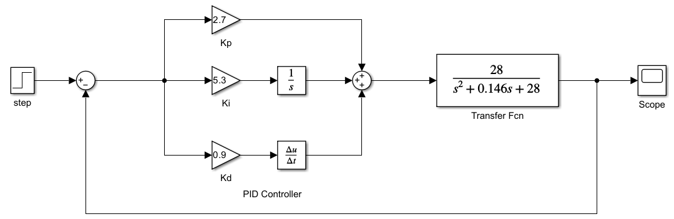
Figure 7. PID Motor Control System Simulation (Photo/Picture credit: Original)
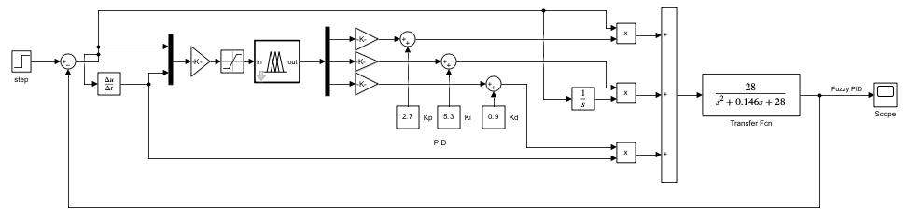
Figure 8. Fuzzy PID Motor Control System Simulation (Photo/Picture credit: Original)
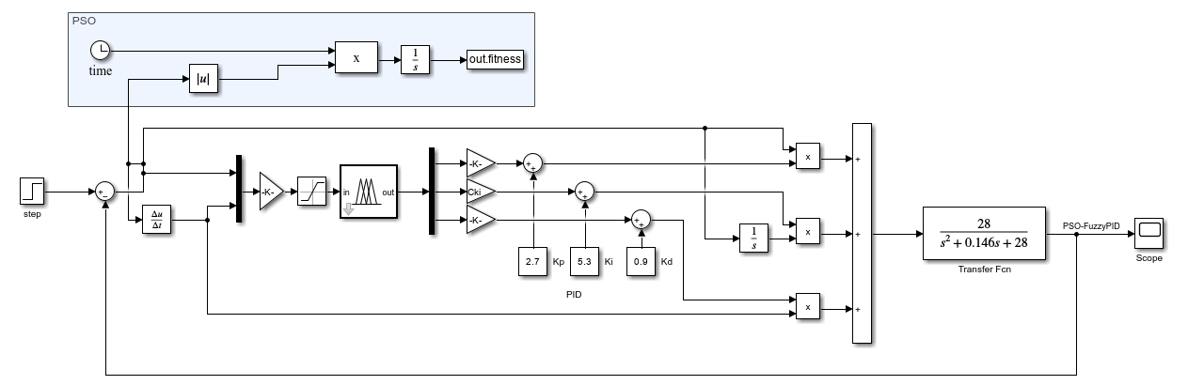
Figure 9. PSO-Fuzzy PID Motor Control System Simulation (Photo/Picture credit: Original)
In the PSO-Fuzzy PID motor control system, the Fuzzy PID, after 20 iterations of the particle swarm algorithm, identifies the most suitable proportion factor. The specific values of the optimized proportion factors are illustrated in Table 2.
Table 2. Optimal Proportion Factor Values
Proportion Factor | $$Ck_{p}$$ | $$Ck_{i}$$ | $$Ck_{d}$$
Optimization Results | 0.7581 | 0.0657 | 0.0040

The proportion factor optimization curve is shown in Figure 10, and the algorithm iteration curve is depicted in Figure 11.
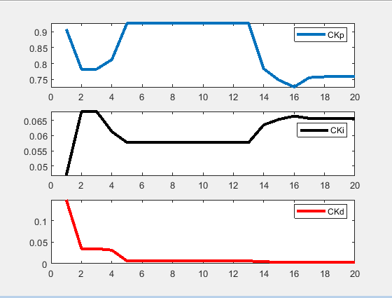
Figure 10. Proportion Factor Optimization Curve (Photo/Picture credit: Original)
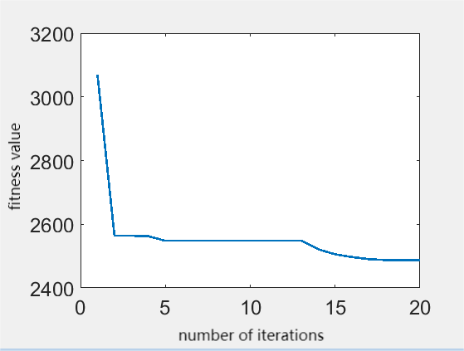
Figure 11. Particle Swarm Iteration Curve (Photo/Picture credit: Original)

Analysis
From the curve in Figure 12, a comparison of the performance of PID, Fuzzy PID, and PSO-Fuzzy PID control methods in terms of overshoot and settling time can be derived, as shown in Table 3. From the performance indicators in the table, it is observed: Fuzzy PID, compared to PID, reduced the settling time by 0.2s and decreased the overshoot by 4.8%. PSO-Fuzzy PID, in comparison to Fuzzy PID, reduced the settling time by 0.2s and achieved an overshoot of 0.
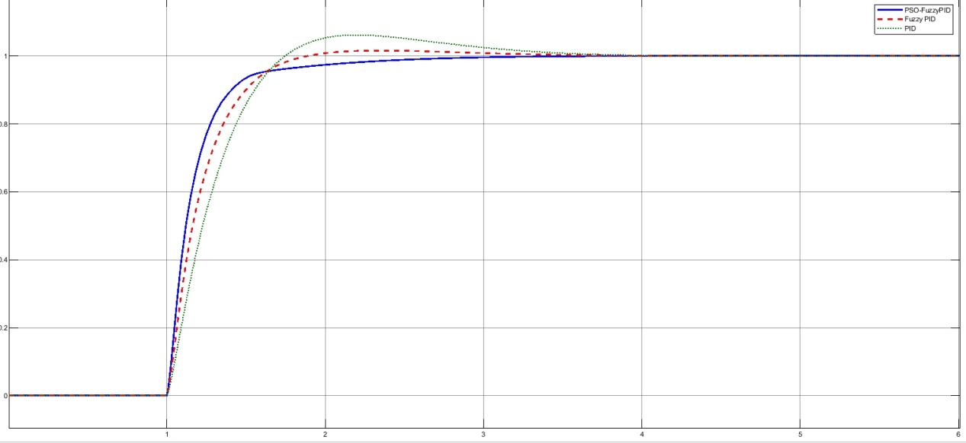
Figure 12. Comparison of Simulation Results (Photo/Picture credit: Original)
Table 3. Comparison of Dynamic Performance
Control Type | Overshoot/ % | Settling Time/s
PID | 6.2 | 3.2
Fuzzy PID | 1.6 | 3
PSO-Fuzzy PID | 0 | 2.8

Summary
This paper investigates the control system of post-disaster rescue robots, with a focus on the control algorithms for their stepper motor systems, and arrives at the following conclusions: (1) The principles of the fuzzy control algorithm and the optimization principles of the particle swarm algorithm are elucidated. A particle swarm-optimized fuzzy PID controller suitable for the stepper motor control system of disaster rescue robots is designed; (2) The design and simulation of three control algorithms—PID, Fuzzy PID, and PSO Fuzzy PID—were completed. Comparative results indicate that the PSO Fuzzy PID control exhibits superiority over the previous two control methods.
Future research could focus on two primary directions: (1) Integration of Advanced Adaptive Control Strategies: While the PSO-Fuzzy PID algorithm exhibits commendable performance in its current applications, system efficacy can be further enhanced through the integration of more sophisticated adaptive control strategies.In the methodological approach, we begin with the development of a sophisticated framework that synergistically integrates Deep Learning (DL) algorithms with the pre-existing PSO-Fuzzy PID algorithm. This integration entails the formulation of a neural network architecture, meticulously engineered to adaptively modulate control parameters in real-time, predicated upon environmental stimuli and performance feedback. Subsequent to the framework's inception, a comprehensive training regimen is employed, utilizing a dataset encompassing a broad spectrum of disaster scenarios. This dataset, rich in environmental conditions and robot performance metrics, serves to fortify the neural network's robustness and adaptability, ensuring its preparedness for diverse operational demands.
(2) Development of a Multi-Objective Optimization Framework: The prevailing PSO-Fuzzy PID algorithm is tailored primarily towards enhancing one or two performance metrics, such as system response time and overshoot, which does not fully capture the complex demands placed on disaster rescue robots' motion control systems. In response to this limitation, the proposal to develop a multi-objective optimization framework, leveraging Multi-Objective Particle Swarm Optimization (MOPSO), represents a significant evolution in approach. This innovative framework aims to simultaneously address and optimize a suite of critical performance metrics, including but not limited to, energy efficiency, accuracy, stability, and adaptability, thereby promising a more nuanced and effective optimization of the robot's operational capabilities.For practical implementation, the Multi-Objective Optimization Framework would begin with a comprehensive mapping of the motion control system's operational parameters against the desired performance metrics. By integrating a MOPSO algorithm, this framework would dynamically adjust control strategies to achieve an optimal balance across these metrics, factoring in the interdependencies and trade-offs inherent in multi-objective optimization. Iterative simulations and pilot deployments in controlled environments would serve to fine-tune the algorithm, ensuring its robustness and reliability. This process would not only optimize the system's performance across multiple dimensions but also introduce a level of adaptability and resilience previously unattainable, markedly improving the disaster rescue robots' efficiency and effectiveness in varied and unpredictable environments.

Acknowledgements
This paper is funded by Scientific research project of Ningxia Education Department. Project Code is CBSC-PA202402200010.

References
- Nosirov, K., Begmatov, S., & Arabboev, M. (2020). "Analog Sensing and Leap Motion Integrated Remote Controller for Search and Rescue Robot System," 2020 International Conference on Information Science and Communications Technologies (ICISCT), Tashkent, Uzbekistan, pp. 1-5.
- Cui, J., Zhang, Y., Duan, X., et al. (2019). "Fuzzy-PID Arithmetic for Omni-Directional Mobile Robot." Machinery, 46(08):47-51+80.
- Meng, J., Zhou, X., Guo, H., et al. (2023). "Fuzzy PID Control for Grab Positioning Accuracy of Multi-position Cylinder Test Bench." Machine Tool & Hydraulics, 51(16):67-75.
- Hou, B., Gong, R., Wang, Z., et al. (2024). "Simulation Analysis on Maneuverability of Tracked Rescue Platform." Mechanical Engineer, (01):110-114.
- Kumar, V.A., Adithya, B., Antony, P.T.B. (2021). "Snake Robots for Rescue Operation." IOP Conference Series: Materials Science and Engineering. IOP Publishing, 1055(1): 012001.
- Talha, B.O.Z., İsmail, A., Kikici, S., et al. (2020). "Electronic and Mechanical Design of a Hexapod Land Searching Robot." International Advanced Researches and Engineering Journal, 4(1): 34-40.
- Phadke, G., Salunkhe, S., Bhuran, S. (2023). "Movement control of amphibious robot using imc based pid controller with fuzzy logic optimization." ICTACT Journal on Soft Computing, 13(2).
- Güldenring, J., Gorczak, P., Patchou, M., Arendt, C., Tiemann, J., & Wietfeld, C. (2020). "SKATES: Interoperable Multi-Connectivity Communication Module for Reliable Search and Rescue Robot Operation," 2020 16th International Conference on Wireless and Mobile Computing, Networking and Communications (WiMob), Thessaloniki, Greece, pp. 7-13.
- Razali, M.R., Faudzi, A.A.M., & Shamsudin, A.U. (2022). "Position and Angular control using Fuzzy Tuned PID Controller for Mobile Robot Path Tracking," 2022 IEEE 5th International Symposium in Robotics and Manufacturing Automation (ROMA), Malacca, Malaysia, pp. 1-6.
- Xie, Z., & Feng, K. (2023). "Application of Improved Particle Swarm Fuzzy PID Algorithm in Temperature Control System." Mechanical & Electrical Engineering Technology, 52(11):222-225.
- Wu, Q. (2021). "Design of Water-Fertilizer Integrated Control System Based on PSO-Fuzzy PID Algorithm." Hebei Agricultural University.

