FPGA-based Multi-Interface Video Capture System for Hi3559

1st Han Xiao
Nanjing Desay SV Automotive Co., Ltd.

Nanjing, China
njustxiaoxiao@126.com
2st Zheng Huijie
College of Information Science and Engineering, HoHai University
Changzhou, China
z1605822025@163.com
3st Min Chaobo
College of Information Science and Engineering, HoHai University
Changzhou, China
chaobomin@outlook.com
Abstract—To overcome the constraints imposed by the Hi3559 processor's limited general video interfaces and poor device compatibility, a multi-interface video capture system based on field-programmable gate arrays (FPGA) is developed. By employing asynchronous double data rate (DDR) access techniques, a decoding selection module is designed to facilitate the transformation of the four video input formats. This video capture system can accept inputs in the PAL, HDMI, Cameralink, and SDI formats. It employs an FPGA to decode these inputs and encodes them into the LVDS format for output, allowing seamless data exchange with the Hi3559 processor through the Mobile Industry Processor Interface (MIPI). The experimental results reveal that our system can precisely transcode 720p@30Hz PAL video and 1080p@60Hz Cameralink, HDMI, and SDI videos to the LVDS format which is adapted to the Hi3559 series. Video format conversion using our system is robust, ensuring smooth and uninterrupted video streaming without flickering or frame loss.
Keywords—FPGA, multi-interface, video format transcoding, DDR

I. Introduction
Video image processing has wide-ranging applications across various industries^{[1,2]}, and video image acquisition is a prerequisite for video transmission. It directly impacts the results of video image processing and has applications in industrial production, national defense, and space exploration^{[3]}. The application of machine vision systems, centered on Digital Signal Processing (DSP) and Advanced RISC Machines (ARM) processors, in the field of artificial intelligence has significantly advanced the development of image acquisition and processing technologies^{[4]}.
The Hi3559 processor utilizes advanced low-power process design, integrating numerous video and image processing modules while boasting powerful computational capabilities. It is widely used in fields such as intelligent security, video surveillance, and autonomous driving. Additionally, the Hi3559 has gained widespread favor among enterprises due to its stability and performance advantages, leading it to hold a leading market share over other similar products. But most of their video interfaces are based on the Mobile Industry Processor Interface (MIPI). The limited availability of general video interfaces makes it difficult to adapt them to various application scenarios, necessitating the development of a multi-interface video capture system. The existing video capture systems generally have single-type general video interfaces. Chenjun Yang^{[5]} combined DSP and FPGA to propose a high-speed embedded platform for image acquisition and processing that communicates with an ARM host via the Host Port Interface (HPI). Wang Yi et al^{[6]} studied a multi-channel HD-SDI video transmission system based on the Hi3559, utilizing a Hi3559+FPGA hardware architecture to achieve the acquisition of 8-channel HD-SDI video images.
Field Programmable Gate Array (FPGA) is known for its flexible programmability, parallel-processing capability, reconfigurability, and short development cycles^{[7]}. Therefore, we designed a multi-interface video capture system using FPGA technology for Hi3559. The system supports decoding input for PAL, High Definition Multimedia Interface (HDMI), Cameralink, and Serial Digital Interface (SDI) video formats, as well as output in Low Voltage Differential Signaling (LVDS) format. It can seamlessly switch between the four input formats, with the output data transmitted via the LVDS interface to the Hi3559 processor. Additionally, the capture card is compatible with other chip types that support LVDS input. Through various configurations, it meets the transmission requirements for different speeds and resolutions, thereby expanding the application scenarios of the machine vision system.

II. System Hardware
A multi-interface video capture system is required to decode PAL, HDMI, Cameralink, and SDI video formats and encode them into an LVDS video. It is also necessary to facilitate the conversion between the four input interface types. The hardware block diagram of the system according to the functional requirements is shown in Fig. 1. It mainly includes the design of the FPGA, power, button control, video input, and video output modules.
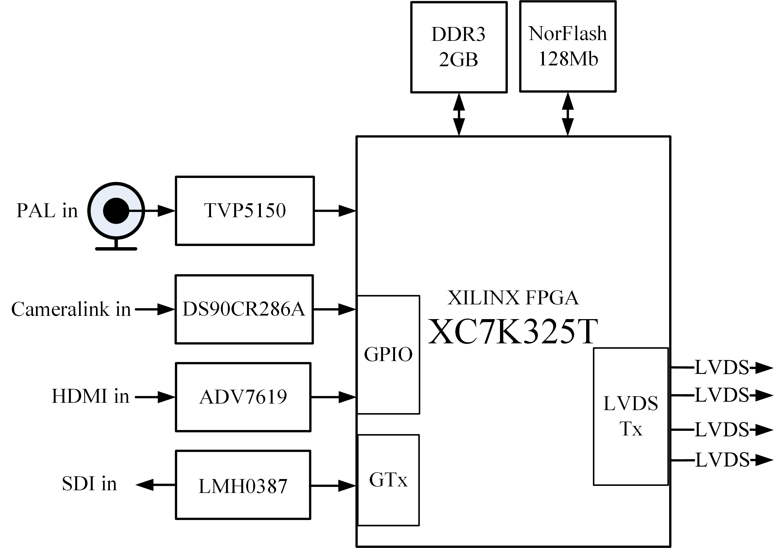
Figure. 1. Hardware block diagram of the system

A. Power Tree Design
Different modules require different voltages for the power supply, and even different power pins on the same module may require different voltages. Therefore, a power-supply design is necessary^{[8]}. The system uses an overall power supply voltage of 12V, which is then converted using different power chips to ensure stable operation of each module. The power-tree design is illustrated in Fig. 2.
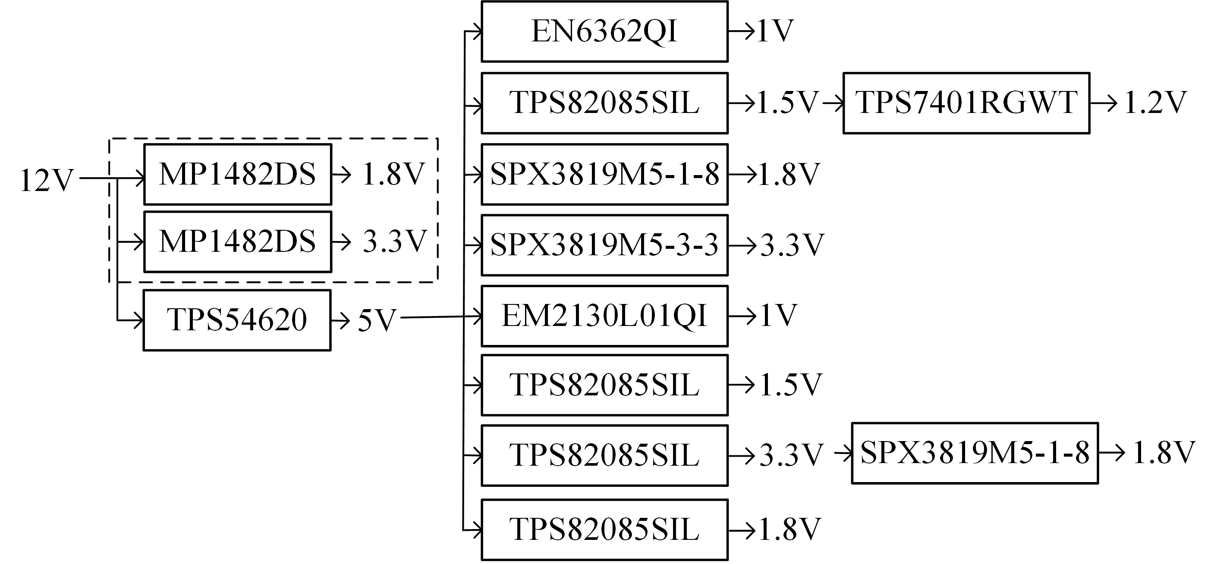
Figure. 2. Power tree design
The voltage conversion within the dashed box is used to power the encoding and decoding modules. The synchronous buck regulator MP1482D is used to step down 12V to 1.8V, 3.3V, and 1.2V, providing the required voltages for various encoding and decoding chips. The power-tree design outside the dashed box is used to power the FPGA. The synchronous buck converter TPS54620 is used to convert 12V to 5V, supporting a current of up to 6A. The 5V voltage is then converted to 1.5V, 3.3V, and 1.8V using the TPS82085SIL power chip. The 1.5V power supply not only powers the DDR, but is also converted to 1.2V for the FPGA using the TPS7401RGWT.

B. Video Input Interface Driver
The PAL video interface transmits analog signals, whereas the FPGA processes digital signals^{[9]}. After processing using the TVP5150 analog-to-digital converter, the output 8-bit YCbCr 4:2:2 format ITU-R BT.656 data can be transmitted to the FPGA for processing. ADV7619 is selected for HDMI decoding. It supports the HDMI 1.4A standard and, after configuration, can convert HDMI video data input from external devices into YCbCr format video signals, ensuring uniformity in the input data format.
The Cameralink video input interface uses the Base mode, which transmits four channels of LVDS serial differential data and one channel of LVDS differential clock signal. The high-speed deserializer DS90CR286A can convert the four pairs of LVDS data streams into parallel 28-bit LVCMOS data, making it convenient for the output to the FPGA for processing. The SDI interface uses high-speed serial transmission^{[10]}, and high-frequency signals can experience significant attenuation during transmission. Therefore, an equalizer, LMH0387, is used for signal conditioning before the SDI video is transmitted to the FPGA for decoding.

C. Video Output Interface Driver
The LVDS interface is a low-voltage differential signaling transmission technology^{[11]}. It only performs timing conversion of the interface, and does not process the image data format. This interface can send decoded video data to an ARM processor for complex image processing. This design implements data transmission between the LVDS interface and HiSilicon Hi3559 processor. This requires configuring the LVDS interface into a mode with one pair of differential clock signals and four lanes to facilitate data exchange with Hi3559.

D. PCB Design
Based on the design of the power module and the overall planning of the video input and output chips, the top-layer Printed Circuit Board (PCB) layout shown in Fig. 3(a) and the bottom-layer PCB layout shown in Fig. 3(b) were completed. The top view of the system shown in Fig. 4(a) and bottom view of the system shown in Fig. 4(b) were obtained.

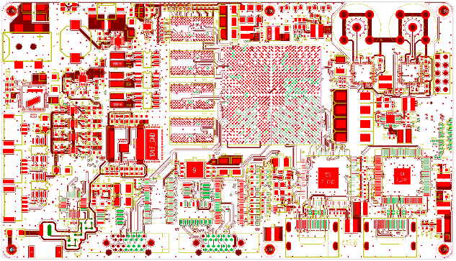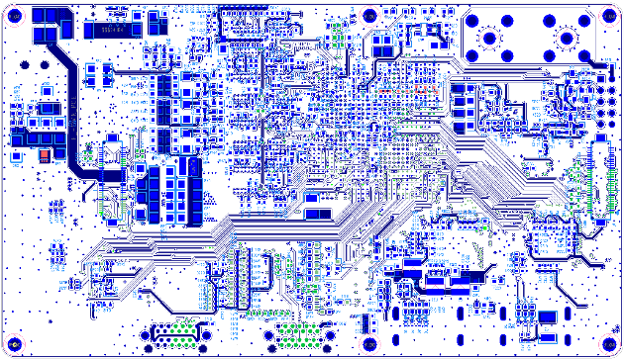
(a) Top (b) Bottom
Figure. 3. Layout and routing diagram of PCB
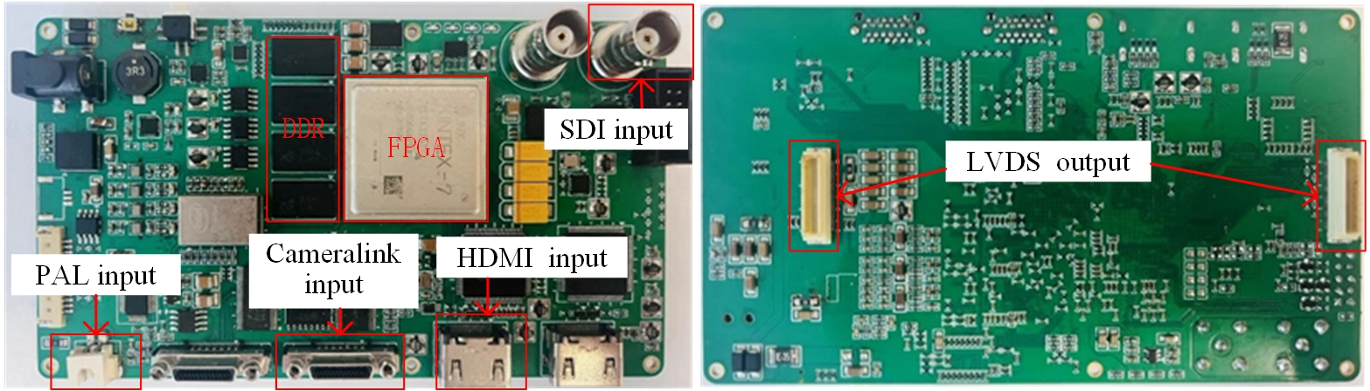
(a) Top (b) Bottom
Figure. 4. FPGA-based Multi-Interface Video Capture System

III. Video transcoding on FPGA

A. Video Format Switching Based on Asynchronous DDR Access
Conversion between different input video formats is achieved using a decoding selection module. The four video inputs from the PAL, HDMI, Cameralink, and SDI interfaces are all converted into the same data format after decoding, facilitating selection by the decoding module and entry into the DDR cache. The principle of video format switching is illustrated in Fig. 5. Based on the input interface connected by external devices, users can use buttons to select the corresponding decoded data to be written into the DDR for caching. The encoding module reads the data from the DDR, performs LVDS encoding, and outputs the data.
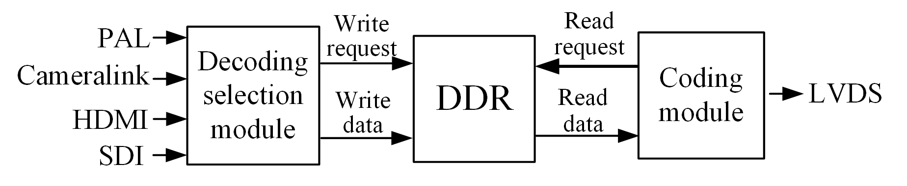
Figure. 5. Schematic diagram of video format switching principle
The decoding selection module is a 4-to-1 multiplexer, and its working principle is illustrated in Fig. 6. The input of the decoding selection module includes the decoded data from the four video formats (data), the corresponding clock signals (write_clk), the write request to DDR (write_req), and the write enable (write_en). The number of times the user presses a button determines the value of the change. Based on the value of the change, the decoded data to be output is selected, along with the clock signal, write request, and write enable for writing to the DDR. The encoding module reads the data directly from the DDR for LVDS encoding. Additionally, because the DDR read and write operations are asynchronous, a ping-pong mechanism is used to avoid frame-interleaving issues.

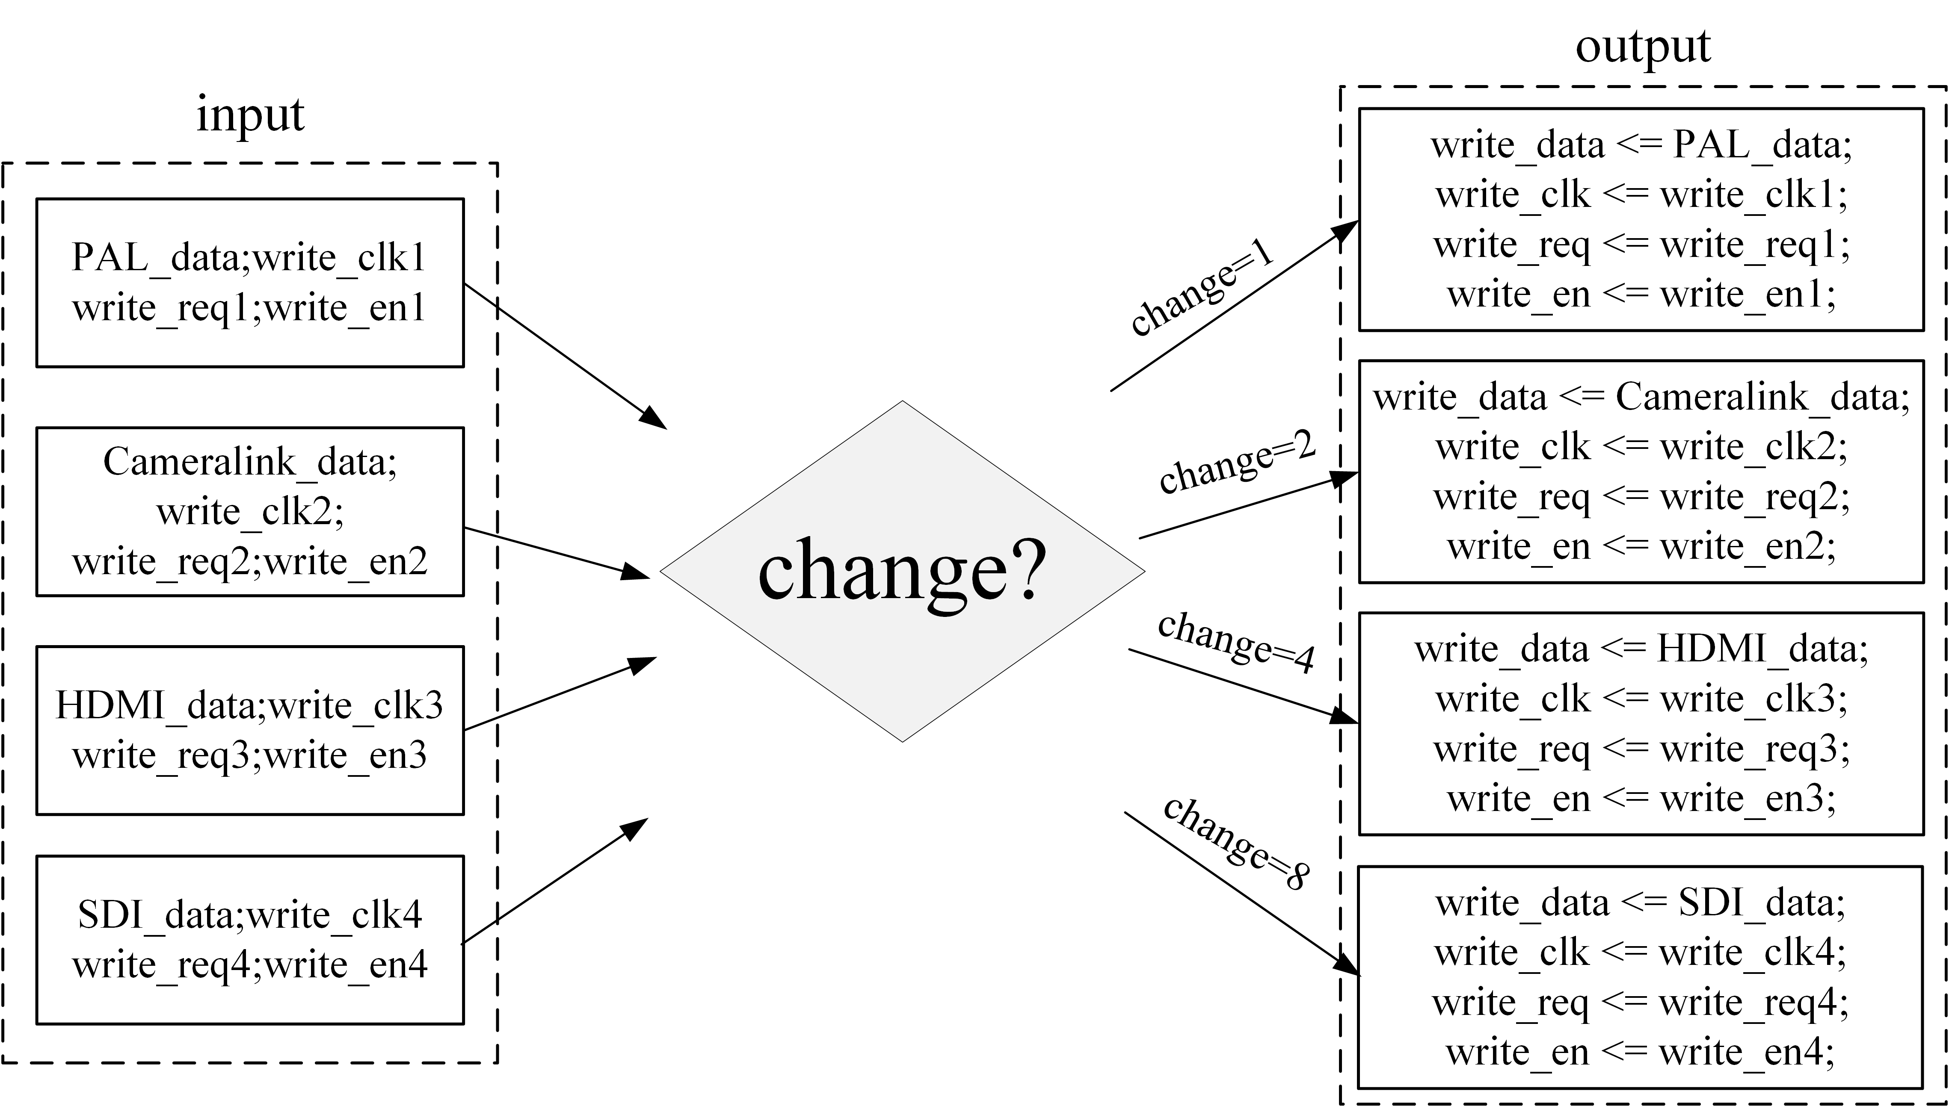
Figure. 6. Working principle of the decoder selector

B. System Logic Framework
Based on the principle of asynchronous DDR read-and-write for video format switching, the overall system logic was designed, as shown in Fig. 7. It consists of seven key modules: clock management, chip configuration, decoding selection, encoding, video input, video output, and memory control. These modules collectively implement the functionality of the multi-interface video capture system.

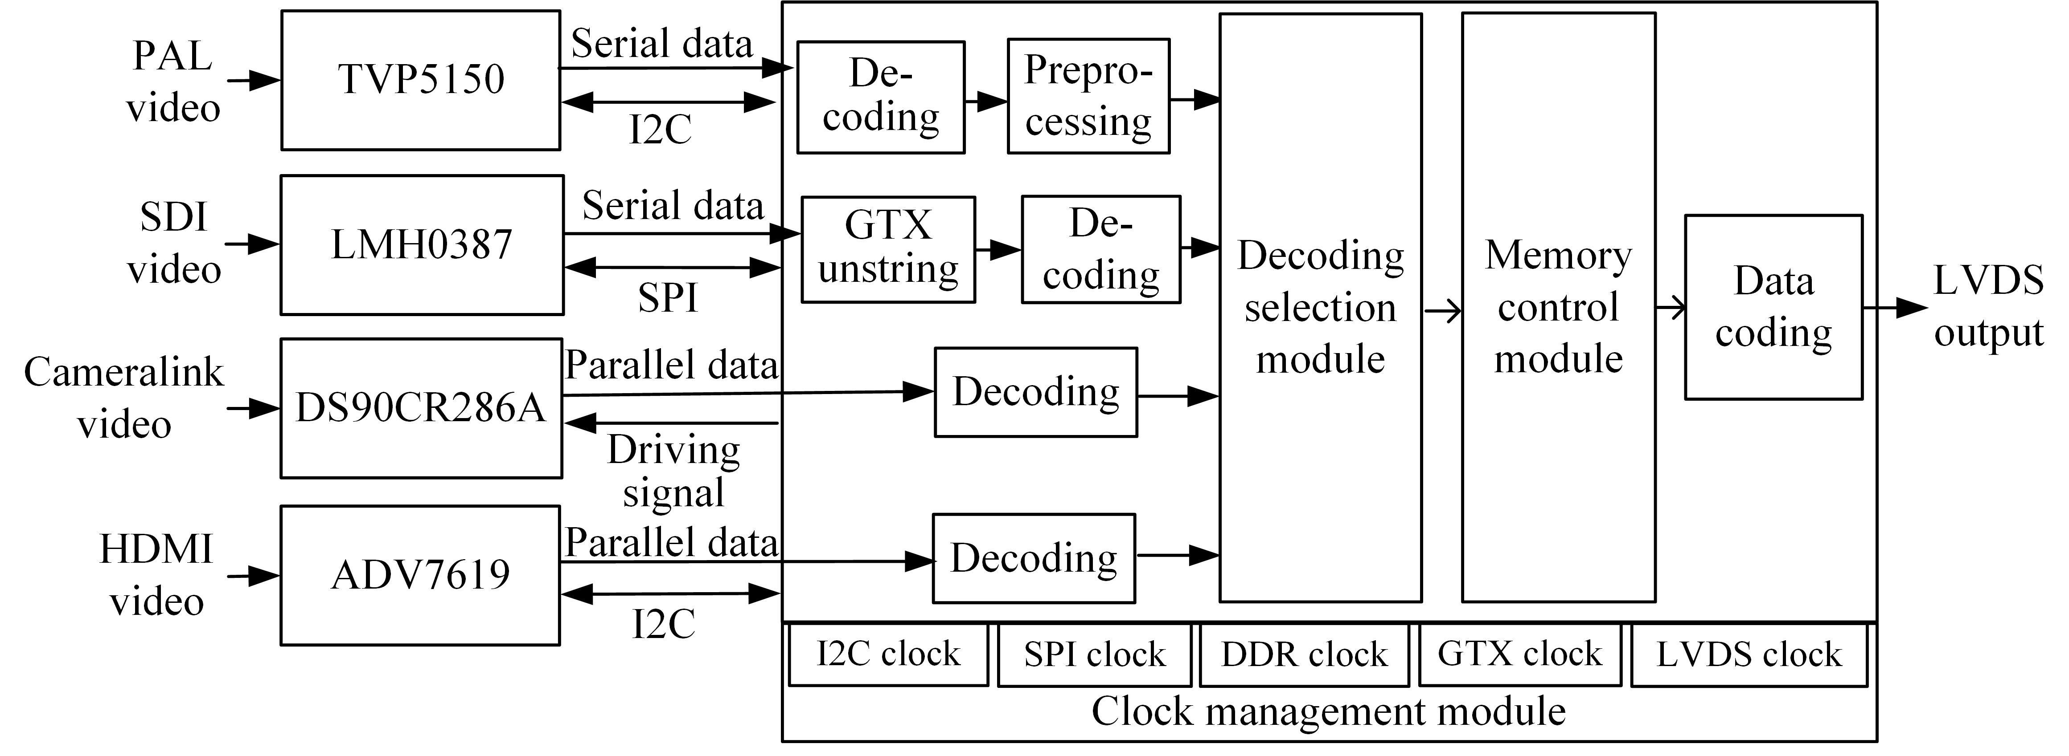
Figure. 7. Overall system logic function design diagram

The input from each video interface is first processed by the respective decoding chip to obtain valid data in a unified format. These data then pass through the decoding selection module and enter the memory control module for caching, followed by encoding and outputting. This ultimately achieves switching between the four video input formats and the LVDS video output operation.

C. PAL Video Decoding on FPGA
Using TVP5150, the PAL video is converted from an analog video to an 8-bit YCbCr BT.656 signal streaming. Fig. 8 shows the decoding logic of the BT.656 video on FPGA. Using a sliding window method, during decoding, when the first three shift register values are detected as 0xff, 0x00, and 0x00, respectively, the decoder further checks the 4th bit of the data. If this bit is 0, the decoder identifies a start code (SAV); otherwise, it indicates the arrival of an end code (EAV). Subsequently, a luminance extractor is used to distinguish between the luminance signal (Y) and chrominance signals (Cb and Cr), and then generate the synchronization signal.

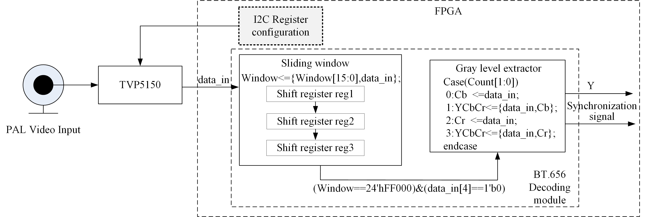
Figure. 8. BT656 video decoding logic on FPGA

The decoded data needs to undergo deinterlacing^{[12]}, which is achieved using an interpolation algorithm. The transformation of odd- and even-field addresses is controlled through an address-switching signal. Initially, the address-switching signal was 0. After all odd field image data are written, the address switching signal flips to 1, and the subsequent data are written to the even field address, ultimately displaying a complete and coherent image.

D. HDMI Video Decoding on FPGA
The decoding logic for the HDMI video is illustrated in Fig. 9. To standardize the format of the decoded video data, ADV7619 is configured via Inter-Integrated Circuit(I2C) registers to output single-edge YCbCr 4:2:2 video data. The write timing for writing image data to the DDR is generated based on the image data and synchronization signals output by the ADV7619. The synchronization signals include the frame sync signal (vs), line sync signal (hs), and data-enable signal (de). When the write timing generator detects the rising edge of vs, it sends a write request to the DDR and subsequently writes data to the DDR based on the write-enable signal.
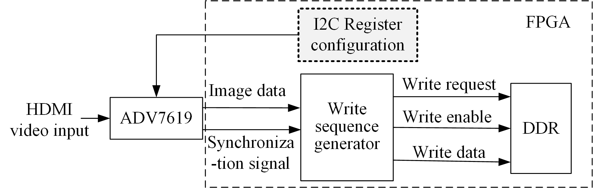
Figure. 9. HDMI video decoding logic block diagram

E. Cameralink Video Decoding on FPGA
The Cameralink camera uses the base mode to input image data, which includes 8-bit grayscale video image data and three synchronization signals. The decoding logic for the Cameralink video is shown in Fig. 10. First, pin 25 of DS90CR286A is pulled high to start the converter, resulting in 28-bit LVCMOS parallel data, including 24-bit RGB signals and four synchronization signals. Subsequently, the write timing generator receives the parallel data, generates a write request to the DDR, and finally generates a write-enabled signal to write the image data to the DDR.
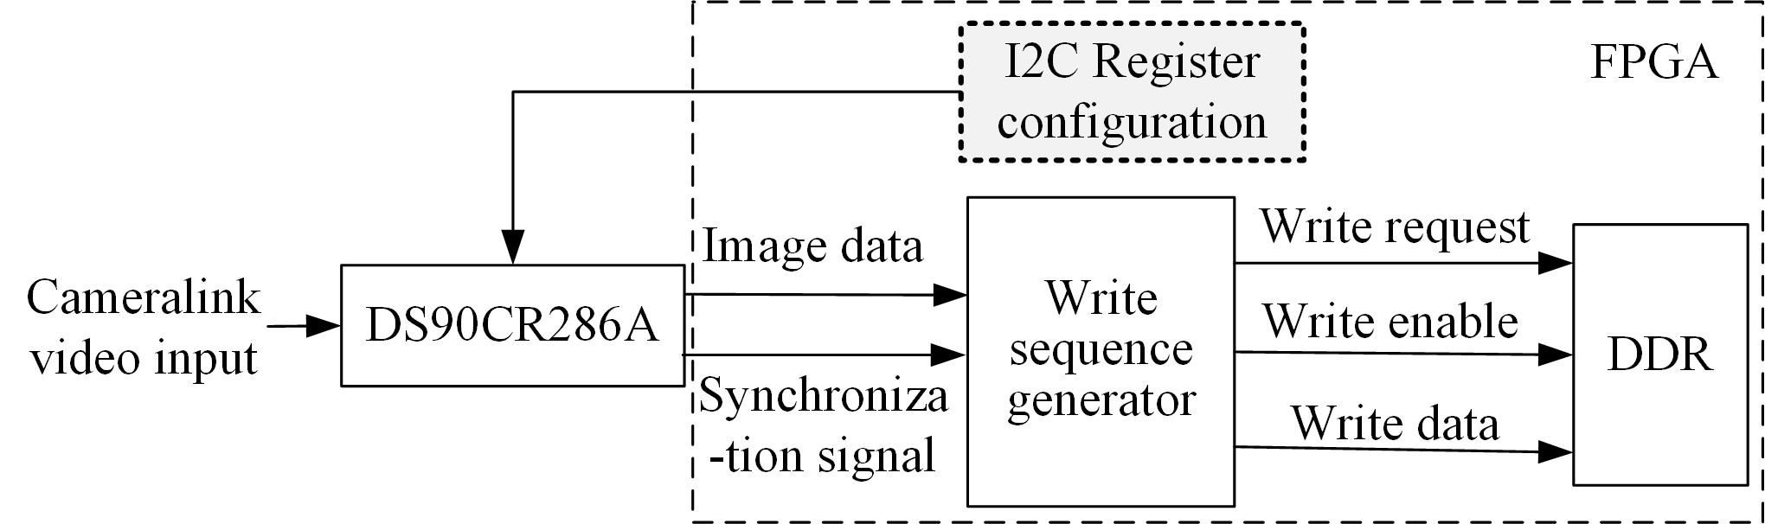
Figure. 10. Cameralink decoding logic block diagram

F. SDI Video Decoding on FPGA
The core function of the SDI video decoding technology is to convert high-resolution 1080P 60FPS SDI video data into parallel digital signals. The block diagram of its decoding logic is shown in Fig. 11.
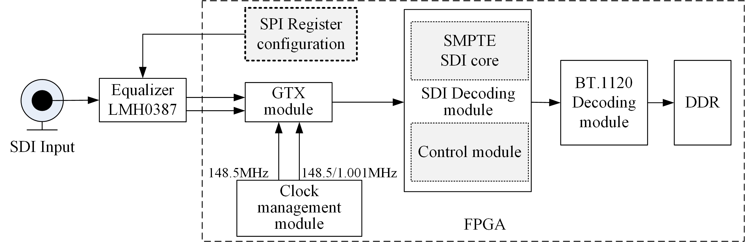
Figure. 11. SDI video data decoding logic block diagram
The GTX module converts the high-speed serial data into parallel data. The parallel video data is processed by the SMPTE-SDI IP core to output digital video data in the BT.1120 format. When decoding BT.1120, a sliding window method is also used. When the current three characters are 0x3ff, 0x000, and 0x000, the fourth character is further checked to see if it matches the sync code. This helps identify the Start of Active Video (SAV) to extract valid pixel data, which is then stored in the DDR.

G. LVDS Video Encoding on FPGA
To better connect the capture system to the Hi3559 processor, the logical design needs to convert parallel data read from the memory control module into the LVDS format for output, with the key aspect being the insertion of synchronization codes. The system uses four lanes to transmit video data with LVDS synchronization codes and pixel data distributed across these lanes. The specific transmission method is shown in Fig. 12. In this context, H represents the synchronization code, and P represents the pixel. The LVDS synchronization code format used by the system is presented in Tab. 1. Special codes SOF and EOF mark the start and end of a frame, respectively, while SOL and EOL represent the start and end of a line, respectively. These codes are composed of four fields, with the first three fields being fixed reference codes, and the last field used to distinguish the start or end of a frame/line.

Table I. LVDS Synchronization Code Format
Word order | Bit width | Synchronization code
Word order | Bit width | SOL/SAV | EOL/EAV | SOF/SAV | EOF/EAV
First word | 8bit | FFh | FFh | FFh | FFh
Second word | 8bit | 00h | 00h | 00h | 00h
Third word | 8bit | 00h | 00h | 00h | 00h
Fourth word | 8bit | 80h | 9Dh | ABh | B6h

During LVDS encoding, the synchronization code embedder first generates vs, de, and 8-bit synchronization codes in accordance with the LVDS transmission protocol. The read-timing generation module generates a read request based on the vs signal and sends it to the DDR. Subsequently, a read-enable signal is sent to ensure that the synchronization codes are accurately embedded in the data read from the DDR. The data is then split and evenly distributed across the four lanes.
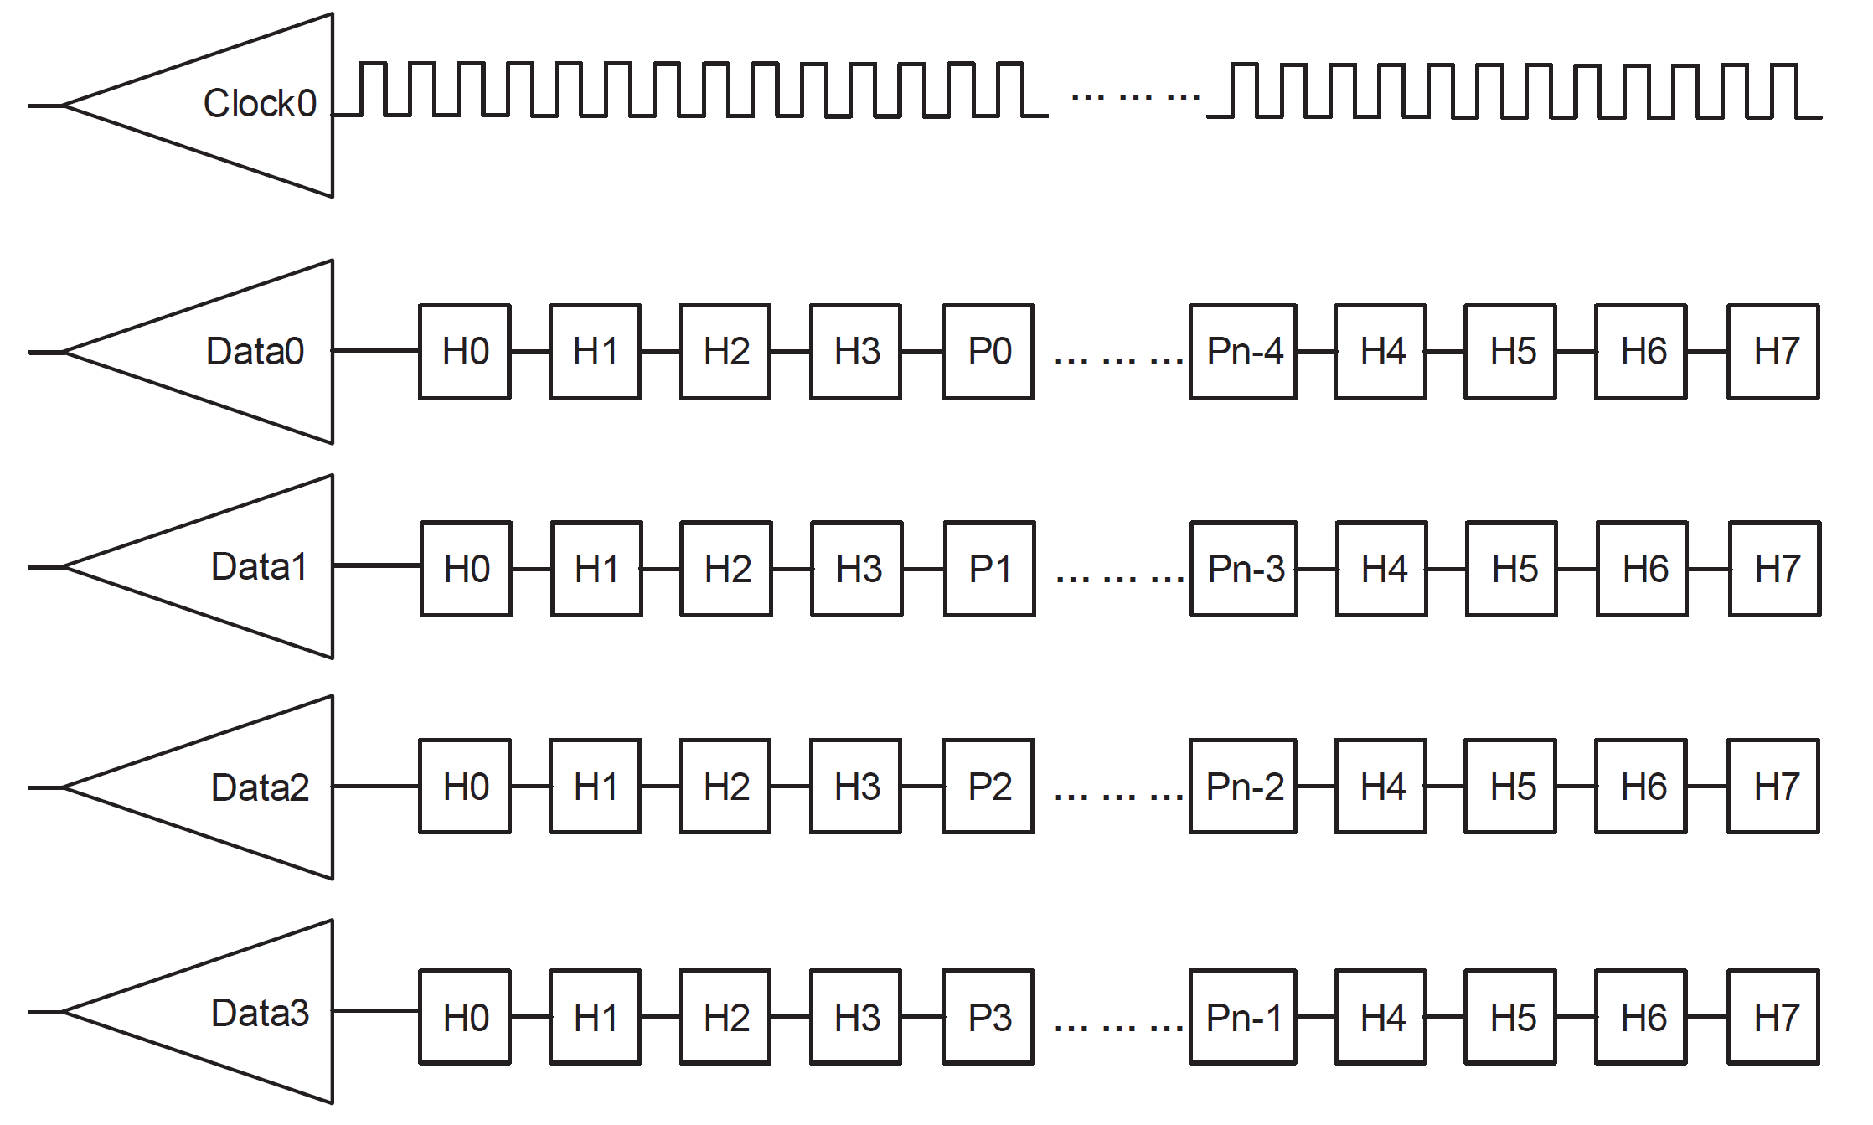
Figure. 12. LVDS synchronization code transmission mode

IV. Experiments and Analysis
The equipment and environment used in the experiments are shown in Fig. 13. In this setup, an SDI adapter board serves as the SDI input source. An analog PAL camera with a resolution of 720×576 and a Cameralink camera with a resolution of 1080p are used as the input sources for the analog PAL and Cameralink video formats, respectively. A laptop acts as the HDMI video source, supporting a resolution of 1080p. A regulated power supply is used to power the cameras. Data transmission between the Hi3559-based module and our system is achieved through a board-to-board connector.
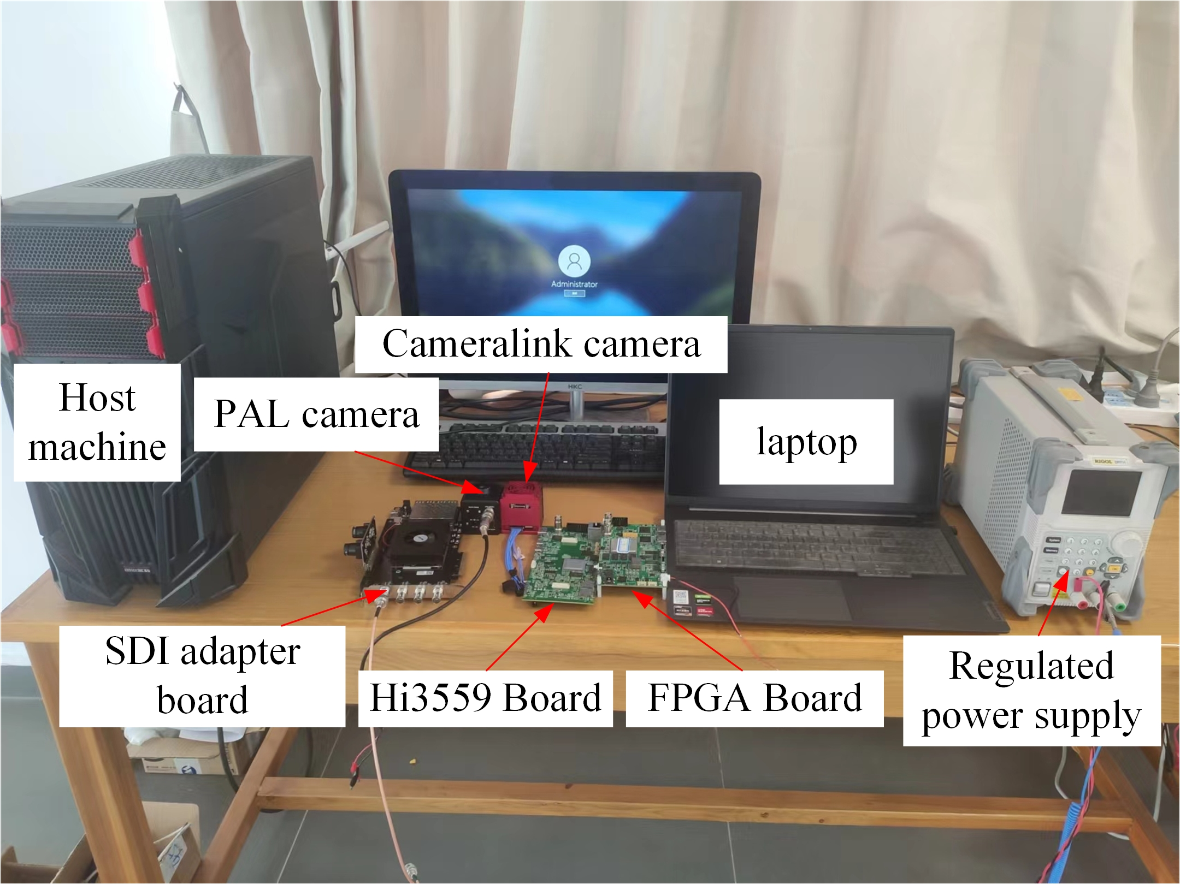
Figure. 13. System verification environment

A. Transcoding Test
We tested the transcoding from PAL, HDMI, Cameralink and SDI to the LVDS formats, respectively. The LVDS video streaming data are transmitted to the Hi3559 module via MIPI for display. The results of LVDS encoding outputs are shown in Fig. 14.
The Hi3559 module continuously provided uninterrupted, high-quality video streaming without any flickering or loss of frames for more than 140 hours without interruption. The stability of the conversion process from the 4 video formats to the LVDS format on our system has been clearly demonstrated. Meanwhile, it is proved that the FPGA-based multi-interface video capture system is compatible with Hi3559.

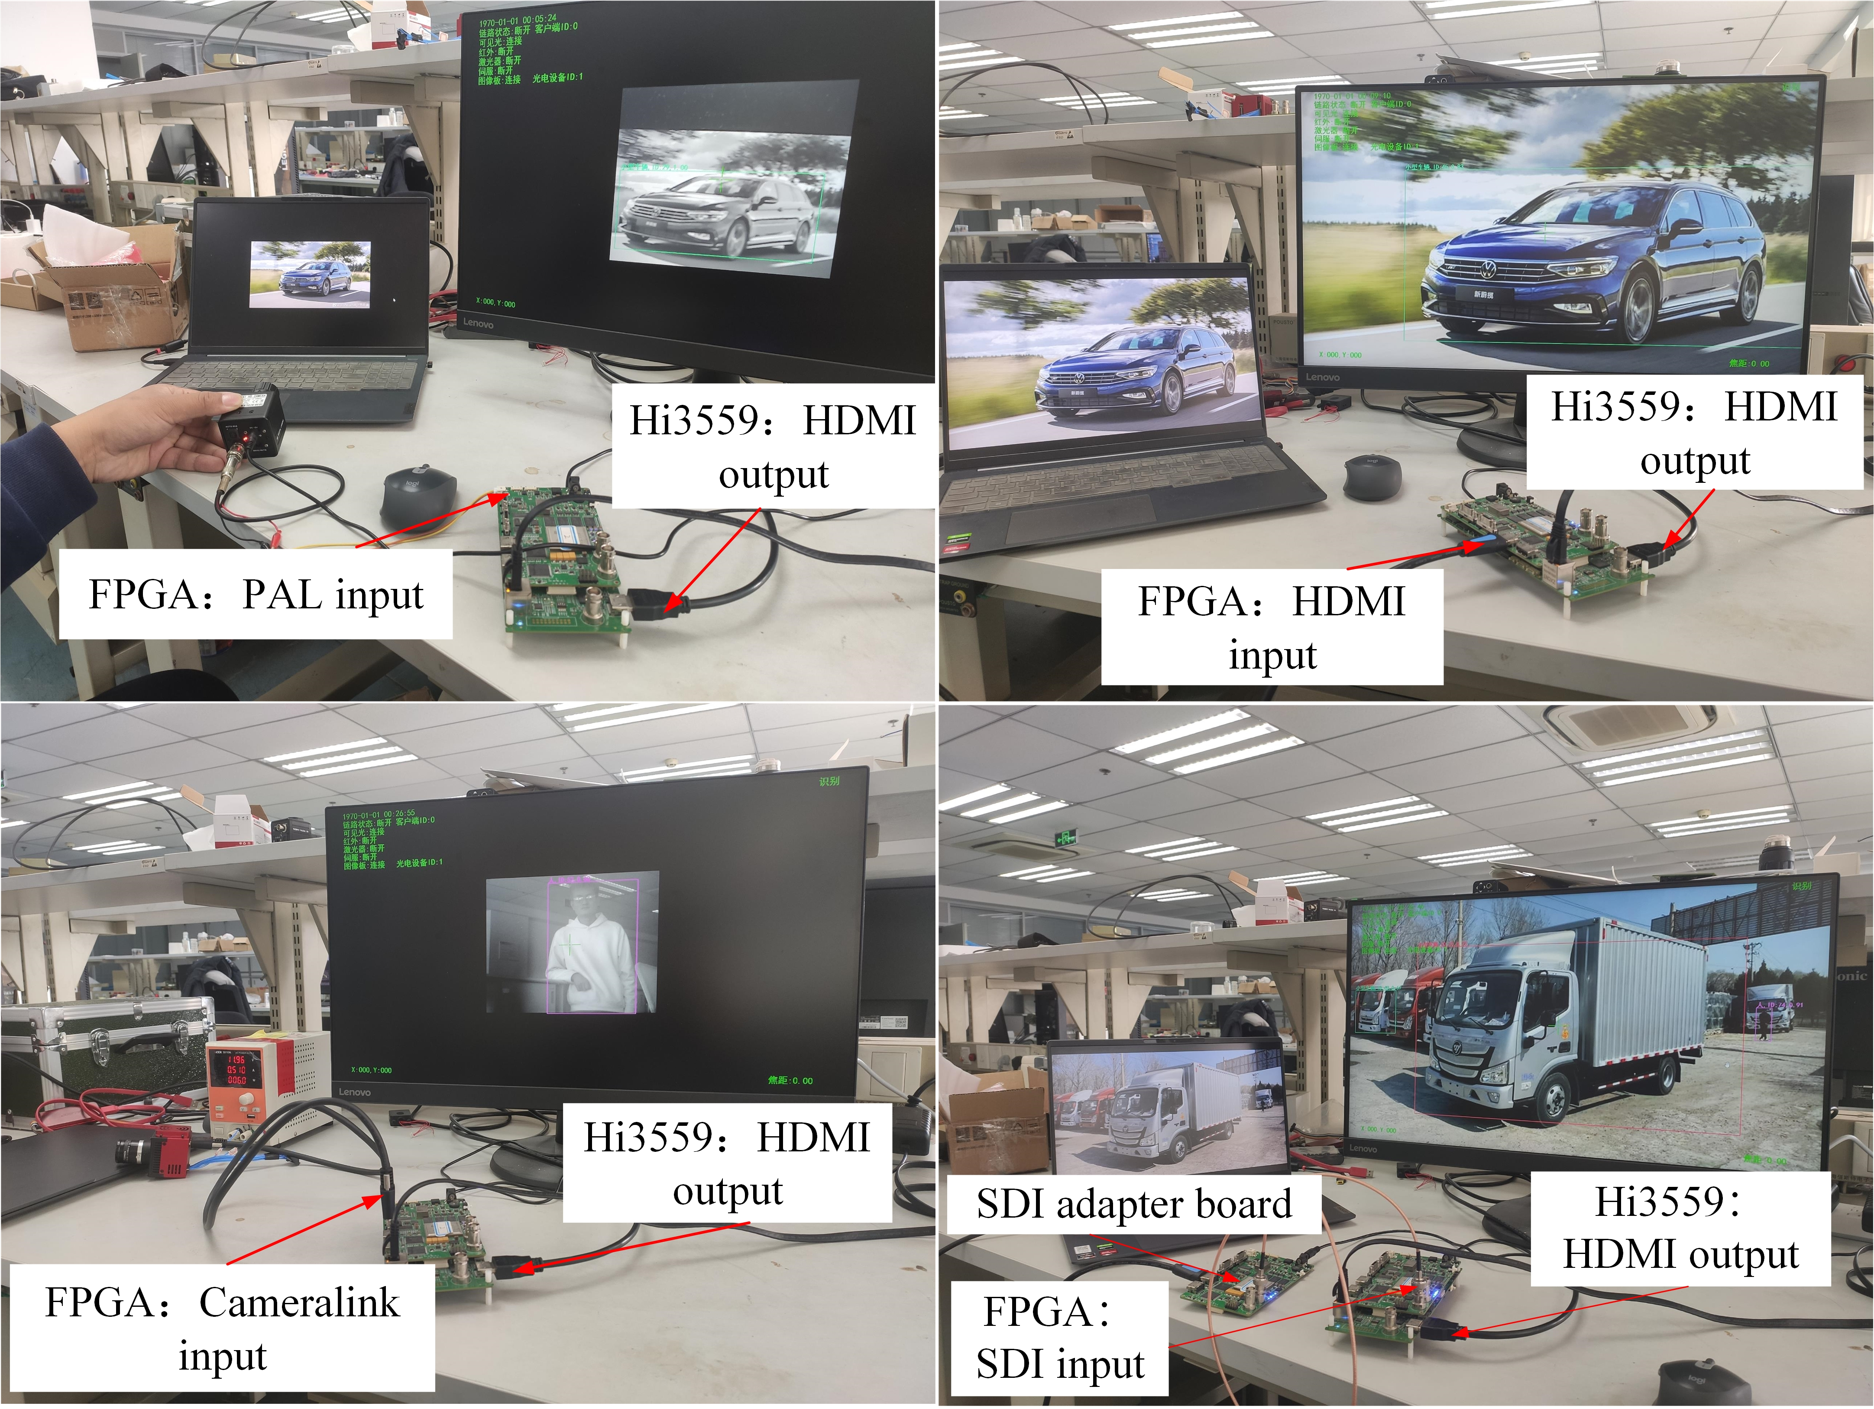
Figure. 14. Transcoding results from PAL, HDMI, Cameralink and SDI to the LVDS format

B. Resource Utilization of FPGA
The resource utilization of FPGA logic resources are listed in Tab. 2. The consumption of various resources, such as LUT, LUTRAM, FF, and BRAM, is below 10%. For critical clock resources, including the MMCM and PLL, the utilization rate is maintained below 50%. This low resource utilization provides an ample margin for further development and expansion.
Table II. FPGA Resource Utilization
Logical resource | Utilization rate | Logical resource | Utilization rate
LUT | 8% | IO | 27%
FF | 3% | BUFG | 41%
BRAM | 1% | MMCM | 30%
LUTRAM | 3% | PLL | 10%

V. Conclusion
To enrich the application scope of the Hi3559 processor, this study constructed an FPGA-based multi-interface video capture system. The capture system adapts to five video interfaces in the hardware and includes a decoding selection module in its logical design, enabling switching between four input video formats. Additionally, the capture system connects to the Hi3559 via the LVDS interface, enhancing the video interface compatibility of the Hi3559. Multiple experiments and performance tests have validated that the system's PAL, HDMI, Cameralink, and SDI video decoding inputs, as well as the LVDS video interface encoding outputs, are stable and effective. In addition, the system's low logic resource utilization offers a robust solution for applying machine vision systems to various scenarios.
However, this design utilizes only four lanes for LVDS interface data transmission, with a transmission rate of just 600Mbps, and does not reach the capture system's maximum transmission capacity. Future research could increase the number of LVDS outputs to exploit the performance potential of the system fully.

References
[1] GOMES S L, REBOUçAS E D, NETO E C, et al. Embedded real-time speed limit sign recognition using image processing and machine learning techniques[J]. Neural Computing & Applications, 2017, 28: 573-584.
[2] MENG P, ZHANG H, WEN H, et al. Design of real-time image processing system of medical high-definition electronic endoscope based on FPGA[C]. 2022 28th International Conference on Mechatronics and Machine Vision in Practice (M2VIP), Nanjing, China, 2022.
[3] YAN Zibo, HAN Wenbo, ZHAI Xuhua. Design of video acquisition system based on domestic FPGA[J]. Journal of Changchun University of Science and Technology, 2023, 46(04): 99-106.
[4] ZHAO Dongqing, MENG Yuhang. High speed image acquisition and transmission system based on FPGA[J]. Computer & Digital Engineering, 2023, 51(08): 1861-1863+1923.
[5] YANG C, CHEN M. Design of High Performance Image Acquisition and Processing Platform Based on DSP and FPGA[C]. 2020 IEEE International Conference on Advances in Electrical Engineering and Computer Applications( AEECA), Dalian, China, 2020: 684-688.
[6] WANG Yi, ZHANG Yu, QIAN Hongwen. Multi-channel HD-SDI video transmission system based on Hi3559[J]. Application of Electronic Technique, 2022, 48(03): 83-87.
[7] WU Qi. Video image acquisition and processing system design and implementation based on FPGA[D], Xi an: Xidian University 2022.
[8] LIU Bo, QIU Kaiqiang, ZHAO Qian. Research on sequence control method of embedded hardware power supply[J]. Aeronautical Computing Technique, 2023, 53(04): 113-116.
[9] ZHAO Qinglin, REN Yongfeng, WU Jingyang. Design of PAL image data decoding and transmission based on FPGA[J]. Integrated Circuits and Embedded Systems, 2024, 24(03): 94-98.
[10] CONTI G, KYRKOU C, THEOCHARIDES T, et al. A novel FPGA-based test-bench framework for SDI stream verification[J]. Eurasip Journal on Image and Video Processing, 2020.
[11] LI J, WU L, LIU C, et al. A Design of LVDS High-speed Data Transmission System Based on FPGA[C]. 5th International Conference on Computer Information Science and Application Technology(CISAT 2022), Chongqing, China, 2022.
[12] FU Sizhe. Design of video deinterlacing system based on FPGA[D]. Beijing: China University of Petroleum, 2022.

