Inclusive Performance Analysis Of 100 Gbps PAM-4 at SerDes Using Digital Equalizers

Gilad Katz
Electrical and computer engineering
Holon Institute of Technology Holon, Israel
giladka@hit.ac.il
Stiven Zlotsky
Electrical and computer engineering
Holon Institute of Technology Holon, Israel
giladka@hit.ac.il
Ido Vinitzky
Electrical and computer engineering
Holon Institute of Technology Holon, Israel
giladka@hit.ac.il
Alon Babecovand
Electrical and computer engineering
Holon Institute of Technology Holon, Israel
giladka@hit.ac.il

Benjamin Wolftson
Electrical and computer engineering
Holon Institute of Technology Holon, Israel
giladka@hit.ac.ilurname
Eduard Sonkin
Electrical and computer engineering
Holon Institute of Technology Holon, Israel
giladka@hit.ac.il

Abstract—In recent years we have witnessed an increase in data transfer rates, which requires the development of new communication methods that can handle high-speed data transfer at challenging communication channels. One of the needs is the transmission of communication over serializer deserializer (SerDes) printed circuit boards (PCBs). which are used to transmit data between chips at high speeds of 10 Gb/s and above, using the Pulse Amplitude Modulation with Four Levels (PAM-4) encoding method, which enables lower losses and relatively low cost.
Significant signal degradation is present in high-speed communication systems at SerDes, and inter-symbol interference (ISI) distortion dominates. One of the most effective methods to mitigate ISI distortion is the use of equalizers.
The goal of this research is to study the performance of communication between two chips (transmitter/receiver) over SerDes PCB at 100 Gbs using the PAM-4 encoding method with an integrated continuous time linear equalizer (CTLE), feedforward equalizer (FFE) and decision feedback equalizer (DFE).
The analysis includes a transmitter/receiver with PAM-4 encoding including the PCB channel response. Further, testing the performance of the combination of different equalizers while defining relevant values and parameters (rate, transmission, convergence rate, and equalizer coefficients). Performance are evaluated using signal-to-noise ratio and bit error rate (BER) metrics.
We investigated the BER performance for five PCBs of different lengths with analog CTLE and digital FFE-DFE equalizers and found that:
For a small number of taps in FFE-DFE, a specific CTLE configuration is optimal, but for an optimal combination of FFE-DFE, a different configuration of the CTLE is the best for all PCB lengths.
We also show that the longer the PCB length, the more coefficients of the FFE-DFE are needed, consequently, more power is required to compensate for a longer PCB length. already defines the components of your paper [title, text, heads, etc.] in its style sheet. *CRITICAL: Do Not Use Symbols, Special Characters, Footnotes, or Math in Paper Title or Abstract. (Abstract)
Keywords— SerDes, PAM-4, Equalization, CTLE, PCB, DSP

Introduction
With the progress and development of technology, we have witnessed a significant increase in the demand for high-speed data transfer. Communication systems and devices, including cell phones, the home computer, and even the vehicles in which we travel, contain a variety of chips that are required to communicate with each other at high rates for data transfer operations and processing. The communication between chips is characterized by short ranges and is required to be fast and efficient to meet technological developments which require a fast rate of transfer and processing of information.
The growing demand for wide bandwidth in electrical devices requires the use of serializer/deserializer transmitters (SerDes) to handle high data transfer rates of 50 Gb/s and above [1]. The common modulation method for communication between chips is Pulse Amplitude Modulation with Four Levels (PAM-4) which allows less losses and a relatively low cost while dealing with fast data transfer [2], [5].
Despite the advantages mentioned above, when the data transfer rate increases beyond 10 Gb/s, the signal transmitted in the channel suffers from significant attenuation and the inter-symbol interference (ISI) phenomenon, caused by the channel imperfection.
The ISI phenomenon causes the eye diagram to close and consequently increases the bit error rate (BER).
To overcome this phenomenon we will use equalizers [3]. There are currently several different types and algorithms for realizing equalizers, in this research we will examine the performance of five different printed circuit boards (PCBs) at different lengths using analog continuous time linear equalizer (CTLE) together with the digital equalizers: feedforward equalizer (FFE) and a decision feedback equalizer (DFE) [4]. Both of these equalizers' coefficients are based on the least mean square (LMS) adaptive algorithm [2].

System Description

Block Diagram
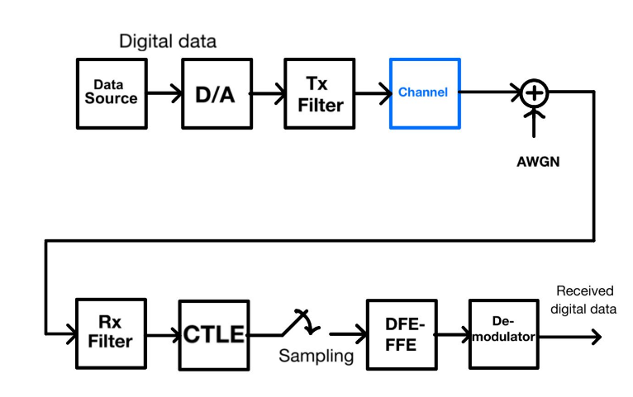
Fig. 1 Block diagram for a digital communication system as implemented
Filters (Tx and Rx) - are implemented by a second-order Bessel filter.
Channel - The channel is modeled using S-parameters obtained using an ADS tool and validated by lab measurements of real layout PCB using a network analyzer (N5227a). S-parameters are different and we will examine the combination of additional equalizers for optimal results if necessary.
CTLE -To understand how each equalizer affects and what is tan he best combination of equalizers, we changed various parameters such as the number of taps and different configurations of the CTLE and we examined how this affected the results. We used a final set of 13 CTLE configurations. We analyzed different PCBs with different lengths to see how the lengths of the PCB affect the performance [6].

De-Modulator performs the opposite operation to modulation such that the output presents a sequence of the desired bits.

PCB
In this analysis, we tested five different PCB channels, that is, five different S parameters were used.
For each of the PCB channels, we performed an analysis and performance evaluation separately, the PCB channels differ from each other in their trace length and layout geometry. All PCBs are based on EM892 dielectric material, loss tangent 0.0013, and dielectric constant of 3.
Fig. 3 presents the S-parameters SDD21 frequency response of the PCB channels of 5, 10, 15, 20, and 25-inch length defined as PCB number five to one, respectively.
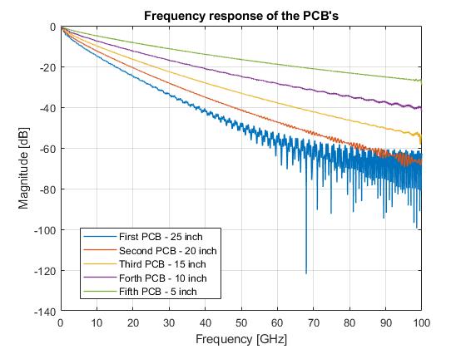
Fig. 2 PCB Frequency responses of 5, 10, 15, 20, and 25-inch length

Evaluating the performance of the equalizer
We examined a combination of FFE-DFE equalizers at this stage to optimize the BER performance [4], [7].
The performance of the equalizer depends on the number of coefficients (taps) which determine the length of the filter and the step size value which determines how much the filter coefficients will be updated in each iteration according to the changes in the received signal and is a scale for the convergence and stability of the filter.
To achieve a performance evaluation, we examined the effect of the FFE+DFE for different signal-to-noise ratio (SNR) values ​​and also examined different options for the length of the filter (different number of coefficients)

BER performance
The effectiveness of the built equalizers was tested according to the convergence of the error and according to the BER curve, performance was tested for different numbers of coefficients to understand how the number of coefficients of each equalizer affects the BER curve.
Fig. 3 shows the BER curves as a function of the SNR for different combinations of equalizer coefficients. It can be seen that as we decrease the number of coefficients of the equalizers, we will get worse results, that is, for the same SNR, a higher BER result is obtained, that is, there are more errors between the received symbols and the transmitted symbols.
We see that in the purple graph in Fig. 3 the BER curve presents a BER floor. Therefore, if we increase the number of coefficients of the FFE to 4 (from 3), we will get more reasonable results, and if we set it to 3, we will get unsatisfactory results.
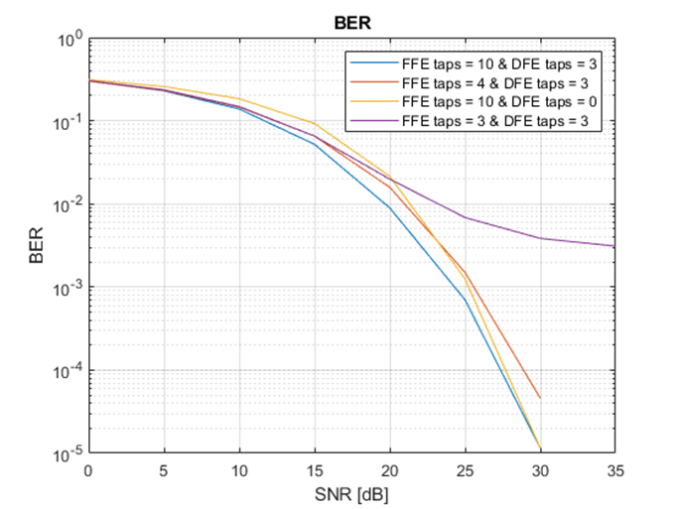
Fig. 3 BER as a function of SNR for different filter lengths for PCB 1
Optimal FFE taps = 10, Optimal DFE taps = 3
We note that when we eliminated the DFE (yellow curve) we got quite a high BER for a low SNR. But, for higher SNR the results are similar to the case where DFE was present. We will have to investigate later why this holds.
Later, it is required to add the FFE equalizer in the transmitter to improve the performance, in addition, the possibility of adding a CTLE equalizer should be checked, and how it will affect the system performance.
Figs. 4a, 4b, 4c, 4d and 4e show a penalty graph as a function of the number of taps of the FFE for PCB numbers 1 to 5, respectively. In these graphs, the selected reference (penalty is 0dB) is 4 taps of DFE and 16 taps of FFE, and at $BER of {10}^{-3}$. For the first PCB, it can be seen that the best combination of the equalizer configuration is 10 taps of FFE and 4 taps of DFE since this combination introduces zero penalty compare to the reference (which includes more taps) with minimum equalizer coefficients.
Figs. 4b, 4c, 4d, and 4e depict the graphs of the (BER) penalty as a function of the number of taps of FFE for the second, third, fourth, and fifth PCB, respectively.
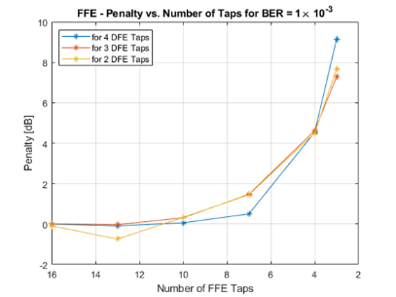
(a)
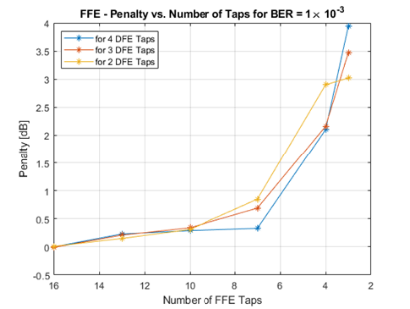
(b)
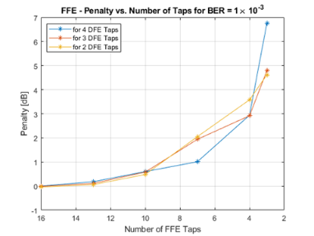
(c)
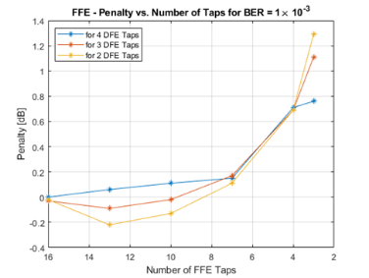
(d)
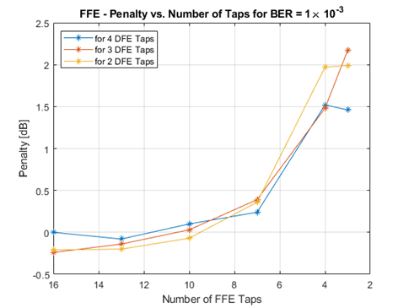
(e)
Fig. 4: Penalty curves as a function of the number of taps in FFE for 2,3,4 taps of DFE. (a) For the first PCB. (b) For the second PCB. (c) For the third PCB. (d) For the fourth PCB. (e) For the fifth PCB.

In Fig. 4b, the best combination is 2 taps of DFE and 16 taps of FFE, It can be seen that by reducing the number of taps the penalty increases, thus more power is required to get the target BER (10-3).
In Figs. 4c, 4d, and 4e, the optimal performance is obtained for 2 taps in DFE and 16 taps in FFE 3 taps in DFE and 16 taps in FFE, and 13 taps in FFE and 2 taps in DFE, respectively.

Adding CTLE

Fig. 5: BER Penalty graph as a function of CTLE configuration for an optimal DFE-FFE combination. The first, to fifth PCBs, are presented as PCB1 to PCB5, respectively

Fig. 5 depict the effect of each CTLE configuration using the optimal combination of FFE-DFE equalizers.
We note that the penalty of all curves is for a different SNR from curve to curve. The selected SNR is the one whose BER is at BER of 10-3. The penalty is attributed to the SNR obtained for the first CTLE configuration (chosen arbitrarily), so we can see in the graphs that the penalty in the first configuration is 0.
It can be seen that CTLE configuration one is optimal for the entire PCB channels since it provides the minimum penalty for obtaining BER= 10-3.

PCB comparison analysis:

As we discussed above the first PCB channel is the longest one, the second PCB channel is shorter, and so on. Fig. 6 is used to understand the effect of the length of the PCB channel on the BER performance, in this Fig. we present a penalty graph as a function of the PCB number (i.e. PCB length).
We have now selected 16 taps in FFE, 4 taps in DFE, and the optimal CTLE configuration. We chose the fifth PCB to be our reference since it is the shortest and we expect that it will require fewer taps to get a BER of 10-3.
It is clearly shown here that with a longer PCB, the penalty increases, to compensate for this more taps for the FFE-DFE are required, thus, power consumption increases.
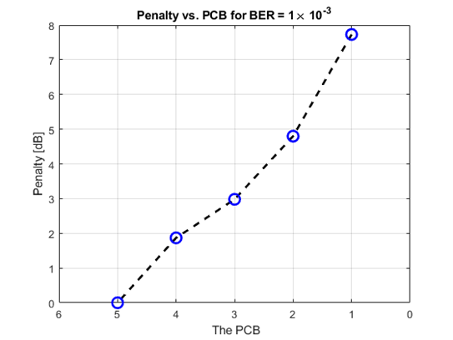
Fig. 6 The penalty obtained for each PCB with respect to fifth PCB at BER of ${10}^{-3}$.

Summary and Conclusion
We investigated the BER performance for five PCB channels at different lengths with analog correction (CTLE equalizer) and digital correction (DFE-FFE equalizers) and found that:
1.) The first 25-inch long PCB needs 4 taps on the DFE, 10 taps on the FFE, and the first CTLE configuration.
2.) The second 20-inch long PCB needs 2 taps in DFE, 16 taps in FFE, and the first CTLE configuration.
3.) The first 15-inch long PCB needs 2 taps in DFE, 16 taps in FFE, and the first CTLE configuration.
4.) The first 10-inch long PCB needs 3 taps in DFE, 16 taps in FFE, and using the first CTLE configuration.
5.) The first 5-inch long PCB needs 2 taps in DFE, 13 taps in FFE, and the first CTLE configuration.
We have seen that for a small number of taps in DFE-FFE, configurations 6-8 of the CTLE are optimal, but for an optimal combination of DFE-FFE, the first CTLE configuration is the best for the entire PCBs.
Although, per each PCB we need almost the same digital and analog equalizers to get the best performance, obviously more power in the longer PCBs is required to achieve the same performance as the shorter PCBs.

References
- Jri Lee, et al, "Design of 56 Gb/s NRZ and PAM4 SerDes Transceivers in CMOS Technologies", IEEE Journal of Solid-State Circuits Volume: 50, Issue: 9, September 2015.
- Jin Liu and Xiaofeng Lin, "Equalization in High-Speed Communication Systems", IEEE Circuits and Systems Magazine Volume: 4, Issue: 2, 2004.
- Xiaoli Wang, Qingsheng Hu, "Analysis and Optimization of Combined Equalizer for High Speed Serial Link", IEEE 9th International Conference on Anti-counterfeiting, Security, and Identification (ASID), 2015.
- Kang-Yu Chang, Zhi-Ming Lin, "Level Selection Based 4-PAM Transmitter for Chip to Chip Communication", IEEE Asia Pacific Conference on Circuits and Systems 2006.
- Dana Arie and Gilad Katz, "Electrical Equalization Analysis of PAM-4 Transmission in Short-Reach Optical Systems", Appl. Sci. 2022, 12, 2255.
- Y. Choi and Y. -B. Kim, "A 10-Gb/s receiver with a continuous-time linear equalizer and 1-tap decision-feedback equalizer," 2015 IEEE 58th International Midwest Symposium on Circuits and Systems (MWSCAS), Fort Collins, CO, USA, 2015, pp. 1-4, doi: 10.1109/MWSCAS.2015.7282072.
- A. Roshan-Zamir et al., "A 56-Gb/s PAM4 Receiver With Low-Overhead Techniques for Threshold and Edge-Based DFE FIR- and IIR-Tap Adaptation in 65-nm CMOS," in IEEE Journal of Solid-State Circuits, vol. 54, no. 3, pp. 672-684, March 2019, doi: 10.1109/JSSC.2018.2881278.

