Evaluating Convolutional Neural Network Models: Performance Perspective in Video Summarization

Dr. Rachit Adhvaryu  Deparment of Computer Science & Engineering  Parul University  Vadodara, India  rachit.adhvaryu24310@paruluniversity.ac.in | Dr. Dipesh Kamdar  Department of Electronics & Communication Engineering  V.V.P. Engineering College  Rajkot, India  dipesh.kamdar.ec@vvpedulink.ac.in | Dr. Kamal Sutaria  Deparment of Computer Science & Engineering  Parul University  Vadodara, India  kamal.sutaria25509@paruluniversity.ac.in

Abstract— The nature of data has changed significantly as a result of the quick development of technology. Text-based datasets have given way to visual data, such as photos and videos. This shift necessitates the development of cutting-edge technologies that can effectively process and analyze visual input, allowing the creation of intelligent systems that can precisely extract insightful information. Convolutional neural network (CNN) models that have already been trained are now essential resources for this project. In this paper, the effectiveness of three well-known CNN models—AlexNet, GoogleNet, and SqueezeNet—in picture classification tasks is thoroughly compared. Our assessment concentrates on object detection performance on three different datasets—animals, birds, and flowers—obtained from the online repository of Kaggle, offering important information about the advantages and disadvantages of each model.
Keywords— Alexnet, Artificial Intelligence, Convolutional Neural Network (Cnn), Deep Learning, Googlenet, Squeezenet

Introduction
The improvement in technology is rising day by day. Moreover, the forms of data has brought a revolutionary wave in the field of research. The rebellion of datasets from text format to pictures and videos has forced an innovators to produce high end systems. Given that, the smart systems are tested in diverse real time environments to determine its reliability. Finding out the necessary information or item from pictures or its frames is a difficult undertaking. Artificial Intelligence has brought revolution in the thinking abilities of the human brains[1] through its technological domains that are dynamic in nature and its capacity to handle pictures in a quick and effective manner. Artificial intelligence has made a significant contribution to humankind by significantly altering daily life.
A. Artificial Intelligence
Artificial Intelligence, also referred to as Machine Intelligence, encompasses an ability to grasp data within its proper context, analyze it, and apply it through adaptive methods. Essentially, AI teaches machines to analyze data and generate desired results. This is accomplished by developing sophisticated intelligent systems that are displayed following the deployment of systems that have developed from methods based on human problem-solving abilities. Creating machines that are able to reason, learn, and solve problems is AI's main goal.
B. Machine Learning
Machine Learning, also referred as a Predictive Analysis, is a substantial application of AI that enables instinctive abstraction of key data from wide-ranging datasets. This method comprises creating a "training dataset," which acts as a scientific prototype of the statistics and facts. Machine learning procedures are used to plan, change, and train high end smart systems. Two primary categories of machine learning exist.: Unsupervised learning, in which the training dataset only embraces inputs and output prediction is carried out; Supervised learning makes use of both inputs and expected outcomes in the training dataset[2].
C. Deep Learning
Deep Learning, distinct from machine learning, primarily focuses on techniques derived from neural network implementation. Deep learning comprises comprehending the problem, identifying the dataset for analysis, picking an acceptable deep learning algorithm, selecting proper training for huge datasets, executing the method, and testing it in real time. Deep learning relies largely on interpretations and is particularly concerned with the types of datasets that are trained. [2]. This dependency can be a limitation, as predicting the output can be difficult and depends largely on the implementation environment. In some cases, deep learning may not yield optimal results due to its reliance on interpretive learning.
D. Neural Networks
Neural networks are intended to detect patterns by running multiple algorithms. They process sensory data by performing machine observations, clustering, or grouping raw inputs[2]. The identified patterns are represented as integers in vector form, which means that all real-world data, such as images, sound, text, or time series, must be translated into these vectors. Operations happen between the concealed input and output layers..
E. Convolutional Neural Network
A Convolutional Neural Network (CNN) is a Deep Learning algorithm that processes images as inputs, assigning weights and biases to different features, or neurons. For each neuron, the output is generated by taking multiple inputs, summing their weighted values, and passing them through specific functions[2]. Compared to other classification methods, CNNs require minimal pre-processing and have proven highly effective in image analysis and detection. Numerous CNN models can efficiently process large sets of images, some of which are discussed in subsequent sections.

RELATED WORK
Wan et al. (2014) proposed that combining audio and visual data can enhance the understanding of video structure and content, benefiting summarization systems. They suggest the creation of an Audiovisual Recurrent Network (AVRN) that integrates both modalities for the video summarization (VS) problem. The AVRN consists of three key components[3]:

Feature Encoding: Utilizes two-stream Long Short-Term Memory Networks (LSTM) to sequentially encode audio and video features, capturing their temporal dependencies. Modality Fusion: Employs an audiovisual fusion LSTM to explore and merge the latent consistency between the audio and visual modalities. Global Dependency Preservation: Uses a self-attention video encoder to maintain the global dependencies within the video. Finally, the integrated audiovisual data and the combined temporal and global relationships are used to generate the video summary displayed on the screen. Their results on the SumMe and TVSum benchmarks demonstrate the effectiveness of each component and show that the AVRN outperforms systems relying solely on visual data for summarization.

Jiang et al. (2019) introduced a video summarization method that provides concise video summaries by integrating three streams and identifying significant video segments. This approach is versatile and unaffected by the video's semantics, syntax, organization, or genre. Subjective assessments show that multimodal saliency indicators can produce informative and visually appealing video skims. Their algorithm excels in summary informativeness without relying on high-level characteristics like plot during computation. Future research aims to develop more sophisticated fusion techniques within and across multiple modalities, such as communication and educational content, non-linear feature correlations, variance-adaptive stream weights, and higher-level features in movie transcripts. They also plan to create a systematic framework for more comprehensive analysis of the summarization algorithm. This method detects perceptually significant video events using models based on audio, visual, and textual information in streaming videos[4].

Zhao, Li, and Lu (2021) tackled two major challenges in RNN-based video summarization. The first challenge is the large size of feature-to-hidden mapping matrices, which become exceptionally large when handling high-dimensional video data, complicating the training process. The second challenge is the insufficient exploration of long-range temporal dependencies. Traditional RNNs have difficulty managing long video sequences, often consisting of tens of thousands of frames. To address these issues, they created a Tensor-Train Hierarchical RNN (TTH-RNN). To better investigate long-range temporal correlations between video frames, this model includes a tensor-train embedding layer and a hierarchical RNN structure. Experimental results on four benchmark datasets (SumMe, TVsum, MED, and VTW) proved the higher performance of the TTH-RNN in video summarization. [5].

Zhao, Li, and Lu (2021) also introduced the H-RNN, a hierarchical RNN designed specifically for video summarization. The H-RNN consists of two layers: the first layer encodes small video subshots extracted from the original video, while the second layer uses the final hidden states of these subshots to determine if each subshot is a key subshot. This hierarchical approach allows the H-RNN to capture extensive temporal dependencies between frames while significantly reducing computational complexity. The H-RNN has been shown to outperform state-of-the-art methods on several prominent datasets, including the Combined dataset and the VTW dataset.

Shiraiwa and Nobuhara's study (2021), in their studies propose enhancing video summarization accuracy by integrating a semantic segmentation model. This approach utilizes semantic segmentation models like U-Net and SegNet to assess frame significance similarity between video summarization and semantic segmentation techniques. They train their models on datasets such as TvSum and SumMe, followed by evaluating their approach against two conventional methods: FCSN and vsLSTM. Quantitative assessment using F-scores reveals that their proposed model outperforms previous techniques by approximately 10%. Moreover, qualitative comparisons of the output videos demonstrate superior visual results with their suggested approach[6].

PRE-TRAINED MODELS OF CNN
As previously mentioned, CNN models are instrumental in training large datasets of images and analyzing them for various applications in research and other fields. Numerous CNN models are designed for learning diverse sets of images and their classes, achieving high levels of accuracy ranging from 75% to 99%, depending on the dataset and its contents. In this paper, our primary focus revolves around three prominent CNN models widely employed for image and video analysis. These CNN models include:

GoogleNet CNN Model
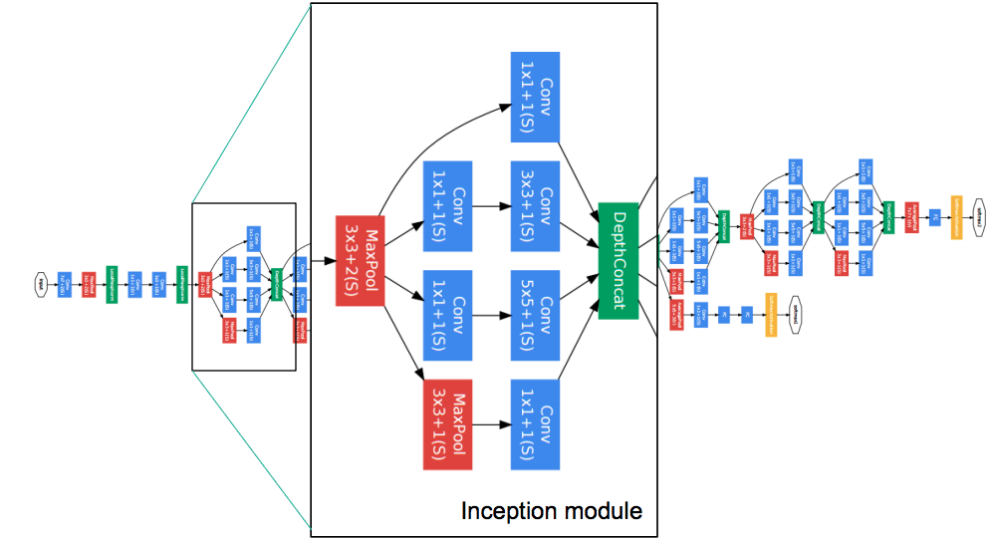
Fig. 1. GoogleNet Architecture
The accompanying diagram depicts the Googlenet cnn model's architecture [8]. GoogleNet is a deep convolutional neural network with 22 layers. This model can work with pre-trained datasets from ImageNet and Places365 [7]. The version trained on ImageNet classifies photos into 1000 object classes, including numerous objects and animals. In contrast, the Places365-trained network classifies photos into 365 separate scene types, including locations such as farms, parks, runways, and lobbies. [7]. GoogleNet has been trained on extensive datasets to learn diverse image representations. Additionally, the input size for GoogleNet is fixed at 224 x 224 pixels..

Squeezenet CNN Model
SqueezeNet is an innovative architecture designed to minimize the number of parameters while maintaining high accuracy levels [9]. This model achieves parameter reduction by initially replacing 3x3 filters with 1x1 filters and subsequently reducing the number of input channels for the remaining 3x3 filters [9]. The architecture includes squeeze layers composed solely of 1x1 filters and expand layers combining 1x1 and 3x3 filters [9]. This parameter-efficient design helps SqueezeNet achieve comparable accuracy to models like VGG and AlexNet. The architecture of SqueezeNet is structured as follows [10]:

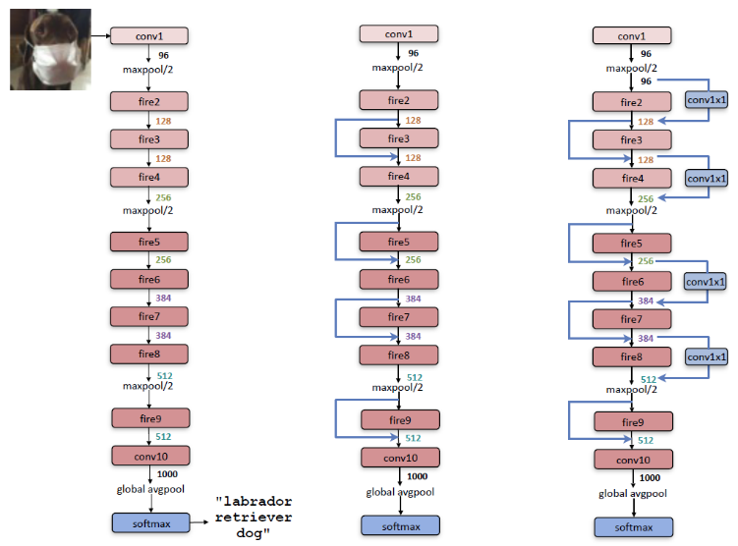
Fig. 2. SqueezeNet Architecture

AlexNet CNN Model
With more filters per layer and stacked convolutional layers, AlexNet has a deeper architecture. Training AlexNet on an Nvidia GeForce GTX 580 GPU takes about 150 hours on average, according to the Supervision group's development [11]. After being trained on millions of photos from the ImageNet dataset, this deep neural network can identify photographs into a variety of categories, including those pertaining to animals, birds, cars, and different things like keyboards, pens, and pencils. [12]. AlexNet has proven to provide effective representations for large-scale image datasets and remains widely utilized in image analysis tasks [12]. Below is the architecture description of AlexNet [13]::

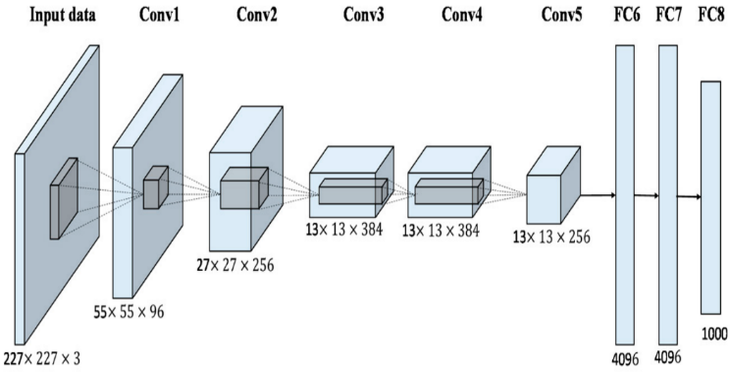
Fig 3. AlexNet Architecture

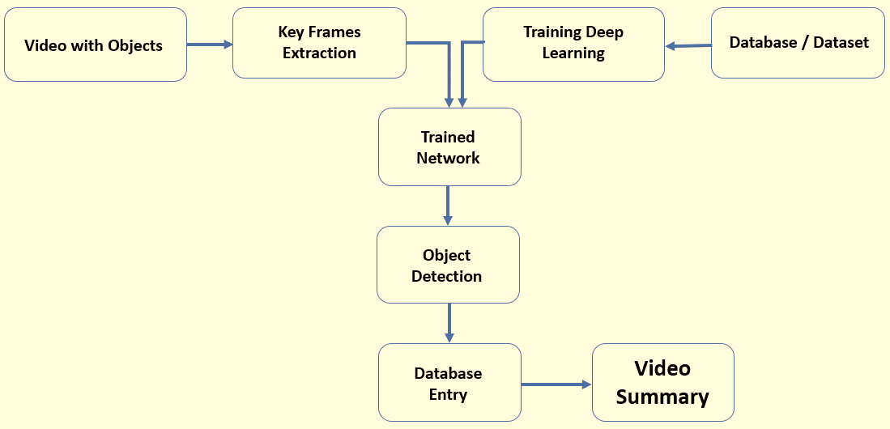
METHODOLOGY AND IMPLEMENTATION
Fig 4. Implemented Model
The system architecture for the implemented model is depicted in Figure 4, outlining the essential steps involved in generating a video summary from input datasets. This architecture details the methodology, necessary procedural steps, and the types of datasets utilized for creating the video summary. Initially, a diverse collection of datasets, sourced online and selected based on project requirements, including animals, birds, and flowers, is gathered. The performance challenges noted are attributed to ImageNet annotations, where images categorized as animals may mistakenly include humans as background elements. The animal dataset comprises 21 classes, while the bird dataset spans 200 categories, and the flower dataset includes 5 classes. Concurrently, the video undergoes processing for object identification, with keyframes extracted accordingly. These datasets and extracted frames are then utilized for object detection using deep learning algorithms. A pre-trained CNN model is employed, leveraging transfer learning to adapt a model previously trained on related tasks. Transfer learning accelerates training time and reduces generalization errors by initializing the neural network structure with prior knowledge. Five distinct CNN models are utilized for training: AlexNet, GoogleNet, SqueezeNet, ResNet-50, and YOLOv3. Once training is completed, object detection proceeds, storing entries of detected objects with probabilities exceeding predefined thresholds in a new dataset format. These entries are stored in a CSV format in an Excel sheet within a database. Ultimately, using these stored dataset entries, the system automatically generates a video summary, complete with annotated time frames for each identified object. This process effectively outlines the workflow and finalizes the video summary generation.

The implementation workflow for video summarization is straightforward: Begin by taking a video as input. Proceed to detect frames with a precision exceeding a specified probability threshold. Capture the initial and final frames for each identified object, compute the time in seconds between these frames, and compile this information—consisting of start time, end time, and object name—into a new data list. This curated data list serves as the final summary. Below outlines the algorithm for video summarization involving animals, birds, and flowers:
Step 1: Input the Video.
Step 2: For each Frame in the Video:
Iterate:
Employ a pre-trained CNN to detect objects.
If the probability of the detected object meets or exceeds the desired threshold: Record object details, including frame specifics, into a Data List.
End condition.
End Loop.
Step 3: For every identified object, retain only the first and last frame numbers; discard all others.
Step 4: Utilizing the first and last frame numbers, calculate and store the start and end times in seconds for each detected object that surpasses the desired probability threshold in a new Data List.
Step 5: Consider the new Data List as the conclusive summary.

PERFORMANCE ANALYSIS
As previously discussed, the performance comparison focuses on three pre-trained CNN models: GoogleNet, SqueezeNet, and AlexNet. To evaluate these models, a diverse dataset with a variety of images was required. After searching online repositories, we selected datasets from the Kaggle Repository, specifically those containing images of animals, birds, and flowers. The Animals dataset includes over 25,000 images of approximately 80 different animals. The Birds dataset comprises more than 11,000 images representing over 200 bird species. The Flowers dataset contains 4,000 color images of five flower species: Daisy, Dandelion, Rose, Sunflower, and Tulip. These images were input into the three CNN models, and their performance was assessed after numerous training sessions and iterations. The sample confusion matrix for the CNN models applied to the Flowers dataset is shown below.
The confusion matrix detailing the overall correct and incorrect detections was produced using an 80% training and 20% validation split, as presented in Table I, Table II, and Table III..
TABLE I. COFUSİON MATRİX OF GOOGLENET

Googlenet | Daisy | Dandelion | Rose | Sunflower | Tulip
Daisy | 155 | 10 | 1 | 5 | 1
Dandelion | 1 | 201 | 1 | 4 | 3
Rose | 2 | 5 | 157 | 6 | 7
Sunflower | 1 | 9 | 2 | 148 | 1
Tulip | 6 | 5 | 21 | 7 | 197

TABLE II. COFUSİON MATRİX OF SQUEEZENET
Squeezenet | Daisy | Dandelion | Rose | Sunflower | Tulip
Daisy | 153 | 10 | 1 | 7 | 1
Dandelion | 2 | 195 | 1 | 9 | 3
Rose | 5 | 2 | 152 | 6 | 12
Sunflower | 3 | 7 | 2 | 145 | 4
Tulip | 8 | 4 | 27 | 5 | 192

TABLE III. COFUSİON MATRİX OF ALEXNET
AlexNet | Daisy | Dandelion | Rose | Sunflower | Tulip
Daisy | 153 | 10 | 1 | 6 | 2
Dandelion | 2 | 199 | 2 | 4 | 3
Rose | 2 | 5 | 157 | 6 | 7
Sunflower | 1 | 9 | 2 | 147 | 2
Tulip | 4 | 4 | 25 | 7 | 196

Table IV shows the level of accuracy achieved by various models on Animal Dataset.
TABLE IV. SUMMARY OF ACCURACY LEVEL ON ANIMALS DATASET
Sr. No. | CNN Model | Total Images | Correctly Detected Images | Accuracy Level
1 | Alexnet | 29275 | 28578 | 97.62%
2 | Googlenet | 29275 | 28031 | 95.75%
3 | Squeezenet | 29275 | 27094 | 92.55%

Table V shows the level of accuracy achieved by various models on Animal Dataset.
TABLE V. SUMMARY OF ACCURACY LEVEL ON BIRDS DATASET
Sr. No. | CNN Model | Total Images | Correctly Detected Images | Accuracy Level
1 | Alexnet | 11388 | 11209 | 98.43%
2 | Googlenet | 11388 | 10999 | 96.58%
3 | Squeezenet | 11388 | 10734 | 94.26%

Table VI shows the level of accuracy achieved by various models on Animal Dataset.
TABLE V. SUMMARY OF ACCURACY LEVEL ON FLOWERS DATASET
Sr. No. | CNN Model | Total Images | Correctly Detected Images | Accuracy Level
1 | Alexnet | 956 | 852 | 89.12%
2 | Googlenet | 956 | 858 | 89.75%
3 | Squeezenet | 956 | 837 | 87.55%

IV CONCLUSİON
Recent research has used a variety of pre-trained CNN models to classify photos and detect objects in big datasets. This study found that the accuracy of these pre-trained models can range from 75% to 99%, depending on the dataset. Our study examined the performance of three pre-trained CNN models—AlexNet, GoogleNet, and SqueezeNet—on datasets containing a variety of things such as animals, birds, and flowers. The results show that all three models had similar accuracy levels, ranging from 85% to 90%. While any of these CNN models can be utilized effectively for image analysis and identification, we choose the AlexNet model because it obtained an accuracy of up to 99%.

REFERENCES

[1] Ujatha, C., Mudenagudi, U.: A Study on Keyframe Extraction Methods for Video Summary, Computational Intelligence and Communication Networks (CICN), 2011 International Conference, vol., no., pp.73,77, 7-9 Oct. 2011
[2] Baccouche, M., Mamalet, F., Wolf, C., Garcia, C., Baskurt, A.: Sequential deep learning for human action recognition. In human Behavior Understanding, pages 29– 39. Springer, 2011
[3] Sabbar, W., Chergui, A., Bekkhoucha, A.: Video summarization using shot segmentation and local motion estimation, Innovative Computing Technology (INTECH), 2012 Second International Conference on, vol., no., pp.190, 193, 18-20 Sept. 2012
[4] Frome, A., Corrado, G., Shlens, J., Bengio, S., Dean J., Ranzato, M., Mikolov, T.: Devise: A deep visual-semantic embedding model, In NIPS, pages 2121–2129, 2013
[5] Lu, Z., Grauman, K.: Story-driven summarization for egocentric video, In CVPR, pages 2714–2721, 2013
[6] Wang, X., Zhang, L., Lin, L., Liang, Z., Zuo, W.: Deep joint task learning for generic object extraction, In NIPS, pages 523–531, 2014
[7]https://in.mathworks.com/help/deeplearning/ref/googlenet.html
[8] https://medium.com/@RaghavPrabhu/cnn-architectures-lenet-alexnet-vgg-googlenet-and-resnet-7c81c017b848
[9] https://www.kdnuggets.com/2016/09/deep-learning-reading-group-squeezenet.html
[10] https://towardsdatascience.com/review-squeezenet-image-classification-e7414825581a
[11] Christoph Lampert, "Deep Learning with Tensorflow", [Online]. Available: http://cvml.ist.ac.at/courses/DLWT_W17/. [Accessed Feb. 12, 2019].
[12] "Alexnet-Pretrained Convolutional Neural Network", [Online]. Available: https://in.mathworks.com/help/deeplearning/ref/alexnet.html. [Accessed Feb. 13, 2019].
[13]ttps://www.google.com/url?sa=i&url=https%3A%2F%2Fwww.mdpi.com%2F20724292%2F9%2F8%2F848%2Fhtm&psig=AOvVaw2ZYMBb3UWB3IlOGgpz_caC&ust=1636518074154000&source=images&cd=vfe&ved=0CAgQjRxqFwoTCKCLsoa3ivQCFQAAAAAdAAAAABAR

