EEG-Based Age and Gender Prediction Using Deep Neural Network

Kaltham Alshayeb
Dept. Collage of Computer Science and Engineering University of Jeddah, Saudi Arabia
Kaltham.m.alshayeb@gmail.com

Walaa Alsumari
King Abdulaziz City for Science and Technology KACST, Saudi Arabia walsumari@kacst.edu.sa

Waleed Almutairi
King Abdulaziz City for Science and Technology KACST
Saudi Arabia walmutairi@kacst.edu.sa

Turky Alotaiby
King Abdulaziz City for Science and Technology KACST, Saudi Arabia
totaiby@kacst.edu.sa

Gaseb Alotibi
Dept. Collage of Computer Science and Information Technology , University of Tabuk,
Saudi Arabia
galotaibi@ut.edu.sa

Abstract—Brain-computer interfaces (BCIs) have witnessed remarkable progress and are finding applications in diverse domains. This research paper introduces a novel application of BCI technology, focusing on the prediction of age and gender via EEG analysis using Deep CNN and ResNet models. A widely adopted EEG recording device was employed to capture cerebral activities from 64 subjects, encompassing both male and female participants, in a comfortable situation with eyes closed and eyes opened. The CNN model achieved an accuracy of 99.8% for age classification and 99.93% for gender classification. On the other hand, the ResNet model attained an accuracy of 99.05% for age and 99.32% for gender classification. Furthermore, our analysis indicates that utilizing all channels of the EEG signals yields superior performance in predicting age and gender compared to brain regions.
Index Terms—BCI, EEG, CNN, ResNet, Deep learning, Age prediction, Gender prediction.

- INTRODUCTION

Brain-computer interfaces (BCIs) and brain-machine interfaces (BMIs) are synonymous terms denoting an advanced technology that facilitates interaction with the environment without reliance on peripheral nerves and muscles. BCIs utilize control signals derived from electroencephalographic (EEG) activity, establishing a non-muscular conduit through which individuals can communicate intentions to external devices such as computers, speech synthesizers, assistive devices, and neural prostheses. This technology holds immense promise, especially for individuals facing severe motor disabilities, as it can substantially enhance their quality of life and potentially reduce healthcare costs associated with intensive care[1].
The human brain operates through a complex network of interconnected neurons, allowing for the transmission of electrical signals that generate various activities within our brain. While some of these signals are confined within the protective myelin layer, certain signals can be captured and an- alyzed. Devices such as Electroencephalography (EEG), Elec- trocorticography (ECoG), and Functional Magnetic Resonance Imaging (fMRI) are employed to record cerebral activities. Among these, EEG stands out for its cost-effectiveness and simplicity in recording methods, making it a widely utilized tool in the development of BCI applications. EEG devices utilize electrodes attached to the scalp to measure the electrical signals emitted by the brain, with non-invasive forms being more common because of their affordability and simplicity of use [2].
The accurate prediction of age and gender plays a crucial role in diverse domains such as healthcare, marketing, personalized services, and security. Electroencephalography (EEG) signals have emerged as a non-invasive and objective method for predicting age and gender, offering valuable insights into various medical conditions [8]. Age-related changes in brain structure and function, as well as gender-specific differences in brain organization and hormonal influences, can be captured through EEG analysis. This approach holds significant potential in assessing neurodevelopmental disorders, neurodegenerative diseases, and psychiatric disorders in relation to age and gender [9] [10]. By analyzing EEG features such as spectral power and coherence, accurate predictions can be made, enabling early detection, personalized treatment strategies, and monitoring of age-related changes and gender-specific differences in brain function. EEG-based age and gender prediction models offer a promising avenue for advancing our understanding and management of a wide range of medical conditions [2].

Several studies have utilized conventional machine learning methods such as Support Vector Machines (SVM) and Random Forest [3] [4] to analyse EEG-acquired brain signals for various BCI applications. The limitation of these traditional approaches lies in their reliance on assumptions to extract relevant features tailored to specific applications, which are grounded in theoretical frameworks that may not universally apply. Consequently, essential features crucial for accurate analysis may be overlooked during the conventional feature extraction process. In contrast, deep learning models aim to automatically learn features that are difficult to extract using traditional methods. In this paper, we propose a methodology for predicting an individual's age and gender using EEG signals recorded with a portable EEG setup comprising 64 channels. This prediction task leverages Deep Convolutional Neural Network (CNN) and ResNet models. The structure of this paper is organized as follows: Section II provides a review of based age and gender prediction EEG approaches. In Section III, we present the methodology employed for dataset collection, preprocessing techniques, and the architecture of our proposed Deep Neural Network models. Subsequently, in Section IV, the performance of the proposed systems are evaluated. Finally, in Section V, summarize the findings and discussing potential avenues for future research.
- LITERATURE REVIEW
Previous studies have found some evidence of the age and gender effects on EEG. In [2], the authors propose a method for age and gender prediction based on EEG analysis. They utilize a deep learning architecture consisting of a hybrid deep BLSTM-LSTM network model. The model incorporates BLSTM, LSTM, and dense layers to classify gender and age using EEG signals. The study employs a dataset comprising EEG recordings from 60 subjects in a relaxed position with closed eyes. The authors preprocess the EEG signals using the Discrete Wavelet Transform (DWT) technique, decomposing them into different frequency bands, including alpha, beta, delta, gamma, and theta. The DWT analysis helps capture nonstationarity in the signals and provides wavelet coefficients corresponding to different brain waves. The proposed method achieves accuracy rates of 93.7% for age classification and 97.5% for gender classification, surpassing state-of-the-art approaches. Notably, the beta band frequencies in the EEG signals are identified as superior predictors for age and gender compared to other frequency bands.
Marjolein et al. [3], utilized longitudinal EEG data from the Netherlands Twin Register (NTR) and Washington University in St. Louis (WUSTL) to investigate age prediction and clas- sification in children and adolescents. EEG recordings were collected at ages 5, 7, 12, 14, 16, and 18, encompassing child- hood and adolescence. Power spectra in 1 Hz wide bins (1-24 Hz) were calculated from the EEG data. Age prediction was performed using random forest (RF) regression and relevance vector machine (RVM) methods, with RF achieving the lowest mean absolute prediction error. The classification task of
distinguishing childhood from puberty/adolescence achieved an accuracy exceeding 94%. The study assessed the stability and heritability of prediction errors, with significant genetic influences observed, leading to heritability estimates ranging from 42% to 79%. The study findings suggest that EEG-based age prediction exhibits comparability to magnetic resonance imaging (MRI) and offers potential applications in tracking neurodevelopment across various groups including typically developing children, preterm children, and those with neurodevelopmental disorders. The stability and heritability scores of prediction errors were notably higher in the GNASA sample compared to the NTR sample, possibly reflecting differences in population or sample characteristics between the cohorts. This research underscores the viability of EEG recordings for age estimation and classification in neurodevelopmental studies. In a related work [4], the authors propose a hybrid model for gender recognition using EEG signals, integrating random forest and logistic regression techniques. The analysis of non-stationary EEG signals involves four common entropy measures, assuming approximate stationarity of statistics. To capture gender-specific EEG features, the EEG data is segmented into short windows, and four distinct feature sets (FE, SE, AE, and PE) are evaluated. The scikit-learn toolbox is utilized for training and testing the models. Random forest models are trained by specifying parameters such as the number of trees and split quality, while logistic regression models utilize parameters like tolerance for stopping criteria and regularization strength. The performance of the hybrid model is evaluated using nested tenfold cross-validation, resulting in an accuracy of 99.82% and an AUC of 99.26%. The study employs EEG data from twenty-eight subjects during a resting state, where participants were in a quiet room, free from external interferences, and had their eyes open for 20 minutes. The last 5 minutes of recorded EEG signals serve as the dataset for analysis. The EEG data is referenced to electrically linked mastoids at A1 and A2 and digitized at a sampling rate of 1000 Hz using a 32-channel electrode setup. In [5], EEG signals were recorded from a diverse dataset of 60 individuals, ranging in age from 6 to 55 years. The dataset consisted of 25 females and 35 males, including school children and individuals from various socioeconomic backgrounds without any medical history. The dataset was categorized into six age classes and two gender classes for prediction purposes. The methodology involved the utilization of a wireless EEG sensor for signal recording, followed by discrete wavelet transform frequency decomposition for feature extraction. A random forest classifier was employed to model the brain signals, and the accuracies of age and gender prediction were compared with support vector machine and artificial neural network classifiers. Three statistical features (mean, energy, and root- mean-square) were extracted from different frequency bands (gamma, beta, alpha, theta, and delta). Notably, beta and theta band oscillations exhibited the highest age prediction rates, while delta rhythm led to the most accurate gender classification. The proposed framework achieved accuracies of 88.33% for age prediction and 96.66% for gender prediction using a user-independent approach. The performance of the

TABLE I
A SUMMARY OF THE EXISTING RESEARCH WORK IN THIS DOMAIN
Paper |  | Dataset (Num-  ber of Subject) | Methodology |  | Accuracy
Pallavi  al.,2019 | et  [2] | EEG signals  recorded from 60 subjects | BLSTM &  LSTM |  | Age - 93.7%  Gender - 97.5%
Marjolein et  al.,2019 [3] |  | EEG signals  recorded from 1538 subjects | RF & RVM |  | Age - 94%
Ping  al.,2019 | et  [4] | EEG signals  recorded from 28 subjects | RF |  | Gender - 99.82%
Barjinder et  al.,2019 [5] |  | EEG signals  recorded from 60 subjects | SVM  ANN | & | Age - 88.33%  Gender - 96.66%
Hongyu  al.,2019 | et  [6] | Private | CNN |  | Age - 51.2%  Gender - 62.7%

rate for the EEG data was 160 Hz. Each participant Fourteen experimental runs were conducted, comprising two one-minute baseline sessions (one with eyes open and one with eyes closed), alongside three two-minute sessions involving 12 distinct movements. [7]. To ensure a balanced and informative dataset for analysis, the data were reduced to 128 records, focusing on 64 participants and two rest mode runs. The individuals are separated into 4 age groups. The Table II below gives an overview about the dataset in details.

TABLE II DATASET DESCRIPTION

Age Group Number of Males Females Class

system was evaluated using

a random forest classifier and
Individuals
19-29 16 8 8 0

30-39 16 8 8 1
40-49 16 8 8 2
50-59 16 8 8 3

compared with alternative classifiers. The study employed a “Leave-One-Person-Out” cross-validation approach to assess the accuracy of the system. The findings suggest the potential application of this method in IoT-based healthcare systems, enabling automatic transmission of age and gender information to hospitals and clinics via the Internet. In [6], focuses on the application of a CNN architecture for the prediction of age and gender, which has not been explored extensively before. The results of this study demonstrate an accuracy of 95.5% for personal identification using the dataset employed. For gender classification, they achieved an accuracy of 62.7%, while the accuracy for age classification reached 51.2%. Table I provides a summary of these studies.
- METHODOLOGY
This section provides an overview of the dataset, preprocessing steps, and the two deep learning architectures. The investigated architectures are Deep Convolutional Neural Network (CNN) and ResNet models. The model comprises multiple layers, including Convolutional, MaxPooling, Flatten, and dense layers. These layers are specifically designed to effectively classify gender and age based on EEG signals. Two networks were implemented one for age estimation and the other one for gender estimation. The overall proposed approach can be seen in Figure 1.
- Dataset
The dataset employed in this study is the EEG Motor Movement/Imagery Dataset, developed by PhysioBank and referenced in [7]. It comprises more than 1500 EEG recordings, each lasting one to two minutes, collected from 109 volunteers. Among them, there are 8 unassigned, 59 female, and 42 male participants, ranging in age from 19 to 67 years. The distribution of age and gender is shown in Figure 2, within the population can be found in Figure 3. The EEG recordings were captured using the BCI-2000 system with 64 electrodes placed according to the international 10-10 system. Some electrodes (Nz, F9, F10, FT9, FT10, A1, A2, TP9, TP10, P9, and P10) were excluded, shown in Figure 4. The sampling
- Preprocessing
In the preprocessing step two tasks were performed: the segmentation and the normalization. Since EEG signals do not naturally exhibit distinct physiological units, this study employs the conventional method of segmenting the EEG streams into epochs based on time intervals. In this project, the raw EEG streams were segmented into 1-second epochs with a
0.5 overlap, as shown in Figure 1. This segmentation strategy allows for capturing sequential patterns and variations in the EEG data. The normalization of each segment is achieved using z-score transformation.
- Data Split
The dataset is divided into training and testing datasets. The training dataset is composed of 90% of the whole data which used to train and validate the CNN network. The remaining 10% was used to test the trained network.
- Brain Region
The EEG signals measure the electrical activity of the brain. Neuroscientists have broken them into different brain regions with each brain region responsible for a particular activity of the brain. Here is a breakdown of the brain regions typically associated with EEG signals [14]:
  - Frontal Region: This region is located at the front of the brain and is associated with higher cognitive functions, such as decision-making, problem-solving, and attention.
  - Frontocentral Region: This region is situated between the frontal and central regions and encompasses areas in- volved in motor control and certain cognitive processes.
  - Central Region: The central region is located in the middle of the brain and is associated with motor control and movement-related processes.
  - Centroparietal Region: This region is situated between the central and parietal regions and is involved in sensory processing, attention, and language comprehension.

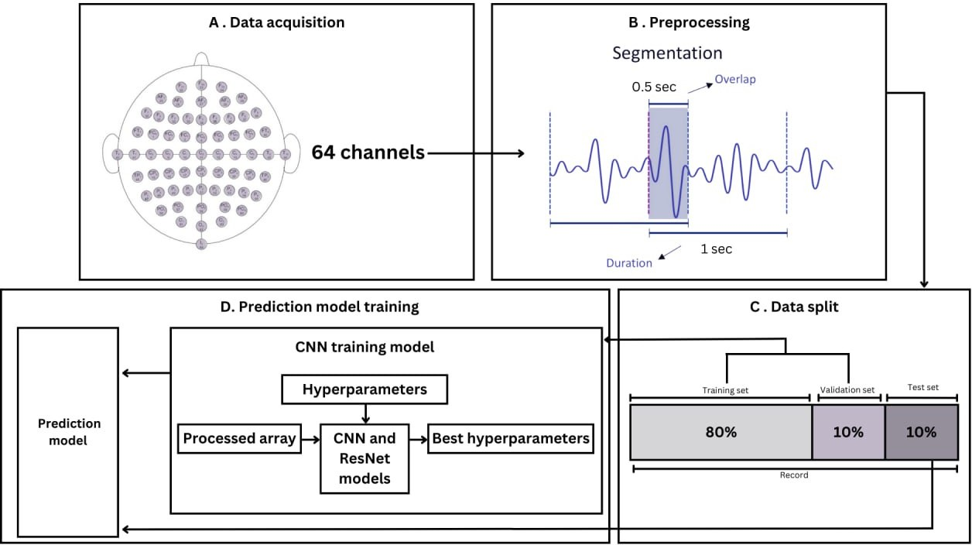

Fig. 1. An overview of the proposed approach for both age and gender prediction

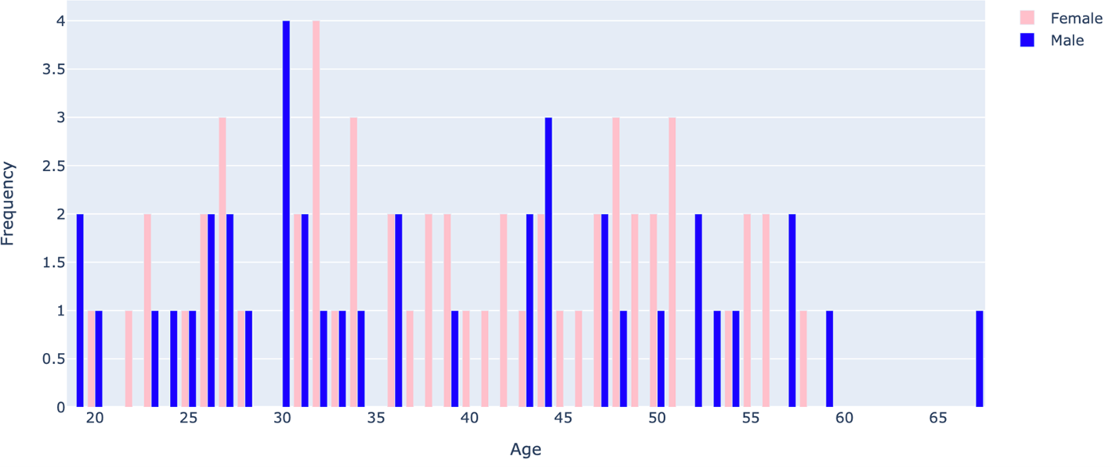

Fig. 2. Age Distribution by Gender
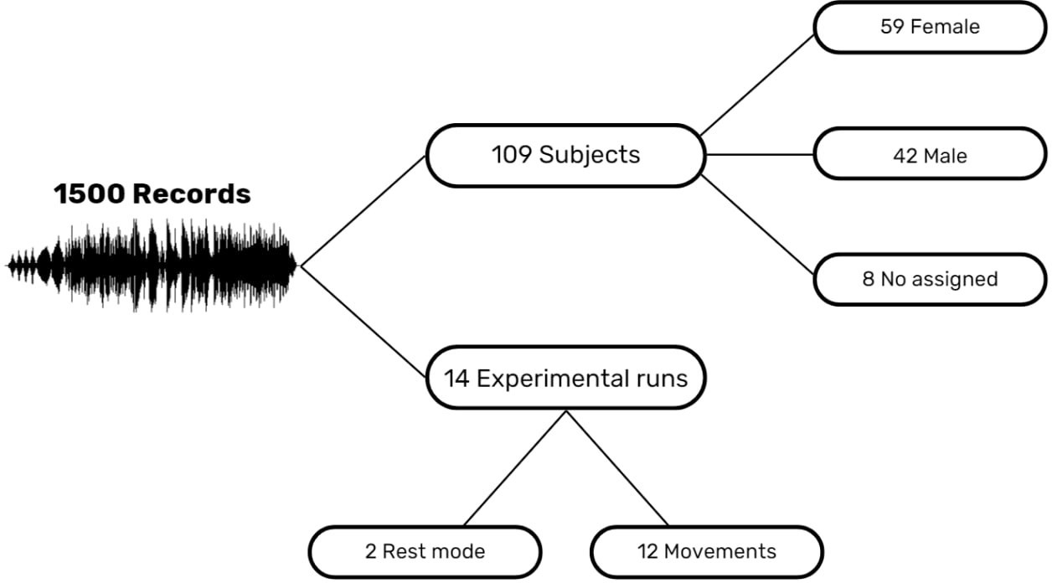

Fig. 3. EEGMMIDB Distribution

  - Parietal Region: The parietal region is located towards the back and top of the brain and is involved in processing sensory information, spatial awareness, and perception.
  - Parieto-Occipital Region: This region is situated be-

Fig. 4. Position of the electrodes according to the 10-10 international system

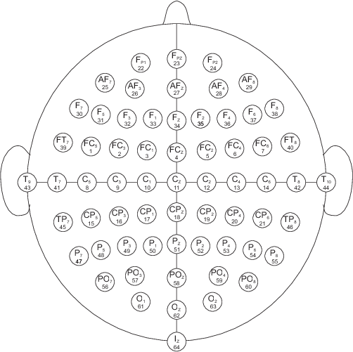
tween the parietal and occipital regions and is involved in visual processing and visuospatial integration.
  - Occipital Region: Situated at the posterior part of the brain, the occipital region plays a pivotal role in visual processing and perception,
  - Temporal Region: This region is located on the sides of the brain, near the temples, and is associated with audi- tory processing, language comprehension, and memory.
Given that distinct brain activities are associated with specific brain regions, it is logical to focus on individual brain regions rather than the entire EEG signal when analyzing particular types of activities. The brain regions are shown in Table III along with corresponding related channels according to the 10-10 international system.

TABLE III
BRAIN REGION WITH CORRESPONDING RELATED CHANNELS ACCORDING TO THE 10-10 INTERNATIONAL SYSTEM

Brain Region Related Channels
Frontal Region Fp1, Fpz, Fp2, F7, F5, F3, F1, Fz, F2, F4,
found to be 10,335,429 for age and 10,333,827 for gender prediction. Table IV presents the detailed architecture of the CNN model.
2) Deep Residual Neural Network (ResNet): The ResNet is

a deep learning architecture. It utilizes residual connections,

Frontocentral Region
F6, F8, Ft7, Ft8
Fc5, Fc3, Fc1, Fcz, Fc2, Fc4, Fc6
or skip connections, to train very deep neural networks effec-

Central Region C5, C3, C1, Cz, C2, C4, C6 Centroparietal Region Cp5, Cp3, Cp1, Cpz, Cp2, Cp4, Cp6 Parietal Region P7, P5, P3, P1, Pz, P2, P4, P6, P8
Parieto-Occipital Region Po7, Po3, Poz, Po4, Po8 Occipital Region O1, Oz, O2
Temporal Region T9, T7, Tp7, C5, C3, C1, Cz, C2, C4, C6,
T8, T10

- Adopted Deep Learning Architecture
Several experiments have been conducted utilizing Deep CNN and ResNet models.
  - Deep Convolutional Neural Network (CNN): The Convolutional Neural Network (CNN) is specifically engineered for analyzing data organized in a grid format, such as images. Modeled after the hierarchical organization observed in the visual cortex of animals, CNN is designed to autonomously and dynamically acquire spatial hierarchies of features, spanning from rudimentary to sophisticated patterns.
  - The CNN model, tested and validated in [13], consists of one main block: The CONV block takes the input data, passes it through the CONV layer, and then applies a Batch Normalization (BN) layer. To introduce nonlinearity, a Scaled Exponential Linear Units (SeLU) activation function is applied to the output.
Each convolutional layer is followed by a max-pooling layer, which contributes control the number of learnable parameters. After the final pooling layer, the output is flattened and fed into a dense layer with 800 neurons. To reduce overfitting, a dropout layer with a rate of 0.3 is placed before the final dense layer [11]. In the last layer, where for classifying the EEG signals for each age group, a final dense layer with 4 neurons is used. For gender classification, the same architecture is used, with the only difference being 2 neurons in the last dense layer. The model begins with a convolutional layer using a filter size of (1, 11) and the smallest number of filters, which is 25. Subsequently, the number of filters increases by half to 50 while maintaining the filter size of (1, 11). The last convolutional block concludes with a filter size of (1, 1) and
the largest number of filters, which is 200.
After the convolutional layers, the model employs a Flatten layer to reshape the output into a one-dimensional vector. This is followed by two dense layers, each consisting of 800 neurons. The final dense layer is responsible for classification, and the number of neurons in this layer is determined by the number of classes (4 for age classification/ 2 for gender classification).
The output of the final dense layer is passed through a softmax layer, which produces a probability distribution over the classes. This allows the model to make predictions based on the highest probability class. According to the provided information, the number of trainable parameters has been
tively. These connections address the problem of vanishing gradients, allowing gradients to flow more easily. ResNet consists of residual blocks with convolutional layers, batch normalization, and activation functions, with the addition of shortcut connections. ResNet has achieved state-of-the- art performance in computer vision tasks and has influenced subsequent CNN architectures [15].
The model starts with an input layer that takes input data. The first convolutional block consists of a 2D convolutional layer with 64 filters, a kernel size of (7, 7), and a stride of (2, 2). The ’same’ padding is used to keep the spatial dimensions the same. Batch normalization and a SeLU activation function are applied to the output. Then, a max-pooling layer with a pool size of (3, 3) and a stride of (2, 2) is used to reduce the
spatial dimensions.
A residual block function is defined to create residual blocks. Each residual block consists of two 2D convolutional layers with batch normalization and SeLU activation applied in between. The shortcut path handles the identity mapping and adjusts the dimensions if necessary. The output of the residual block is the element-wise sum of the shortcut and the main path, followed by a SeLU activation.
The model applies four residual blocks with increasing filter sizes and decreasing spatial dimensions. The filter sizes used are 64, 128, 256, and 512, respectively. The spatial dimensions are reduced by a factor of 2 in each block using strides of (2, 2).
After the last residual block, a GlobalAveragePooling2D layer is used to convert the 2D feature maps to a 1D vector. Then, a Flatten layer reshapes the output into a one- dimen- sional vector. Next, two dense layers with 800 neurons each and SeLU activation are applied. A dropout layer with a rate of 0.3 is placed between these dense layers to mitigate overfitting.
The output layer consists of a dense layer with the number of neurons equal to the number of classes (4 for age classi- fication/ 2 for gender classification), followed by a softmax activation function to produce a probability distribution over the classes. According to the provided information, the number of trainable parameters has been found to be 5,316,004 for age and 5,314,402 for gender prediction. Table V presents the detailed architecture of the ResNet model.
The models were trained for a maximum of 100 epochs, and Early Stopping techniques were employed to prevent overfit- ting when the accuracy no longer improved [12]. Additionally, the data is reshaped, and the labels are converted to one-hot encoding. These preprocessing steps help prepare the data for feeding into the Deep CNN and ResNet models. After obtaining data from various brain regions, each region is analyzed to determine their respective contributions in

TABLE IV
CNN MODEL NETWORK ARCHITECTURE

Layer Name #Filters #Neurons Filter Size/Stride/Pad Input Shape Learnable Parameters
Input Layer - - 64 160 1 -
× ×
CONV Block 1 25 1 11/1/0 64 160 1 300
× × ×
CONV Block 2 25 1 2/1/0 64 150 25 1375
× × ×
Max Pooling 1 - 1 3/1 3/0 64 149 25 -
× × × ×
CONV Block 3 50 1 11/1/0 64 49 25 14000
× × ×
Max Pooling 2 - 1 3/1 3/0 64 39 50 -
× × × ×
CONV Block 4 100 1 11/1/0 64 13 50 55500
× × ×
Max Pooling 3 - 1 3/1 3/0 64 3 100 -
× × × ×
CONV Block 5 200 1 1/1/0 64 1 100 21000
× × ×
Max Pooling 4 - 1 1/1 2/0 64 1 200 -
× × × ×
Flatten 800 - - -
Dense Layer 800 - 12800 10240800
Dropout (0.3) - - 800 -
Dense Layer 4/2 - 800 1602
SoftMax - - - -
Total Parameters 10,334,577

TABLE V
RESNET MODEL NETWORK ARCHITECTURE
Layer Name | #Filters #Neurons | Filter Size/Stride/Pad | Input Shape | Learnable Parameters
Input Layer  CONV Block 1 | -  64 | -  7 ×7/2 × 2/0 | 64 ×160 × 1 | -  3456
Max Pooling 1 | - | 3 ×3/2 × 2/0 | 32 ×80 × 64 | -
CONV(Residual) Block 1 64 |  | 7 ×7/2 × 2/0 | 16 ×40 × 64 | 37184
CONV(Residual) Block 2 64 |  | 7 ×7/2 × 2/0 | 16 ×40 × 64 | 37184
CONV(Residual) Block 3 128 |  | 7 ×7/2 × 2/0 | 8 ×20 × 128 | 74368
CONV(Residual) Block 4 128 |  | 7 ×7/2 × 2/0 | 8 ×20 × 128 | 147584
CONV(Residual) Block 5 128 |  | 7 ×7/2 × 2/0 | 8 ×20 × 128 | 9344
CONV(Residual) Block 6 256 |  | 7 ×7/2 × 2/0 | 4 ×10 × 256 | 296192
CONV(Residual) Block 7 256 |  | 7 ×7/2 × 2/0 | 4 ×10 × 256 | 590080
CONV(Residual) Block 8 256 |  | 7 ×7/2 × 2/0 | 4 ×10 × 256 | 35072
CONV(Residual) Block 9 512 |  | 7 ×7/2 × 2/0 | 2 ×5 × 512 | 1182208
CONV(Residual) Block 10 512 |  | 7 ×7/2 × 2/0 | 2 ×5 × 512 | 2359808
CONV(Residual) Block 11 512 |  | 7 ×7/2 × 2/0 | 2 ×5 × 512 | 135680
GlobalAveragePooling  Flatten | 512  512 | -  - | 2 ×5 × 512 | -  -
Dense Layer | 800 | - | 512 | 410400
Dropout (0.3) | - | - | 800 | -
Dense Layer | 4/2 | - | 800 | 1602
SoftMax | - | - | - | -
Total Parameters |  |  |  | 5,320,162

64 ×160 × 1

-

determining an individual’s age and gender. Experiments have shown that all channels contribute to better classification ac- curacy in determining both the age and gender of individuals. The results obtained are discussed in the next section.
- RESULTS
An EEG-based prediction technique relies on the signal length and the number of EEG channels used as inputs. In our experiments, we utilized the Deep CNN and ResNet models to explore the performance of different brain regions, includ- ing Frontal, Frontocentral, Central, Centroparietal, Parietal, Parieto-Occipital, Occipital, and Temporal regions, as well as all channels combined.
When using all channels as inputs, the Deep CNN model achieved the maximum accuracy of 99.93% for gender prediction
and a highest accuracy of 99.8% for predicting the age of individuals. Similarly, when employing the ResNet model, utilizing all channels yielded the highest accuracy of 99.05% for age and 99.32% for gender prediction.
During the training process, we monitored the validation accuracy closely. The training of both models was halted either when the validation accuracy started to decrease or when no further improvement was observed.
The accuracies achieved for different brain regions using the Deep CNN model are presented in Table VI, while the accuracies obtained using the ResNet model for various brain regions are displayed in Table VII. Using both models CNN and ResNet with individual brain region showed that the Frontal and the Temporal regions achieved the highest accuracy in both age and gender prediction. In contrast the

TABLE VI
THE ACCURACY OF THE DEEP CNN MODEL FOR EEG-BASED AGE AND GENDER ACROSS DIFFERENT GROUPING OF BRAIN REGION

All Channels Brain Region

Frontal Re- Frontocentral Central Re-
Centroparietal Parietal Re-
Parieto-
Occipital
Temporal

gion
Region
gion
Region
gion
Occipital
Region
Region

 |  |  |  |  |  |  | Region
Age | 99.8% | 98.17% | 95.52% | 94.43% | 93% | 90.69% | 80.71% | 76.22% | 97.21%
Gender | 99.93% | 98.23% | 93.48% | 95.11% | 91.3% | 91.85% | 76.36% | 72.01% | 98.78%

TABLE VII
THE ACCURACY OF THE RESNET MODEL FOR EEG-BASED AGE AND GENDER ACROSS DIFFERENT GROUPING OF BRAIN REGION

All Channels Brain Region

Frontal Re- Frontocentral Central Re-
Centroparietal Parietal Re-
Parieto-
Occipital
Temporal

gion
Region
gion
Region
gion
Occipital
Region
Region

 |  |  |  |  |  |  | Region
Age | 99.05% | 94.77% | 88.18% | 82.07% | 80.37% | 85.12% | 73.51% | 71.33% | 90.42%
Gender | 99.32% | 94.5% | 85.8% | 82.27% | 78.74% | 82.34% | 69.57% | 73.64% | 86.21%

Occipital region obtained the lowest accuracy on both age and gender prediction. Notably, the results demonstrate that employing all channels as inputs yields superior performance compared to using individual brain regions alone.
The confusion matrix in Figure 5 illustrates the results of age prediction using the Deep CNN model across all channels. Upon analyzing the figure, it becomes apparent that the age group of 19-29 (Class 0) exhibited the fewest misclassifica- tions, with only one individual out of 374 being erroneously categorized into the age group of 50-59 (Class 3). In the age group of 30-39 (Class 1), there was one misclassification where one individual out of 374 was classified into the age group of 50-59 (Class 3). Additionally, in the age group of 40-49 (Class 2), one out of 357 individuals was mistakenly classified into the age group of 19-29 (Class 0).
The confusion matrix for gender classification using all channels is displayed in Figure 6. In this case, the model misclassified 1 female member as male out of a total of 724 female individuals.
The confusion matrix presented in 7 illustrates the results of age prediction using the ResNet model across all channels. The analysis reveals interesting patterns in the misclassifications observed among different age groups. Notably, the age group of 30-39 (Class 1) exhibited the fewest misclassifications, with only 2 individuals out of 374 being assigned to the incorrect age group of 19-29 (Class 0). On the other hand, the age group of 19-29 (Class 0) experienced the highest number of misclassifications. Out of 374 individuals, 4 were wrongly categorized as belonging to the age groups of 30-39 (Class 1), 40-49 (Class 2), and 50-59 (Class 3). Similarly, within the age group of 40-49 (Class 2), there were 5 misclassifications out of 357 individuals. Among these, 4 were misclassified as belonging to the age group of 19-29 (Class 0), and one was misclassified as belonging to the age group of 50-59 (Class 3). Additionally, the age group of 50-59 (Class 3) demonstrated misclassifications, with only 3 individuals out of 367 being
assigned to the incorrect age group of 40-49 (Class 2).
The confusion matrix for gender classification using all channels is shown in Figure 8. In this case, the model misclassified 1 male member as female out of a total of 748 males, and it misclassified 9 females out of a total of 724 female individuals.

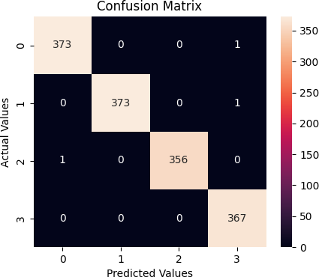
Fig. 5. Confusion matrix for age classification on all channels using the Deep CNN model.

- CONCLUSION AND FUTURE WORK
Predicting the age and gender of individuals has significant applications in various fields, including healthcare, online retail, and biometrics. EEG signals, being unique to each individual, contain valuable information. In this study, we aim to develop a robust system for age and gender prediction by analyzing EEG signals. Our dataset consists of recordings from 64 individuals, including both males and females, captured during periods of eyes closed and eyes opened in a resting position. The accuracies achieved in the Deep CNN model for

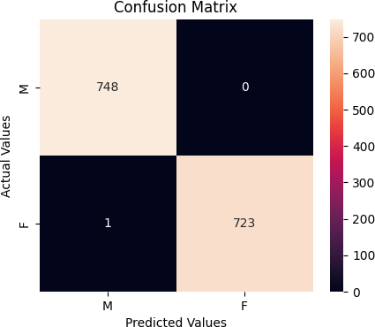

Fig. 6. Confusion matrix for gender classification on all channels using the Deep CNN model.

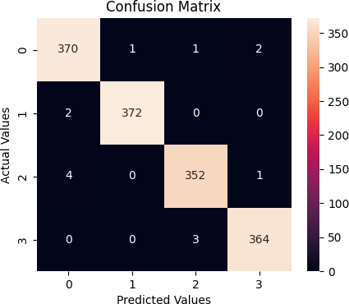

Fig. 7. Confusion matrix for age classification on all channels using the ResNet model.

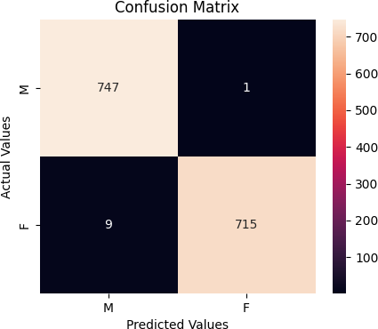

Fig. 8. Confusion matrix for gender classification on all channels using the ResNet model.
age and gender classification are impressively high, reaching 99.8% and 99.93%, respectively. Similarly, the ResNet model also demonstrates remarkable accuracies, achieving 99.05% for age and 99.32% for gender classification. However, the raw data was segmented into different brain regions to assess how brain activity is influenced by age and whether gender differences impact brain activity. Our analysis reveals that utilizing all channels provides superior accuracy for gender and age classification. In the future, it would be beneficial to collect additional data for the purpose of this experiment. Expanding the age groups to cover a range of 5-80 years would enable the application to be used by elderly individuals as well. Further experiments will be conducted to enhance the learning classifiers and refine the classification system. Additionally, the aim is to apply the developed system in real- time applications, paving the way for practical and real-world implementation.
REFERENCES
- Simanto, Saha., Khondaker, Abdullah, Al, Mamun., Khawza, I., Ahmed., Raqibul, Mostafa., Ganesh, R., Naik., Sam, Darvishi., Ahsan, H., Khan- doker., Mathias, Baumert. (2021). Progress in Brain Computer Inter- face: Challenges and Opportunities.. Frontiers in Systems Neuroscience, 15:578875-578875. doi: 10.3389/FNSYS.2021.578875.
- Luo, J., Xue, N., & Chen, J. (2022). A Review: Research Progress of Neural Probes for Brain Research and Brain–Computer Interface. Biosensors, 12(12), 1167.
- Marjolein, M., L., J., Z., Vandenbosch., Dennis, van, ’t, Ent., Dorret, I., Boomsma., Andrey, P., Anokhin., Dirk, J.A., Smit. (2019). EEG- based age-prediction models as stable and heritable indicators of brain maturational level in children and adolescents.. Human Brain Mapping, 40(6):1919-1926. doi: 10.1002/HBM.24501.
- Ping, Wang., Jianfeng, Hu. (2019). A hybrid model for EEG-based gender recognition.. Cognitive Neurodynamics, 13(6):541-554. doi: 10.1007/S11571-019-09543-Y.
- Barjinder, Kaur., Dinesh, Singh., Partha, Pratim, Roy. (2019). Age and gender classification using brain–computer interface. Neural Computing and Applications, 31(10):5887-5900. doi: 10.1007/S00521-018-3397-1.
- Hongyu, Liu., Lianghua, He., Shaohua, Shang., Jian, Lu., Meng, Wan., Shuang, Liu. (2019). Convolutional Neural Network for Resting State EEG Signal Analysis. 138-143. doi: 10.1109/ICNSC.2019.8743338.
- Schalk, G.; McFarland, D.J.; Hinterberger, T.; Birbaumer, N.; Wolpaw,
J.R. BCI2000: A General-Purpose Brain-Computer Interface (BCI) System. IEEE Trans. Biomed. Eng. 2004, 51, 1034–1043.
- Jean, Li., Jeremiah, D., Deng., Divya, Bharatkumar, Adhia., Dirk, De, Ridder. (2021). Resting-state EEG sex classification using selected brain connectivity representation.. arXiv: Signal Processing, doi: 10.1007/978- 3-030-69951-2 13.

- T., Teissier., Eric, Boulanger., Vincent, Deramecourt. (2020). Normal ageing of the brain: Histological and biological aspects.. Revue Neu- rologique, 176(9):649-660. doi: 10.1016/J.NEUROL.2020.03.017.
- Marina, A., Pavlova. (2017). Sex and gender affect the social brain: Beyond simplicity.. Journal of Neuroscience Research, 95:235-250. doi: 10.1002/JNR.23871.
- Sabiri, B., El Asri, B., & Rhanoui, M. (2022). Mechanism of Overfitting Avoidance Techniques for Training Deep Neural Networks. In ICEIS (1) (pp. 418-427).
- Ferro, M. V., Mosquera, Y. D., Pena, F. J. R., & Bilbao, V. M. D. (2023). Early stopping by correlating online indicators in neural networks. Neural Networks, 159, 109-124.
- Lun, X., Yu, Z., Chen, T., Wang, F., & Hou, Y. (2020). A simplified CNN classification method for MI-EEG via the electrode pairs signals. Frontiers in Human Neuroscience, 14, 338.
- Sanei, S., & Chambers, J. A. (2021). EEG signal processing and machine learning. John Wiley & Sons.
- Wu, Z., Shen, C., & Van Den Hengel, A. (2019). Wider or deeper: Revisiting the resnet model for visual recognition. Pattern Recognition, 90, 119-133.

