IoT Based Smart Home Using Virtual Key

Edna Elizabeth N¹
Department of Electronics and Communication¹
Sri Sivasubramaniya Nadar College of Engineering1
Kalavakkam, Chennai, India
ednaelizabethn@ssn.edu.in
Jeffrey Isaac.S²
Department of Computer Applications²
Hindustan Institute of Technology and Science²
Chennai, India
isaacjeffrey01@gmail.com
Sophia Janit³
Department of Computer Applications³
Hindustan Institute of Technology and Science³
Chennai, India
rsophia@hindustanuniv.ac.in

Abstract— In this comprehensive documentation, we embark on an enlightening journey into the dynamic realm of Internet of Things (IoT) home automation. From the seamless integration of smart devices to the complex orchestration of automated processes, IoT home automation redefines the very essence of domesticity. We explore the landscape of cutting-edge advancements, delving into the intricate interplay of sensors, actuators, and connectivity protocols that underpin the functionality of smart homes. Furthermore, we delve into the practical applications of IoT in various aspects of home management. This includes optimizing energy efficiency, monitoring the environment, controlling personalized comfort, and enhancing security measures. As we navigate through real-world case studies and exemplary implementations, we gain invaluable insights into the practical challenges and opportunities inherent in deploying IoT solutions within residential settings. In our proposed work, we have developed a prototype for a smart IoT based smart home to control and monitor various systems such as light, lamp, socket and fan using ESP32 controller. The various controls are performed through relays. The data is sent to the firebase cloud through Wi-Fi and stored in the cloud. Later the appliances are switched ON/OFF through virtual key using mobile APP. By using virtual keys, we address pertinent ethical and privacy considerations, shedding light on the importance of responsible data stewardship and robust cybersecurity measures. These are crucial in safeguarding the integrity of smart home ecosystems. By combining theoretical frameworks with empirical observations, we aim to provide a comprehensive understanding of IoT home automation.
Keywords— Smart home, IoT, ESP32, Relays, Virtual key, Mobile APP, firebase cloud

Introduction
In recent years, Internet of things (IoT) integration has revolutionized the way we live, work, and play in our homes. From intelligent thermostats that respond to our needs to smart security systems that ensure our safety, IoT home automation has become the foundation of modern life. Welcome to IoT home automation, the world of which has never been so exciting. Whether you’re a tech aficionado looking to get involved in Do It Yourself (DIY) projects, or a homeowner looking to simplify your daily life, IoT home automation is here to help [1], [2].
We will explore the endless possibilities of IoT devices, dive into the ins and outs of how home automation systems work and explore how these innovations are redefining the concept of home life. Welcome to home automation, where comfort, efficiency, and convenience all come together in harmony. In today's fast-paced world, convenience is paramount, and what better way to achieve it than through the seamless integration of technology into our daily lives. Enter IoT home automation – a revolutionary system that empowers homeowners to control every aspect of their living space directly from the palm of their hand thanks to smartphone connectivity [2].
Gone are the days of manually adjusting thermostats, flipping light switches, or wondering if the garage door is left open. With IoT home automation, these tasks become effortless and intuitive, allowing users to create personalized schedules, monitor energy usage, and even receive real-time alerts and insights about their home's status – all from the convenience of their smartphone. Whether it's ensuring optimal comfort, enhancing security measures, or simply enjoying the peace of mind that comes with knowing your home is in sync with your lifestyle, IoT home automation offers a myriad of possibilities to transform the way we interact with our living spaces [3].
In an era defined by the seamless integration of technology into our daily lives, the advent of IoT home automation has ushered in a new era of domestic convenience, empowering homeowners to remotely monitor and adjust a plethora of household functions – from lighting ambiance and room temperature to security systems and energy consumption – all via their smartphones, epitomizing the convergence of cutting-edge innovation and personalized control for an unparalleled living experience.
In today's interconnected world, IoT home automation, which allows homeowners to effortlessly control various aspects of their living space such as lighting, temperature, security, and even appliances, all through the convenience of their smartphones, represents a paradigm shift in home living, offering unparalleled convenience, comfort, and peace of mind [3].
The existing work is implemented using web-based mobile App, but the proposed model uses novel virtual key that is operated and implemented using Mobile APP-MIT App Inventor. The controller ESP32 used in the proposed model is simple to implement and cost effective that monitors and controls various appliances. [Table 1]

RELATED WORKS
Khalil Mohamed et.al [2023], proposes a system that integrates both IoT and cloud computing technologies [3] thereby to increase the system's performance. The CPU used is the Node MCU. Automatic irrigation is performed in home gardens by using a system that integrates various smart devices, and security alarms, and operates in both manual and remote modes. The system [3] can be controlled over IoT cloud service, and watering is made easier by setting parameter thresholds, minimizing water waste, and utilizing water as needed.
Cristina Stolojescu-Crisan et al [4] [2021], describes the system called qToggle and performs by leveraging the power of a flexible and powerful Application Programming Interface (API) [1]. A smartphone application [2] has been developed that allows users to control a series of home appliances and sensors. Since the qToggle system is user friendly, flexible, and can be further developed by using different devices and add-ons, many of the ESP8266/ESP8285 chips [1] and/or Raspberry Pi based boards use qToggle system.
Olutosin Taiwo et al [5] [2021], proposed a camera to capture images of objects triggered by their motion being detected. In this paper, the machine learning concept is used to avoid false alarm to differentiate between the images of persons at home and with an intruder. Also, it improves home automation system functionality and enhances home security. In the scientific website [1], to classify the features of the image captured and determine if it is that of a regular home occupant or an intruder before sending an alarm to the user, support vector machine algorithm is proposed. The design of the mobile application allows a graphical display of the activities in the house.
Parul Dubey et al [6] [2023], describes the home automation system using android that is capable of existing in both virtual and real environments. Control is sent from an Android phone to a node MCU for all the home appliances to function properly.
Manoj Vairalkar et al [7] [2023] explains the use software-based virtual buttons that can be placed anywhere on a user interface and can be activated using any other inputs or simply by means of touch. [2] Using IoT, virtual buttons can be created and deployed remotely, making them an ideal solution for controlling and managing devices in various environments. Users can operate and control devices without the need for physical buttons or switches by connecting virtual buttons to physical devices through the internet.
Muhammad Abbas Khan et al [8] [2022], describes that the proposed system operates by connecting the robust Application Programming Interface (API) [1], which is the key to a universal communication method. The Home Automation System used devices, often implemented actuators or sensors that have an upwards communication network followed by HAS (API). The devices of the HAS) use Raspberry Pi boards and ESP8285 chips.
From the above literature survey, we infer that the existing models are quite cost effective and certain papers propose only monitoring of devices. So, our proposed model provides a virtual key that monitors and controls the devices remotely and provides a cost-effective prototype that can be made simple to implement.

PROPOSED IOT MODEL
The proposed model of an IoT based smart home using virtual key consists of the following modules as shown in figure 1.

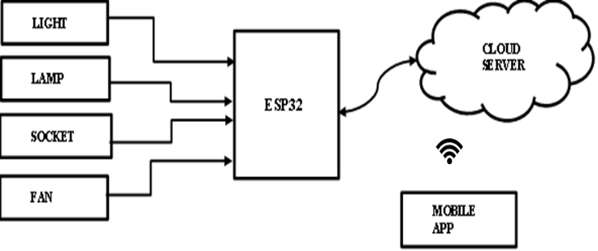
Fig 1 Basic smart home system architecture
The basic appliances such as light, lamp, socket and fan are connected to the relays and in turn connected to the ESP32 controller. The ESP32 controller is shown in figure 2 and the details of it are explained in the hardware part. The output of the ESP32 is connected to the firebase cloud server. The C++ programming is programmed in such a way that the above said appliances can be made ON/OFF. The data is stored in the firebase cloud and by using Mobile App, which is considered as virtual key, the above said appliances can be controlled through Wi-Fi. ESP32 is chosen because it is easy to handle and cost effective when compared to raspberry pi.
The software and the hardware requirements of the proposed model is as follows:
3.1 Software requirement:
The functional requirements or the overall description documents include the product perspective and features, operating systems and operating environments, graphics requirements, design constraints and user documentation. The appropriation of requirements and implementation constraints gives the general overview of project.
- C++
- MIT App Inventor
- Firebase - Cloud
C++: C++ is used as the major language in Arduino-IDE software to code, compile and upload to the firebase database (cloud computing) software, which is an open source and finally to get the output through ESP32 hardware device. Optimized C++ code can minimize resource usage, reduce latency, and maximize battery life, critical factors in IoT applications where energy efficiency is paramount. C++ provides robust support for concurrency and multithreading, allowing developers to design asynchronous, event-driven systems capable of handling multiple tasks simultaneously. C++ is inherently cross-platform, enabling developers to write code that can run on a wide range of hardware platforms and operating systems commonly found in IoT environments.
MIT App Inventor: MIT App Inventor [9] provides a visual development environment that allows users to create Android apps without any prior programming experience. The intuitive drag-and-drop interface, combined with a blocks-based programming model, enables users to design and prototype IoT home automation apps quickly and easily. MIT App Inventor offers a rich library of pre-built components and widgets that users can drag and drop onto the design canvas to create the user interface of their app. MIT App Inventor supports Bluetooth and Wi-Fi connectivity, allowing users to communicate with IoT devices wirelessly and control them from their Android devices.
Firebase - Cloud: Using Firebase Cloud for IoT home automation [10] offers several benefits, including real-time data synchronization, scalable backend infrastructure, and seamless integration with mobile and web applications. Firebase Realtime Database provides a NoSQL cloud-hosted database that enables real- time synchronization of data between clients and servers. In an IoT home automation system, sensor data from devices such as temperature sensors, motion detectors, and door sensors can be streamed to the Firebase Realtime Database in real-time.
3.2 Hardware requirement
ESP 32
The ESP32 [10] is a powerful microcontroller as shown in fig 2, is widely used in IoT home automation. It has built-in Wi-Fi and Bluetooth connectivity, making it ideal for connecting devices within a smart home ecosystem. The dual-core processor, ample memory, and various GPIO pins make the ESP32 suitable for controlling various home automation functions.
Home automation uses the ESP32 because it is compatible with popular IoT platforms and frameworks like Arduino IDE, Micro Python, and ESP-IDF. It's easy for developers and hobbyists to deploy smart home solutions.
The ESP32 creates a central hub for connecting and controlling various smart gadgets in homes. It could be used to monitor and adjust the temperature using smart thermostats, turn lights on and off remotely, receive notifications about security events, and even automate tasks based on sensor data.
Wireless sensors and actuators can be placed throughout the home without the need for constant recharging or replacement because of the low power consumption of the ESP32.
Connectivity, processing power, and affordability make the ESP32 an excellent choice for building scalable and cost-effective home automation systems.
The integration of Wi-Fi and Bluetooth capabilities, coupled with its robust processing power, make the ESP32 a compelling choice for orchestrating a diverse range of IoT home automation tasks seamlessly.

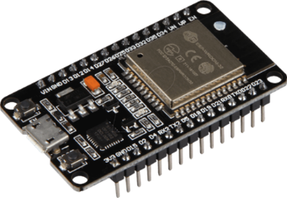

Fig 2. ESP 32 Image [10]

Table 1 shows the comparison of the proposed model with the existing models. The proposed model is cost effective when compared to other existing models and user friendly. Moreover, the controller ESP32 used in our model is very simple to implement.

TABLE 1 COMPARISON OF THE PROPOSED IOT MODEL
Home  Automation  System | Communi-cation | Controller | User Interface | Applications
qToggle [4] | Wi-Fi | Raspberry PI, ESP8266 | web-based mobileApp | Home automations, indoor and outdoor, irrigations, security, monitoring, power and energy, management (including solar energy), Google  assistant compatible [4].
IoT [7] | Bluetooth | Node mcu | Relay module | Switch on the light
Home automation system (HAS) [8] | Wi-Fi | RPi boards and ESP8285 chip | HAS Web App | Controlling Home appliances (A/C, Television, Speakers, Ceiling Lights) for  energy and power saving
Our model: Cloud (computing) data base | Wi-Fi | ESP32-new version | Virtual key using Mobile  APP-MIT App Inventor | Monitoring power and energy by controlling light, fan, socket, and lamp for smart home.

RESULTS AND DISCUSSION
In our proposed work, the home automation system is implemented for four appliances such as fan, light, socket and lamp. It can be extended to many applicances as per our requirements. The basic prototype model consists of ESP32 controller to which the applicances are connected through four 12 volt relays. The ESP32 is coded using Python and the datas are sent to the firebase cloud . The data stored in the cloud is accessed by means of mobile app which uses the -MIT App Inventor [9]. The appliances can be turned ON/OFF through Wi-Fi using the mobile virtual keys created using the app inventor. The laptop acts as a firebase cloud and the entire set up is shown in the figure 3. Figure 4 shows output when the virtual key via mobile app is turned on, the corresponding appliance will be switched ON through the relay and the corresponding LED will glow.

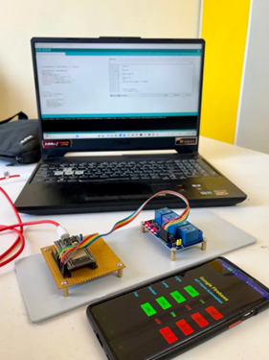

Fig 3. Implementation of hardware with mobile App

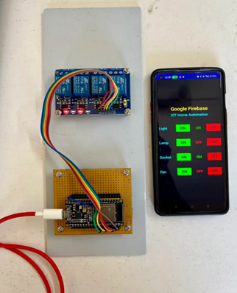

Fig 4. Relay output with appliances in ON/OFF mode

4.1. MIT App Inventor dashboard screen

The working of the MIT app is shown in figure 5. The output data stored in the firebase are shown in figure 6 and the appliances outputs are shown in figure 7.

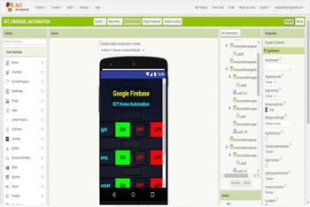

Fig 5. MIT App Inventor -dashboard screen

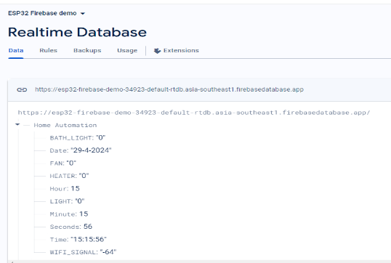

Fig 6. Firebase database

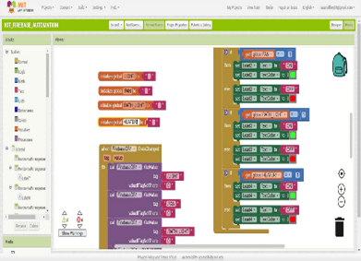

Fig 7. MIT APP inventor- appliances outputs.

CONCLUSION
A prototype of IoT based smart home to control and monitor various systems such as light, lamp, socket and fan using ESP32 controller has been implemented. The various controls were performed through relays. The data obtained is sent to the firebase cloud through Wi-Fi and is stored in the cloud. Later using virtual keys through mobile app, the appliances were switched ON/OFF via relays.
As future work, this can be extended as, controlling of various other appliances by many users from remote places such as offices when people forget to switch off the light or fan at home. This can be developed using long-term evolution techniques and the work can be enhanced using security during data transfer.

References

- https://scand.com/company/blog/iot-and-home-automation-what-does-the-future-hold/
- https://www.digiteum.com/iot-smart-home-automation/.
3. Khalil Mohamed, Ayman El Shenawy, “A Smart IoT-Based Home Automation System for Controlling and Monitoring Home Appliances” International Review of Automatic Control (I.RE.A.CO.), Vol. 16, N. 5, ISSN 1974-6059, September 2023. DOI: 10.15866/ireaco.v16i5.23872.,
4. Cristina Stolojescu-Crisan, Calin Crisan, and Bogdan-Petru Butunoi, “An IoT-Based Smart Home Automation System”, Sensors 2021, 21, 3784. https://doi.org/10.3390/s2111378, pp 1-23
5. Olutosin Taiwo 1 and Absalom E. Ezugwu. “Internet of Things-Based Intelligent Smart Home Control System”, Hindawi Security and Communication Networks, Volume 2021, Article ID 9928254, 17 pages, https://doi.org/10.1155/2021/9928254
6. Parul Dubey, Harshita Chourasia, Shilpa Ghode, “A Novel Approach to Degin Home Automation using IoT Applications”, 2023 International Conference on Advancement in Computation & Computer Technologies (InCACCT), ISBN: 979-8-3503-9648-5/23/$31.00, DOI: 10.1109/InCACCT57535.2023.10141754.
7. Manoj Vairalkar, Ratandeep Umak, Shivam Marwadi,Janhvi Shende, Sumit Tikhade, “VIRTUAL BUTTON USING IOT”, International Research Journal of Modernization in Engineering Technology and Science, Volume:05/Issue:04/April-2023, pp. 4274-4278. DOI: https://www.irjmets.com/uploadedfiles/paper//issue_4_april_2023/35601/final/fin_irjmets1682335192.pdf
8. Muhammad Abbas Khan, Ijaz Ahmad, Anis Nurashikin Nordin, A. El-Sayed Ahmed, Hiren Mewada, Yousef Ibrahim Daradkeh, Saim Rasheed, Elsayed Tag Eldin 8 and Muhammad Shafiq, “Smart Android Based Home Automation System Using Internet of Things (IoT)”, Sustainability 2022, 14, 10717. https://doi.org/10.3390/su141710717, pp. 1-18.
9. News & events. MIT App Inventor. (n.d.). https://appinventor.mit.edu/
10. Mike, Santos, S., Mj, Kashif, Cedric, Gbmlr, Junior, F. L. P., Jojo, Jc, Monte, M., Luiz, Eyal, Ziegler, O., Juerg, Jim, MosheB, Ian, Silva, J. J. D. da, Rodrigo, … Hansie. (2021, October 30). ESP32: Getting started with firebase (realtime database). Random Nerd Tutorials. https://randomnerdtutorials.com/esp32-firebase-realtime-database/

